Introduction:
The purpose of this personal development report is to map out my current skills, evaluate my progress and set actionable plans for my future goals. This allows me to identify the gap between my current skills and the standard of Landscape Architecture industry. Plus, this process provides a logical foundation for evolving my existing skills. All of this is to help me survive and develop in my BA (Hons) in Landscape Architecture.
Personal Profile:
Strengths | Weaknesses
- High concentration, patience, and a strong work ethic.  - Skilled in model making with a natural intuition for spatial arrangement and aesthetics.  - Solid tech skills (7.5/10) and a high capacity for learning new tools. | - Anxiety and overthinking are linked to perfectionism; difficulty accepting mistakes.  - Limited communication and critical thinking skills and struggling to articulate ideas.  - Inconsistent time management (6.75/10), easily influenced by mood and weather.
Opportunities | Threats
- Refining hand-drawing skills to integrate with digital drawings and site analysis.  - Enhancing Photoshop proficiency for better accuracy in grid systems and materials. | - Internal pressure and high expectations to be perfect.  - Performance anxiety, particularly during presentations and high-pressure situations.
(Birmingham City University, 2026)
Action Plan:

- Action Plan -
 | Stage 1 – Planned Action | Stage 2 – Rationale for Action | Stage 3 – Development Process | Stage 4 – Timescale | Stage 5 - Evaluation | Comments
 | Objective, action, goal, target or development need | Why are you focusing upon the action/objective highlighted? | Individual steps needed to achieve the action/objective  What activities do I need to undertake to achieve my objectives?  What support/resources do I need to achieve my objectives | Over what time frame will the action be addressed | Reflections on development and the impact upon practice
1 | Quick sketching skills | It allows me to experiment with different layout options before starting to draw the details in the software.  It helps me quickly generate ideas to be able to communicate my thoughts.  More flexible hand-drawing instead of focusing mostly on principles. | - Start sketching everything without erasing or using pen instead of pencil.  - Instead of drawing lines, use large areas to capture space.  - Stare intently at the subject and redraw it without looking down at the paper.  - Reference books:  + Richards, J. (2013) Freehand drawing and discovery: urban sketching and concept drawing for designers. 1st edition. Hoboken, NJ: WILEY. | Achieve by week 10. | My hand gets used to the movements, helping my strokes become decisive, smooth, and steady. This confidence is most evident when quickly sketching ideas without having to erase repeatedly.  I have become more accustomed to using ink pens or liners to quickly sketch ideas. My ability to generate ideas has also improved, although they are not yet perfect or aesthetically pleasing.
2 | Work life balance | It helps me to have healthy lifestyle, good health for a huge work pressure and workload.  I can work more efficiently without loosing much energy.  I can distribute workload efficiently. | - Booking a meeting with Bhavik for this session.  - Making a to-do list which includes all the tasks I must finish.  - Highlighting one of the most important tasks which needs to be completed soon or by the nearest deadline.  - Set up Google Calendar to create specific time limits for each task and for the deadline due. | Achieve by week 10. | I work more productivity because this helps me identify core priorities immediately, avoiding being overwhelmed by a large workload.  I work more systematically, maintaining a high level of focus to develop creative ideas without distractions or falling behind schedule.
3 | Multidimensional Thinking | Avoid impulsive decisions  Reduce the risk of mistakes  Choose the optimal solution instead of the one that "seems right" | - `Apply “Six Thinking Hats” Models: https://www.debonogroup.com/services/core-programs/six-thinking-hats/.)  - Asking why for every step of process. | 21st August 2026. | Instead of focusing solely on what I only think, I learned to evaluate from multiple perspectives: from technical feasibility (White Hat), maintenance risks (Black Hat) to economic and community value (Yellow Hat). I can be creative (green hat) with my own intuition (red hat) without deviating from the general design criteria (blue hat).
4 | Better presentation skills | Help me can explain my work in professional way.  Be more confident while talking.  Can handle the pressure when a lot of people looking at myself. | - Recommend method:  + Apply 4Ps of Effective Presentations https://flevy.com/blog/4-ps-of-effective-presentations/?srsltid=AfmBOoqe6cuSG6XXJPd_p9Kjwehh1_u-sul2cxm7X_dJNTVTTLlM0C6T  + TED talk  https://youtu.be/-FOCpMAww28?si=o75u1szuE0cb7r54  - Do a small presentation of any topics in front of mirror everyday. | 31st March 2026. | I have developed a more effective technique of collecting materials for my presentation. Instead of overwhelming viewers with every small detail, I now focus on a clear, coherent core, which makes my projects more professional and accessible.  My presentation skills shifted from reading slides to guiding the audience. Through regular practice in front of a mirror, I evolved technical proficiency to explain material choices without hesitation. This changed my mindset; I now view the presentation as a worthy gift for audience. As a result, I have used eye contact and more professional demeaner while doing the presentation, allowing me to receive feedback from the audience.
5 | Better Photoshop skills | Helps me realize creative ideas like digital collage in my field. | - Try to apply new tools in small projects to identify more functions of photoshop  - Start using Photoshop instead of Canva | Achieve by Week 10. | I can use Pattern Overlay or Clipping Mask to embed real texture images into architectural forms. Instead of just using solid colour blocks, applying materials gives elevation or perspective drawings more depth and emotion. Plus, I can create transparent or frosted glass effects. This allows objects to overlap without losing detail in the underlying layers.

Future Plan:
According to the Global Engineering Design & Technology Journal (Sun, 2024), the use of plant-based and nature-based solutions to address urban heat reduction is crucial. Therefore, understanding plant diversity is extremely important for the future. Furthermore, the use of software such as AutoCAD, BIM, and GIS to manage environmental data is essential, as emphasized by the Landscape Institute (2021). In addition, project practices must ensure inclusiveness, create safe spaces for all social strata, and improve the mental and physical health of urban residents, as outlined in ASLA (2025).
Conclusion:
To conclude, this PDP (Development Report Plan) helped me reevaluated my potential and challenges in the field of Landscape Architecture. Through SWOT model and the development of a specific action plan, I was able to clearly identify my strengths and weaknesses. Implementing these action plans helped me bridge the gap between my current capabilities and the stringent industry standards of the future.
Reference
Birmingham City University, 2026. Summary Report: Birmingham City University Indicator for Phuong Vi Nguyen. Birmingham: Birmingham City University

Richards, J. (2013) Freehand drawing and discovery: urban sketching and concept drawing for designers. 1st edition. Hoboken, NJ: WILEY.

The De Bono Group (2019). Six thinking hats. [online] The De Bono Group. Available at: https://www.debonogroup.com/services/core-programs/six-thinking-hats/.

Sun, S. (2024). The Role of Landscape Architecture in Addressing Climate Change and Environmental Challenges. Global Journal of Engineering, Design & Technology, [online] 13(2), pp.1–2. doi: https://doi.org/10.35248/2319-7293.24.13.219.

Landscape Institute (2021) Landscape for 2030: How landscape practice can respond to the climate crisis. London: Landscape Institute.

American Society of Landscape Architects (2025) Landscape Architecture 2040: Climate & Biodiversity Action Plan – Executive Summary for ASLA Members (2026-2030). Washington, D.C.: ASLA Fund

Quick sketching skills
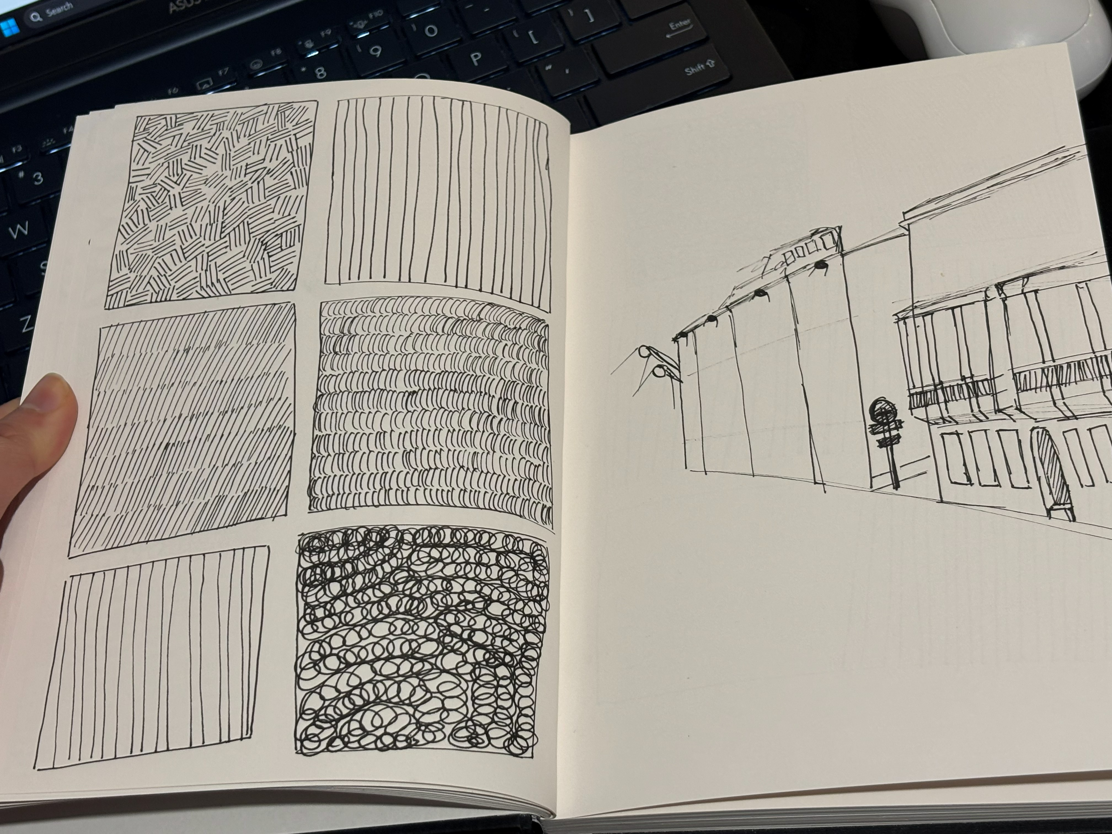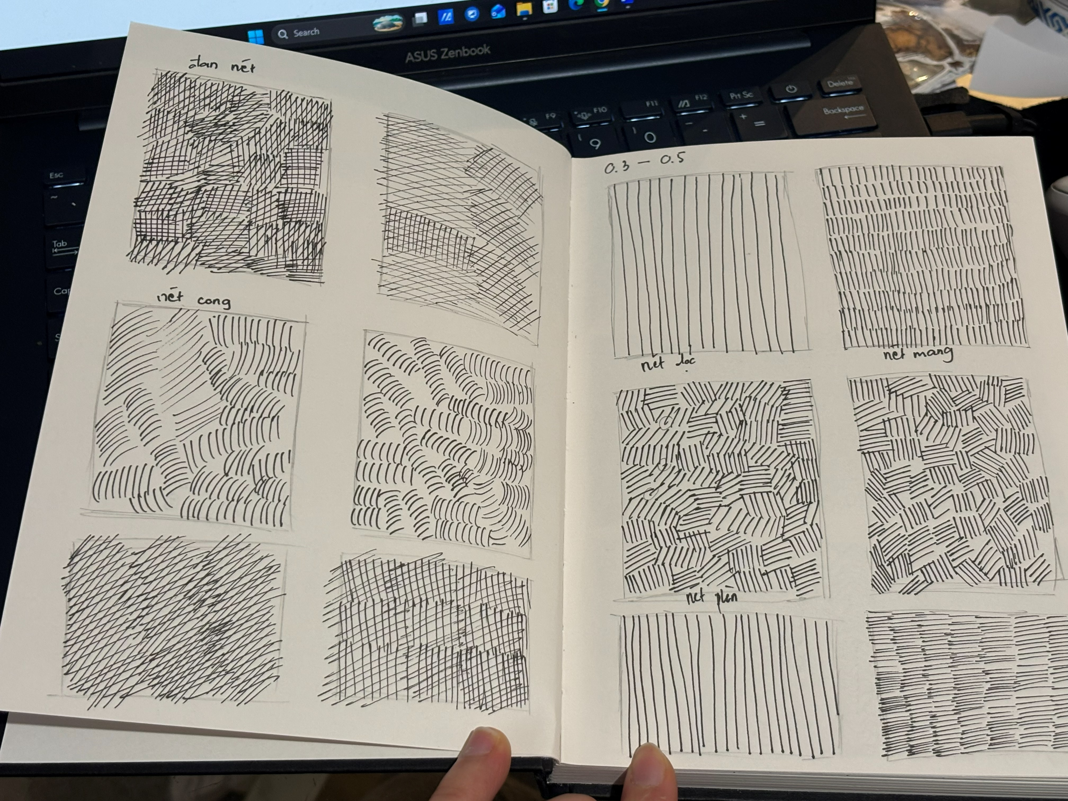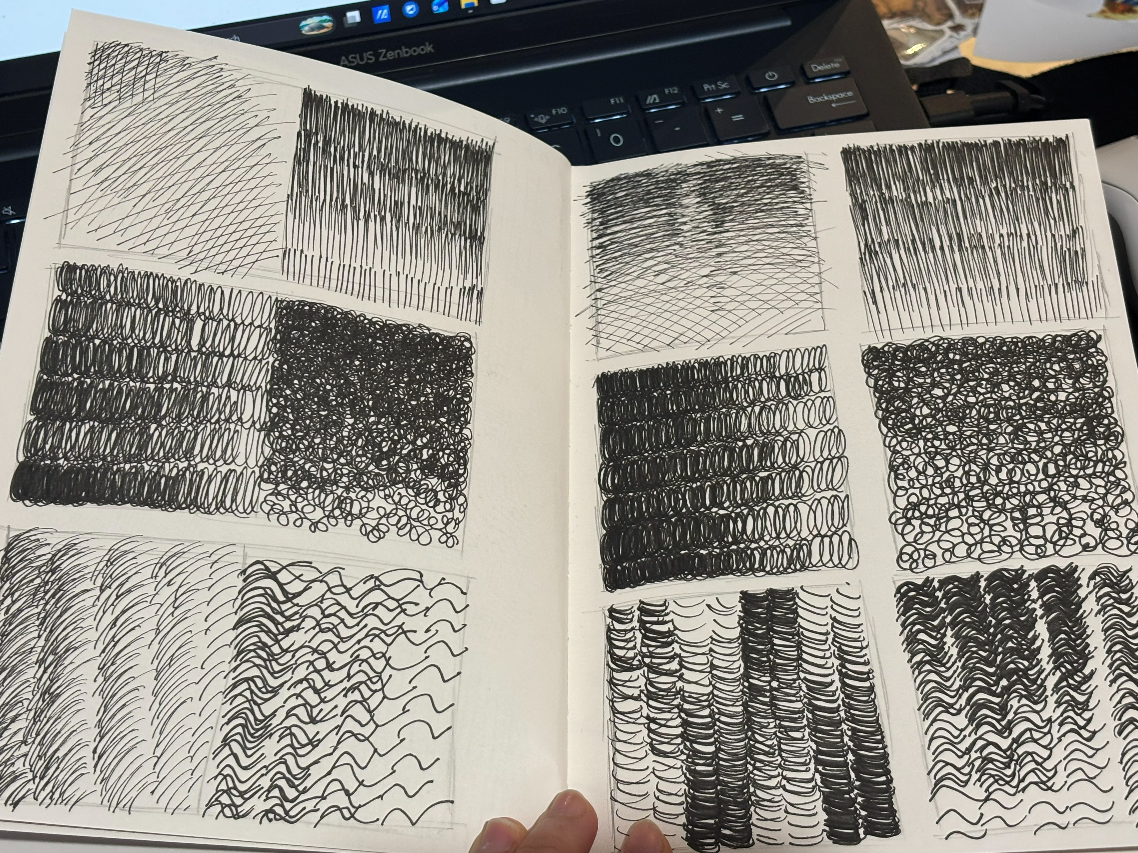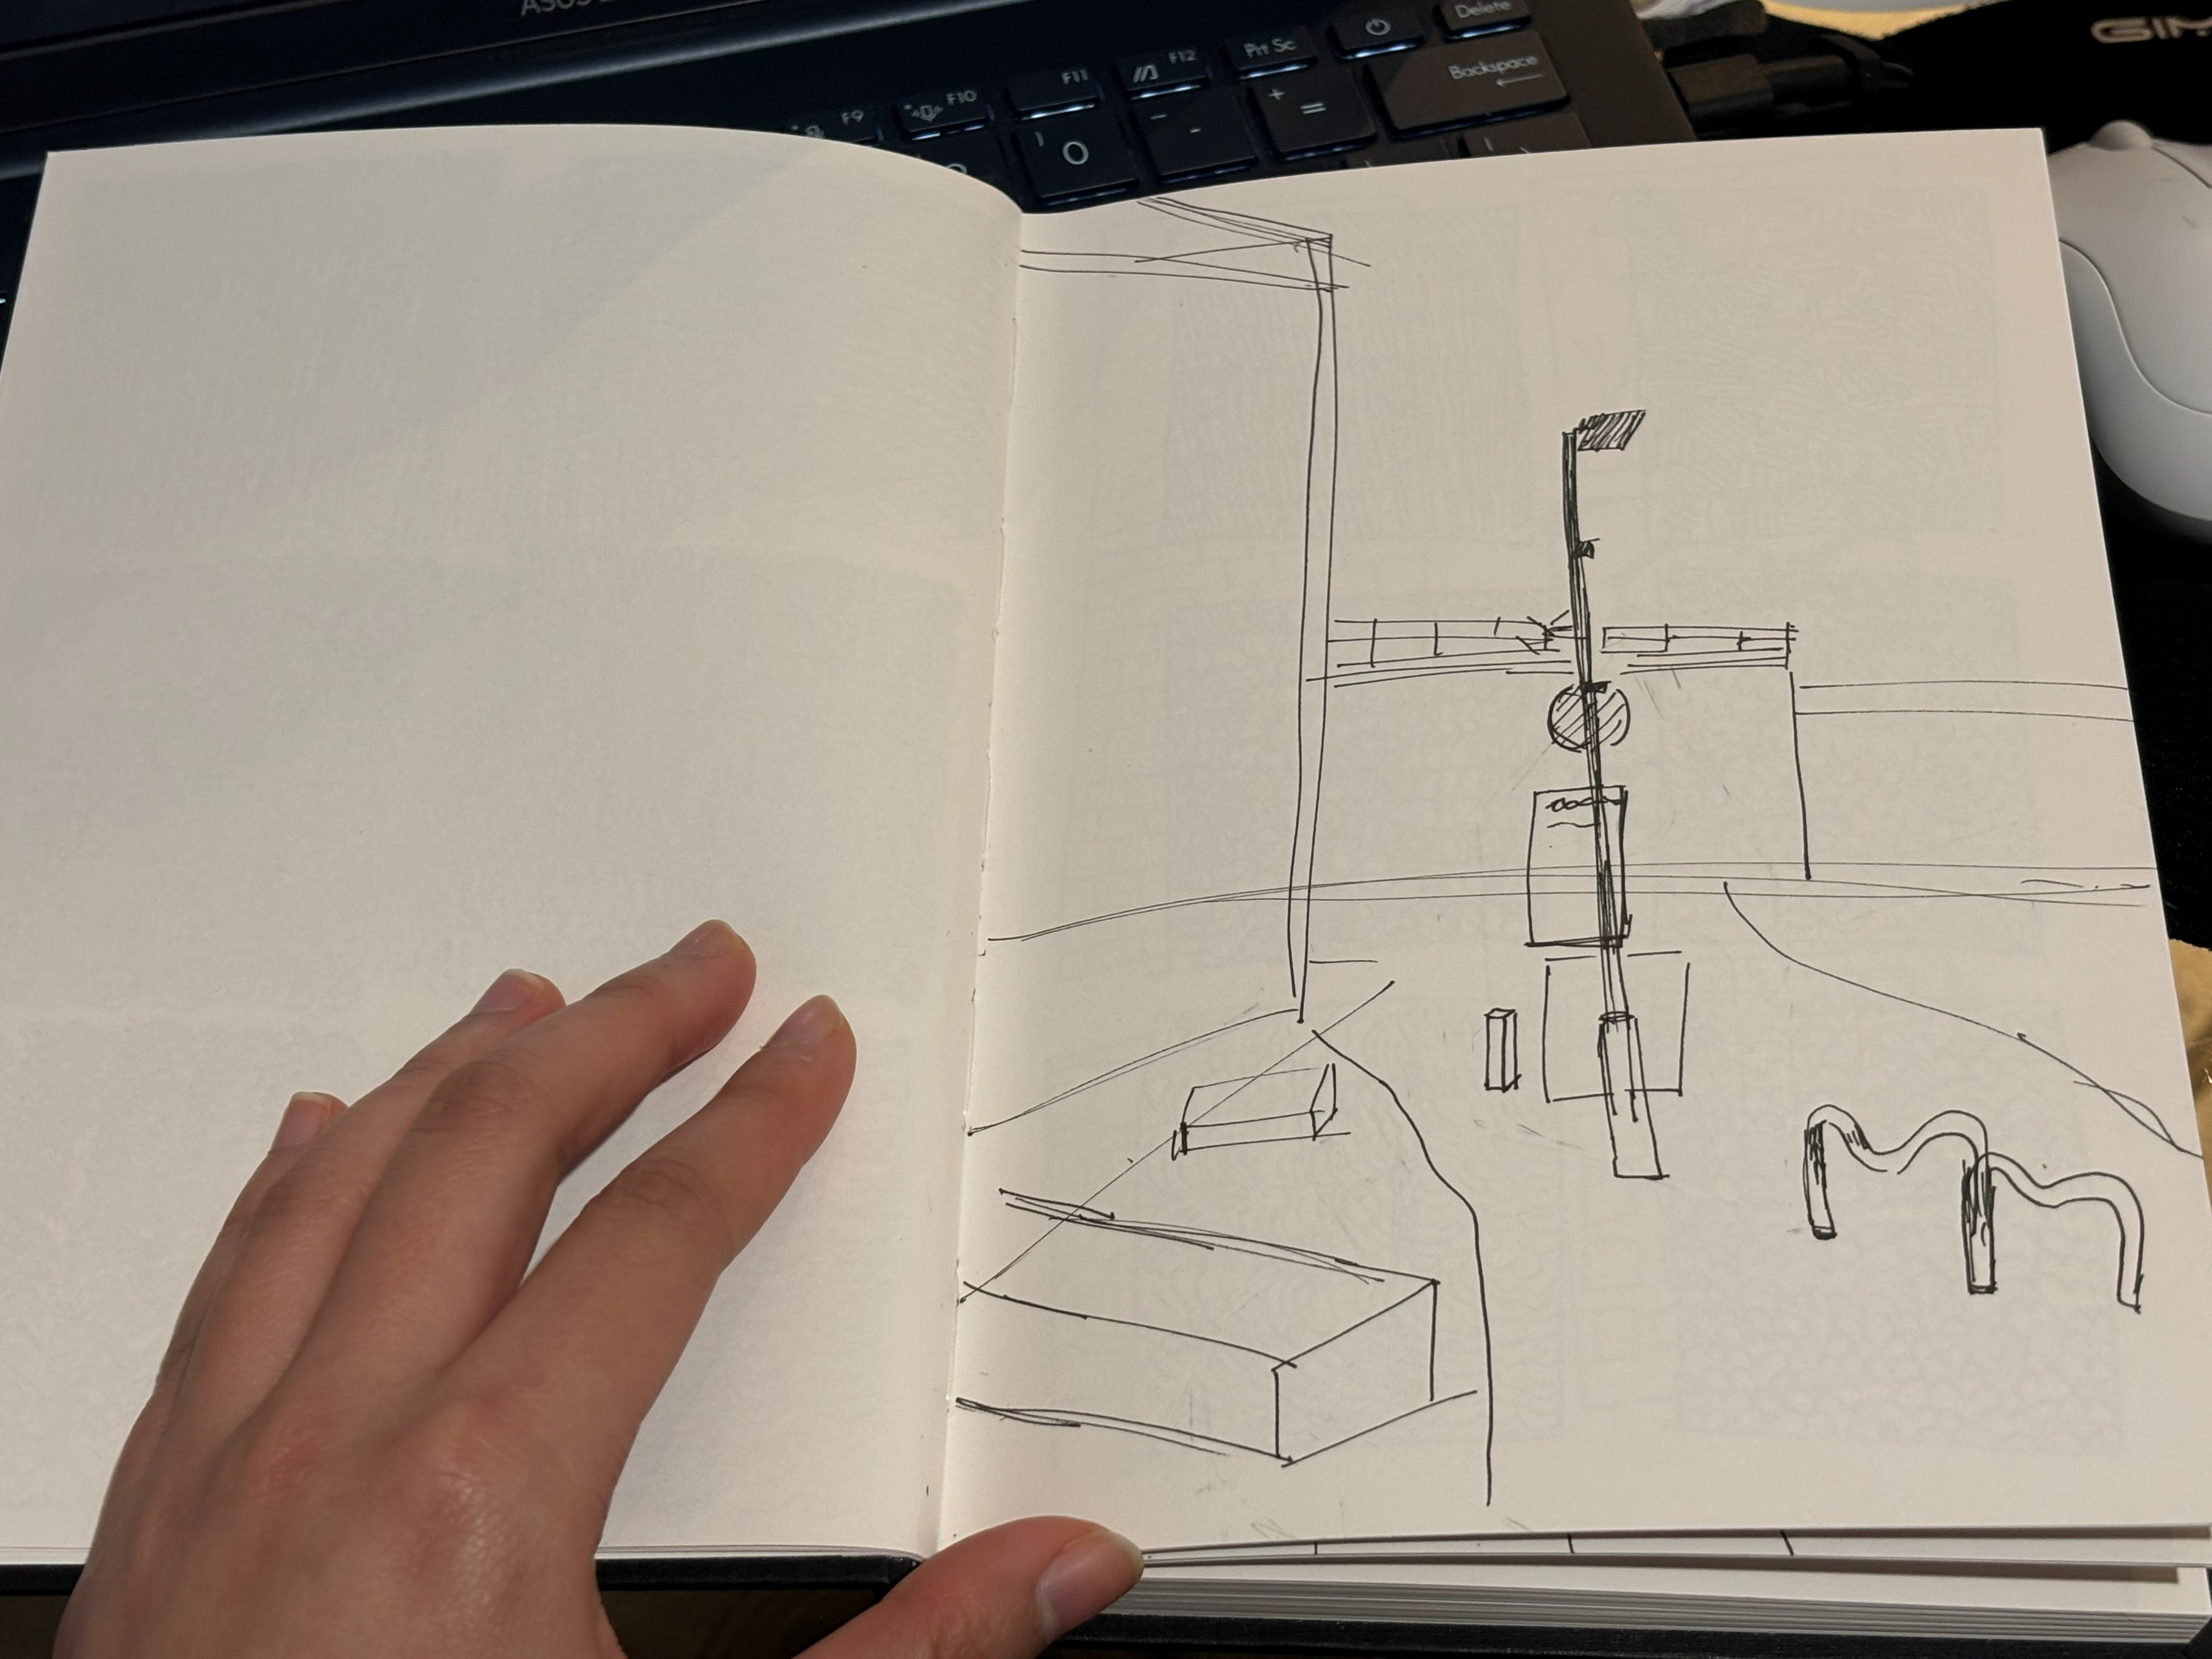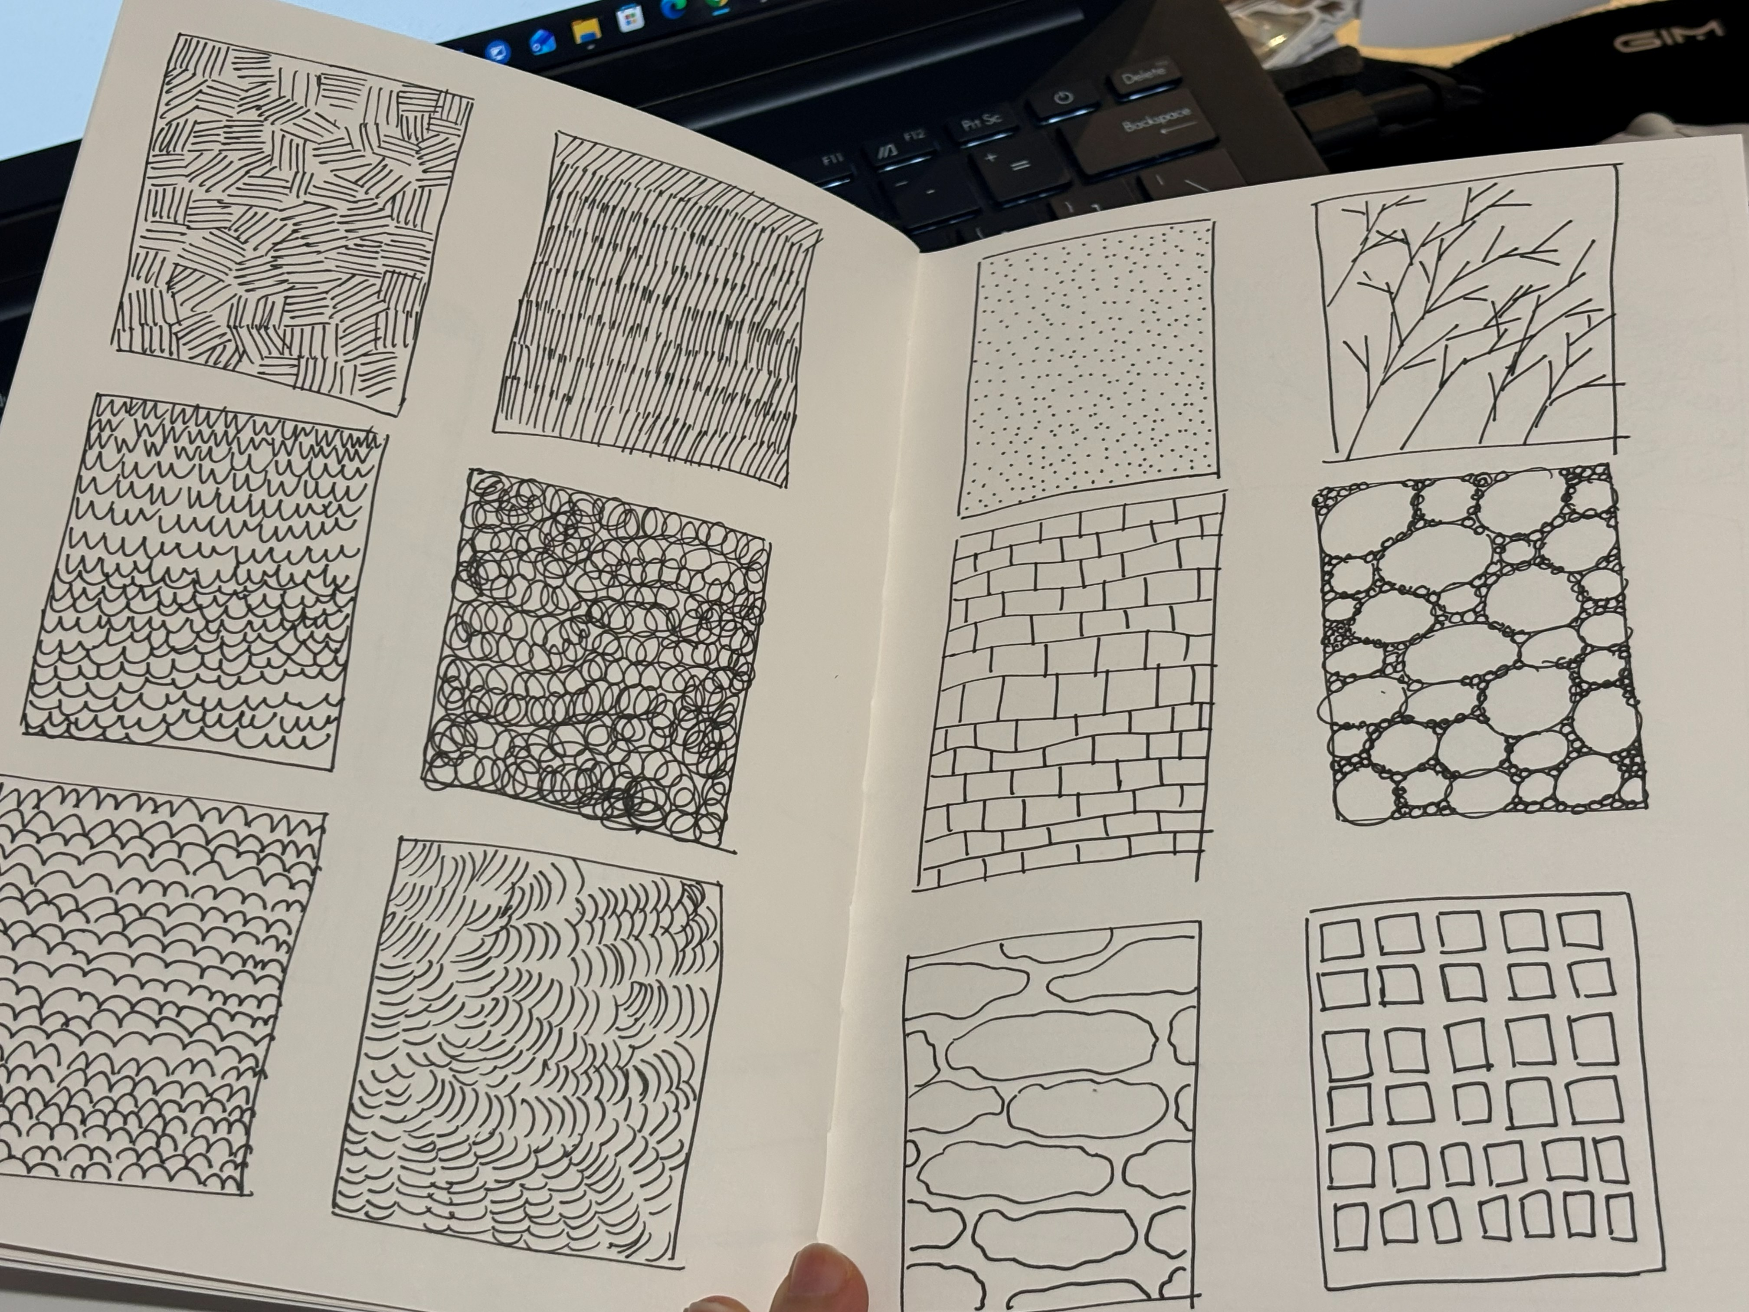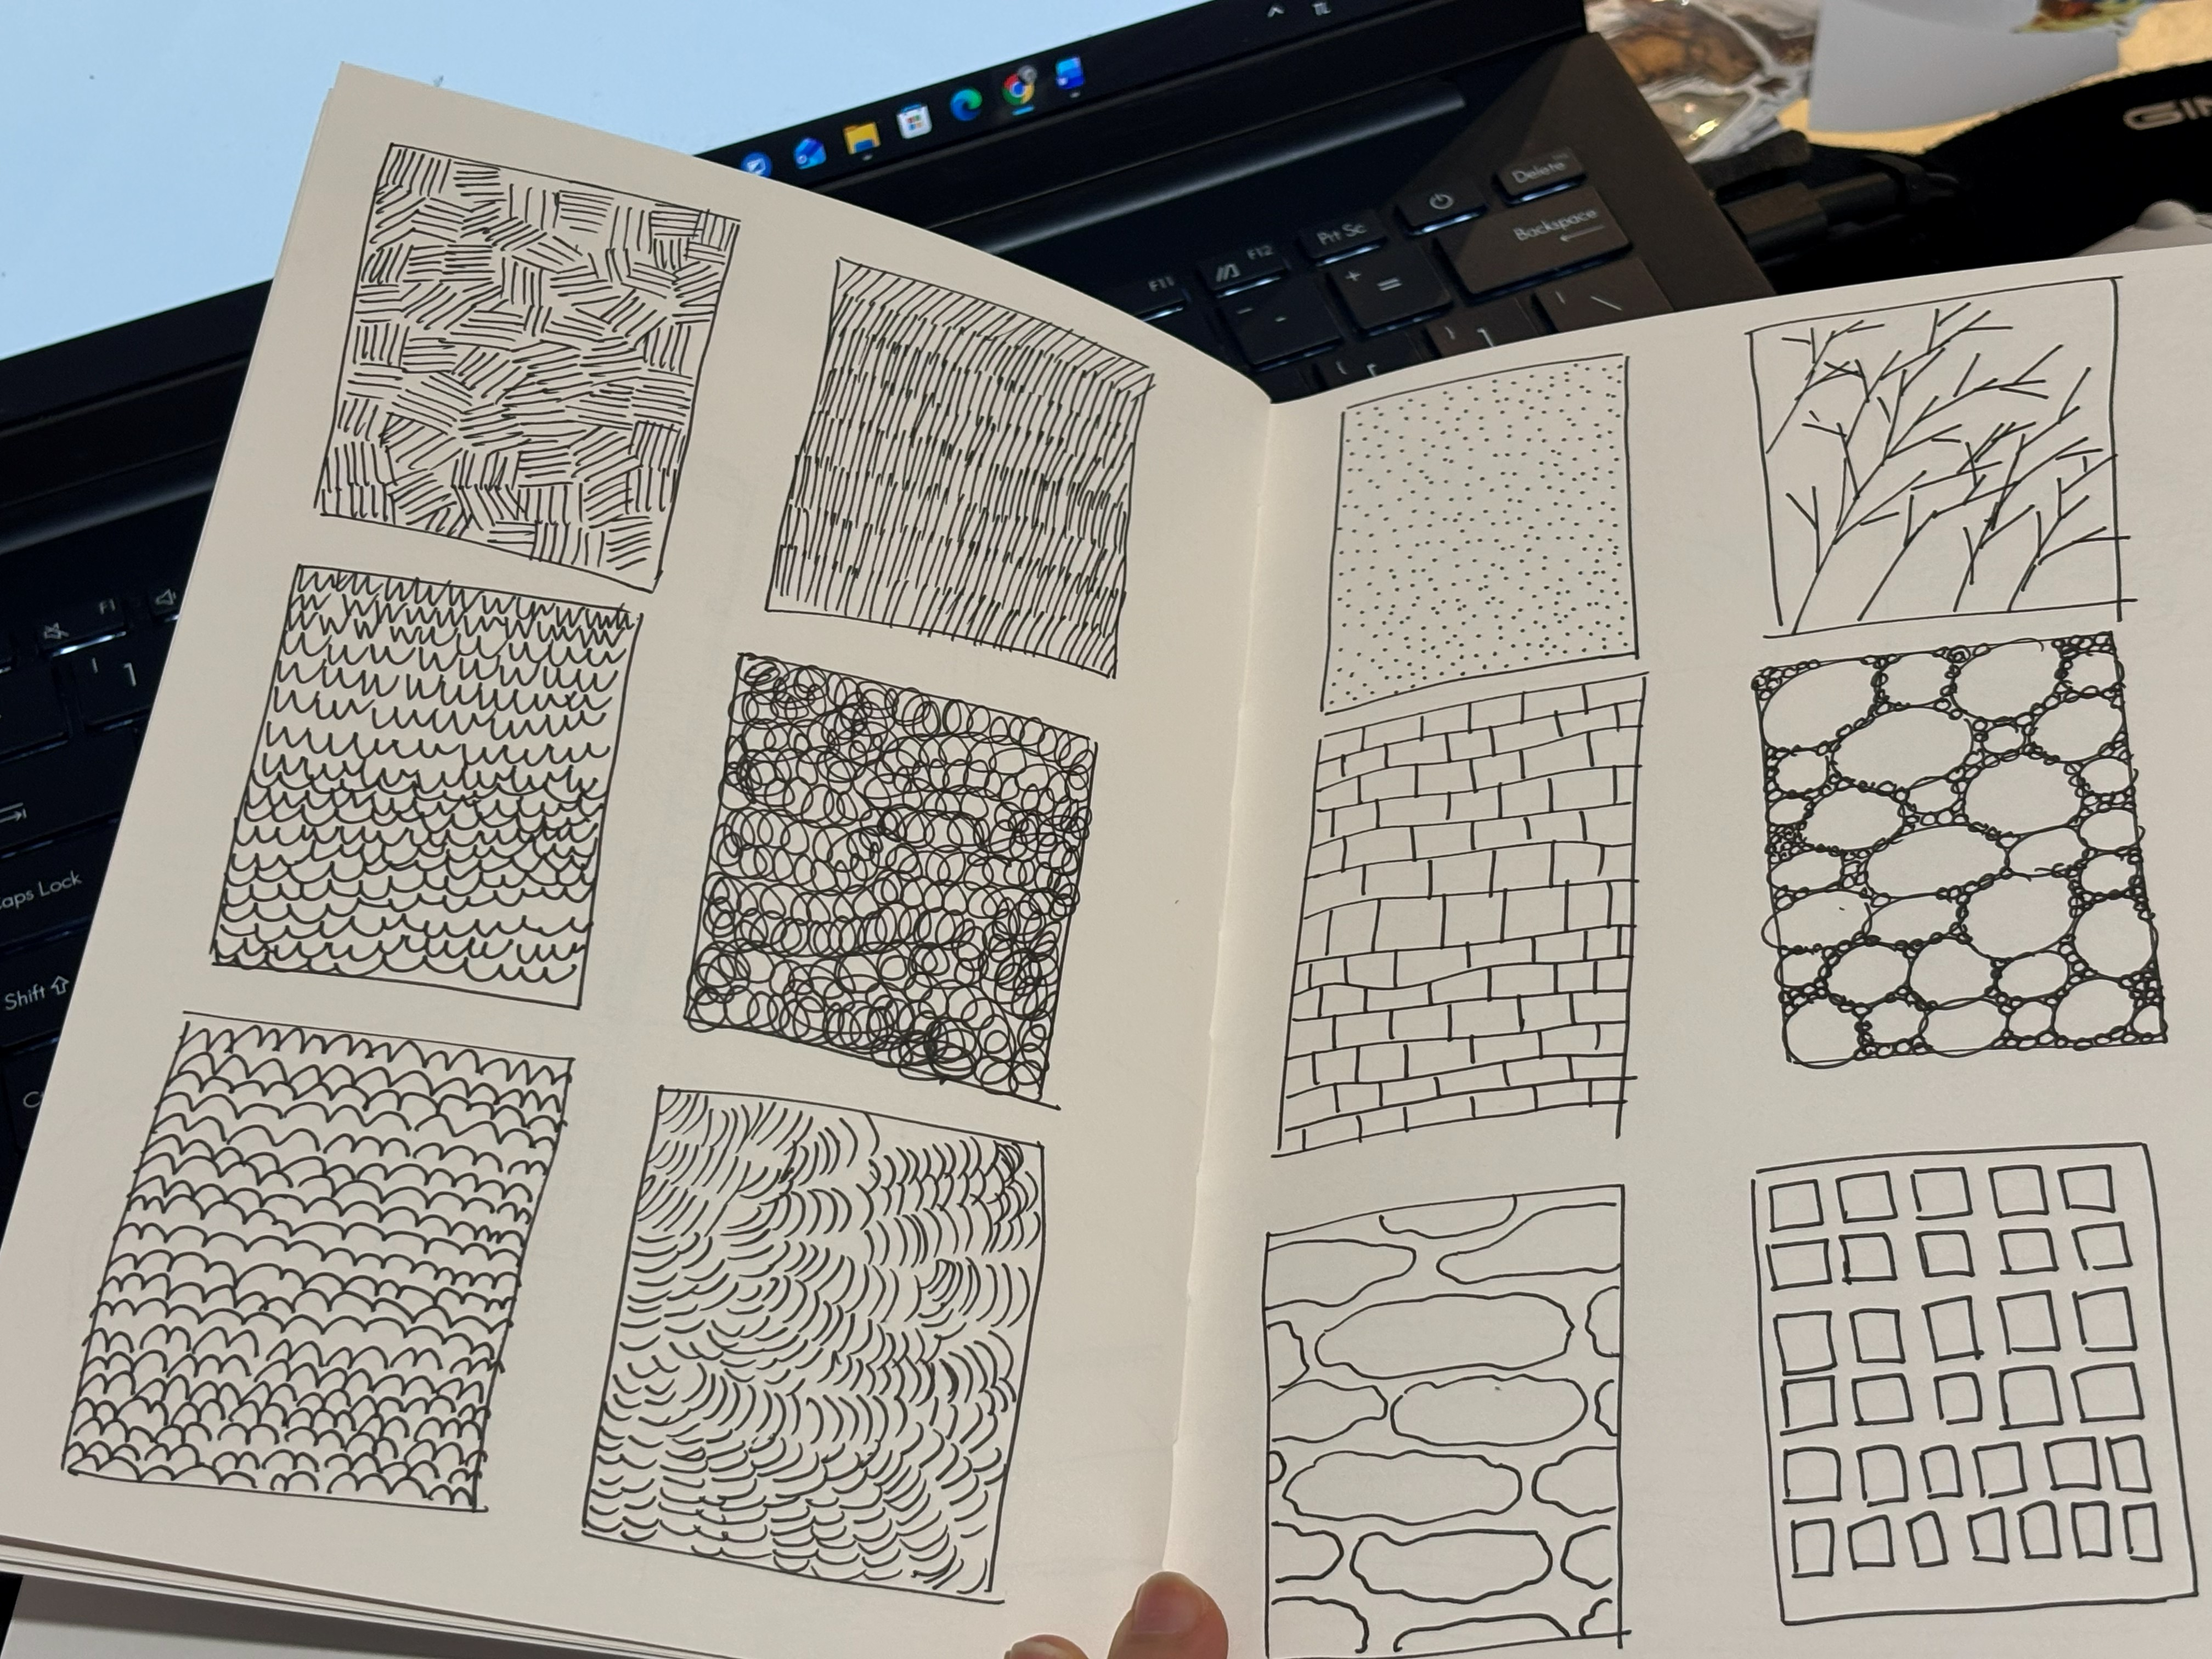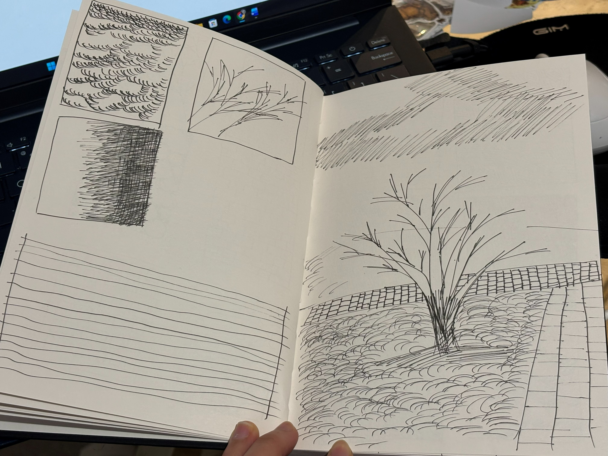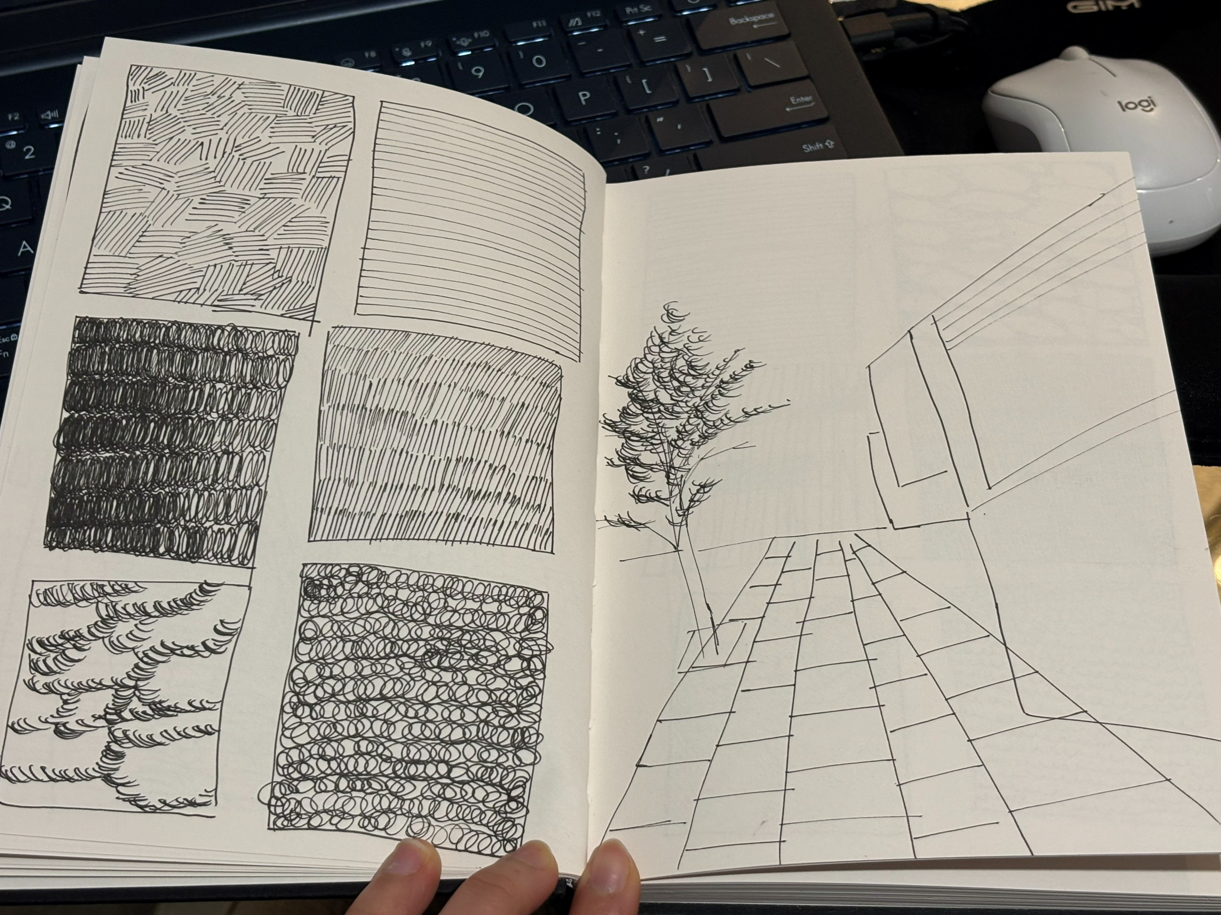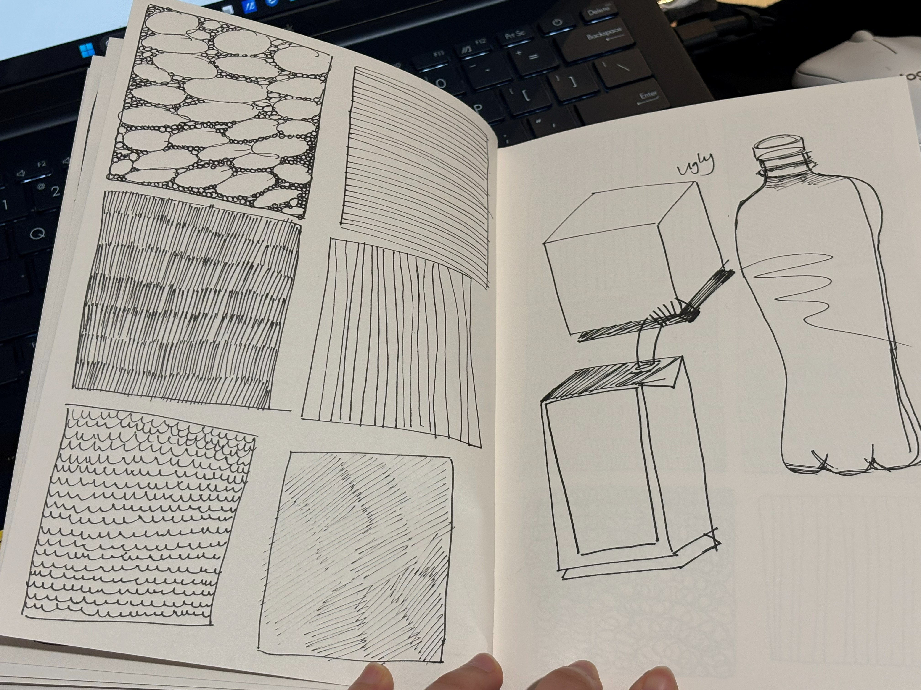
Work-life balence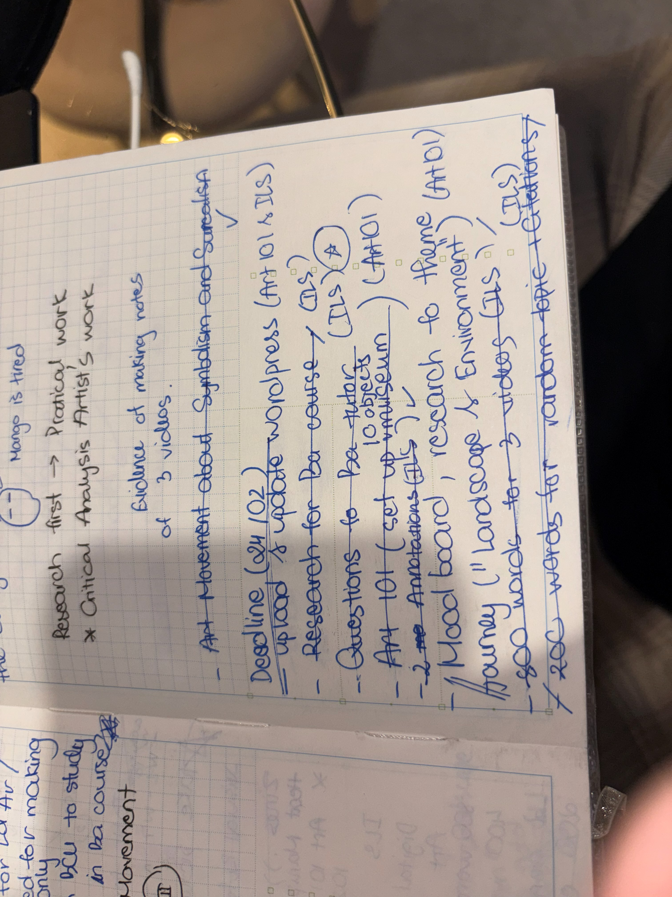
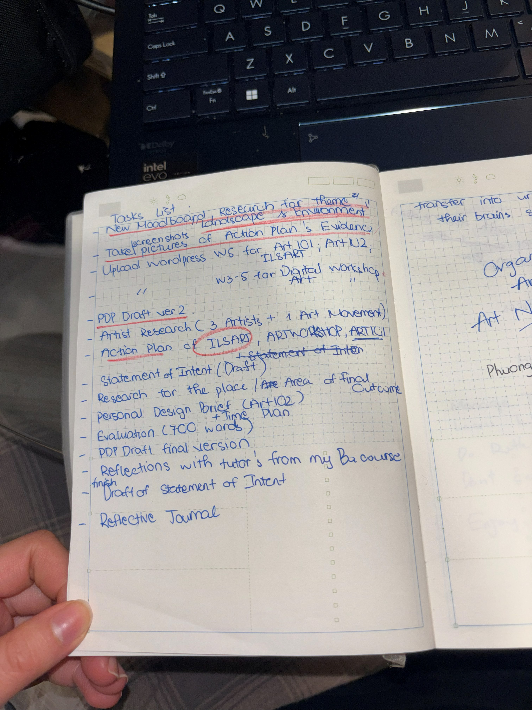
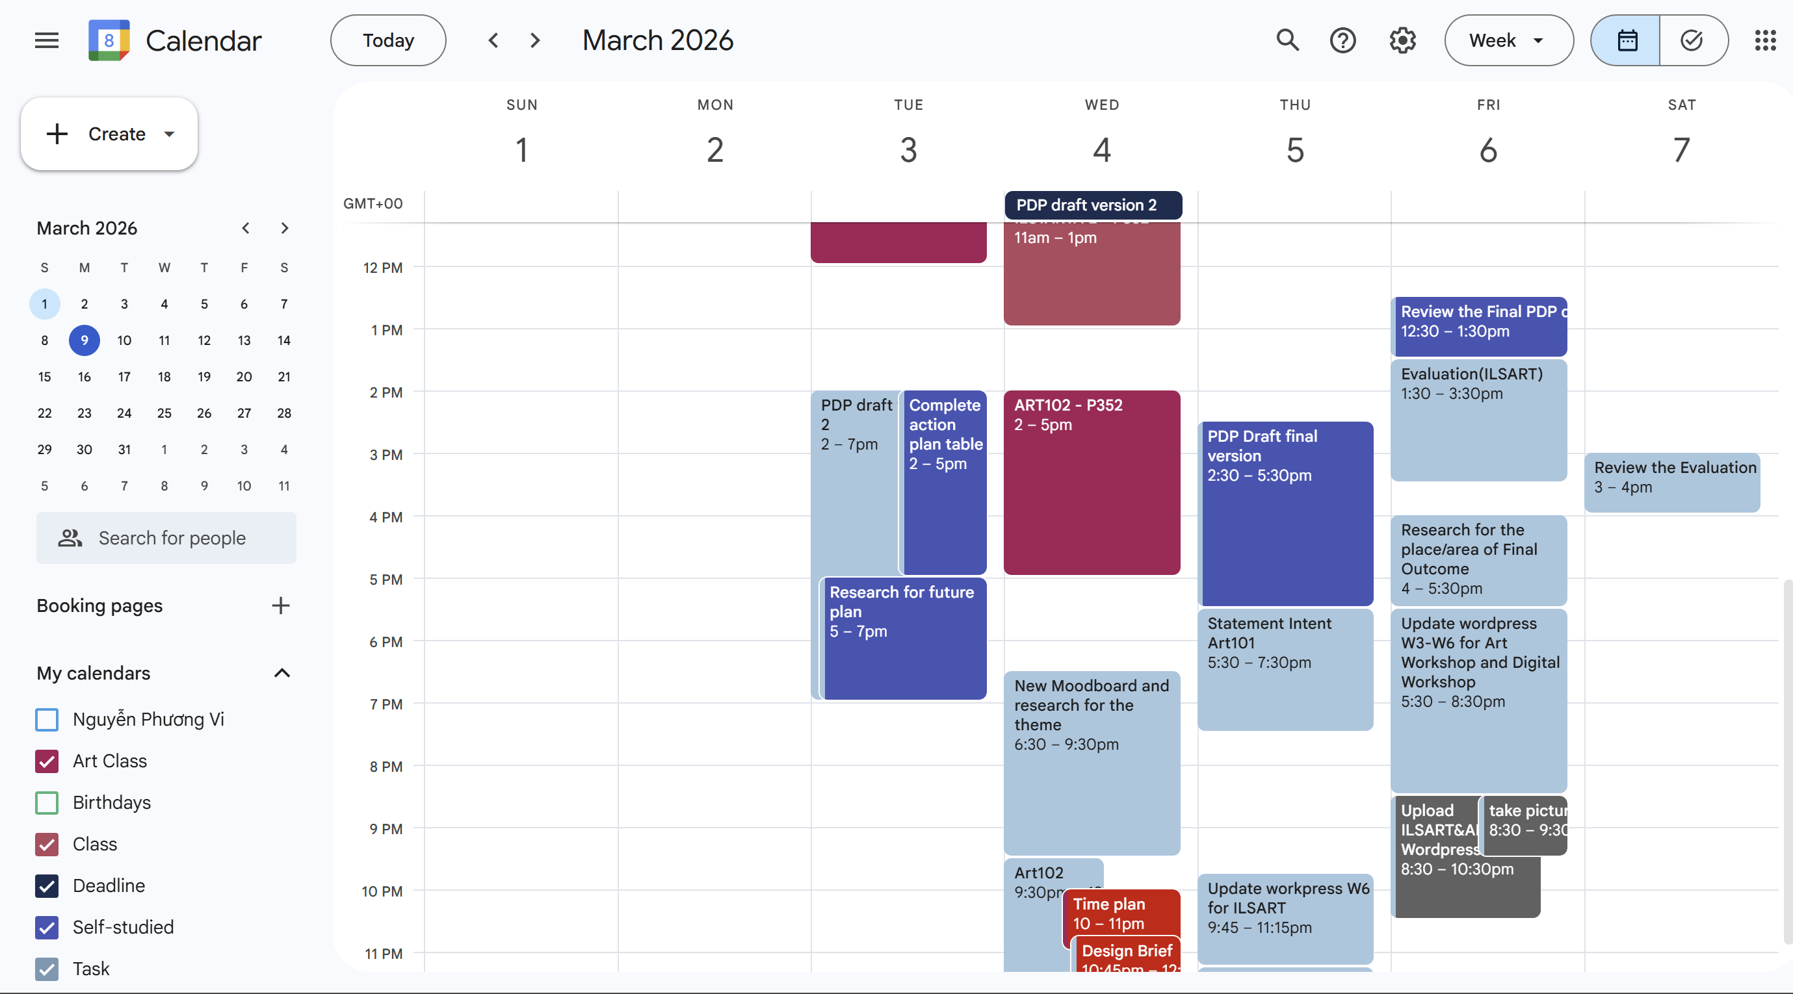
Multidimensional Thinking

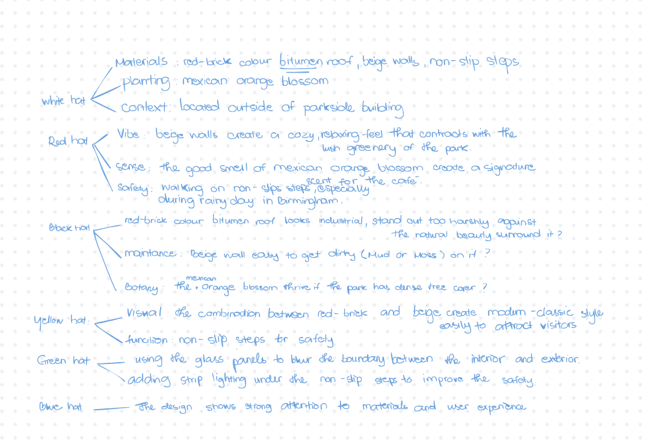
Better Presentation skills
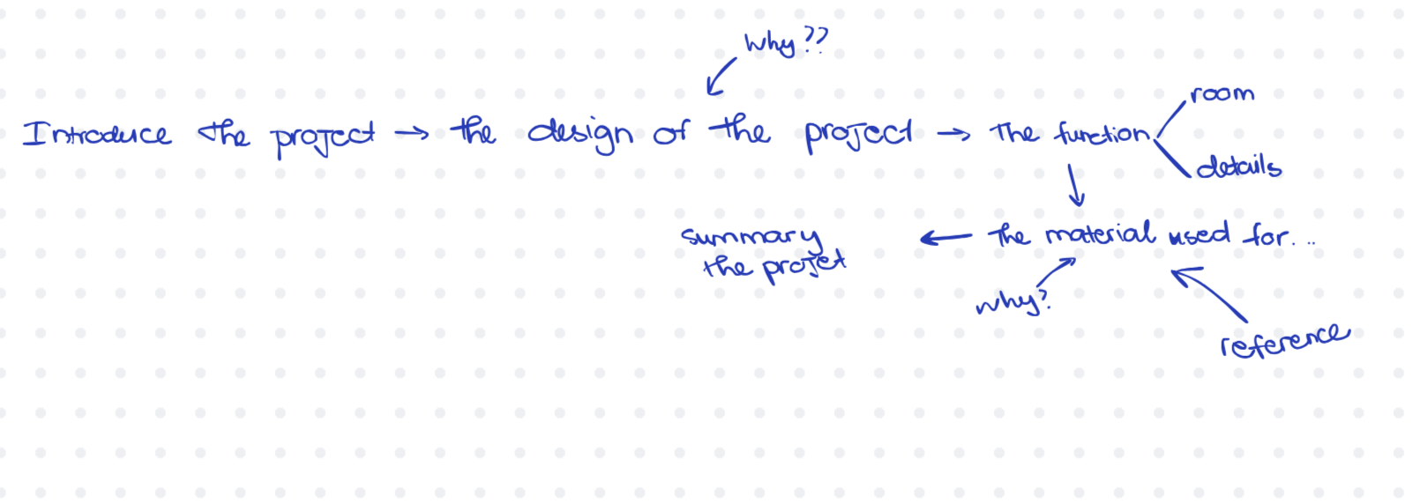
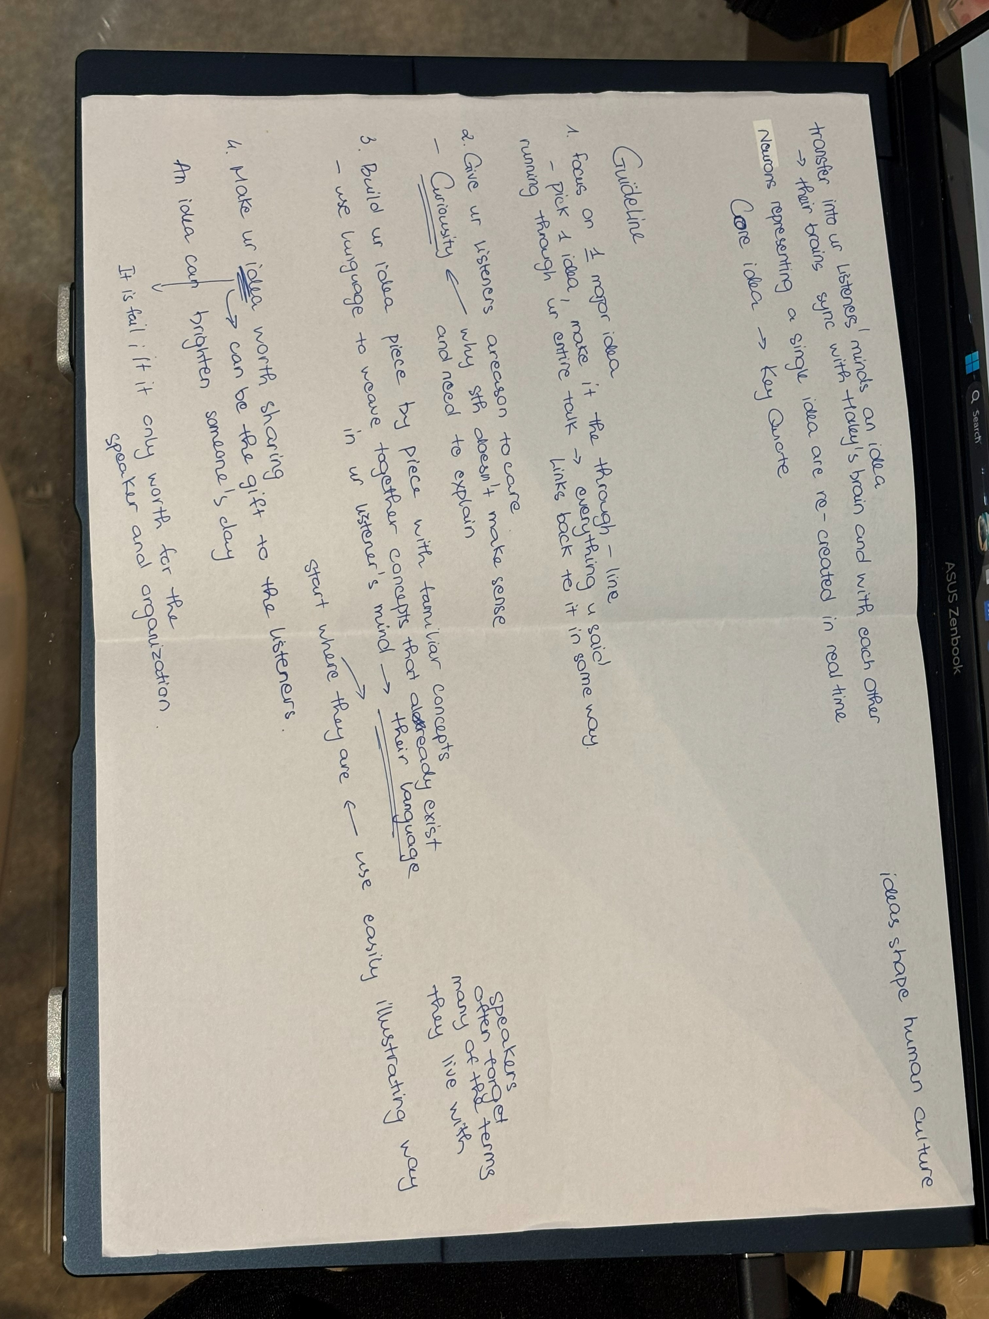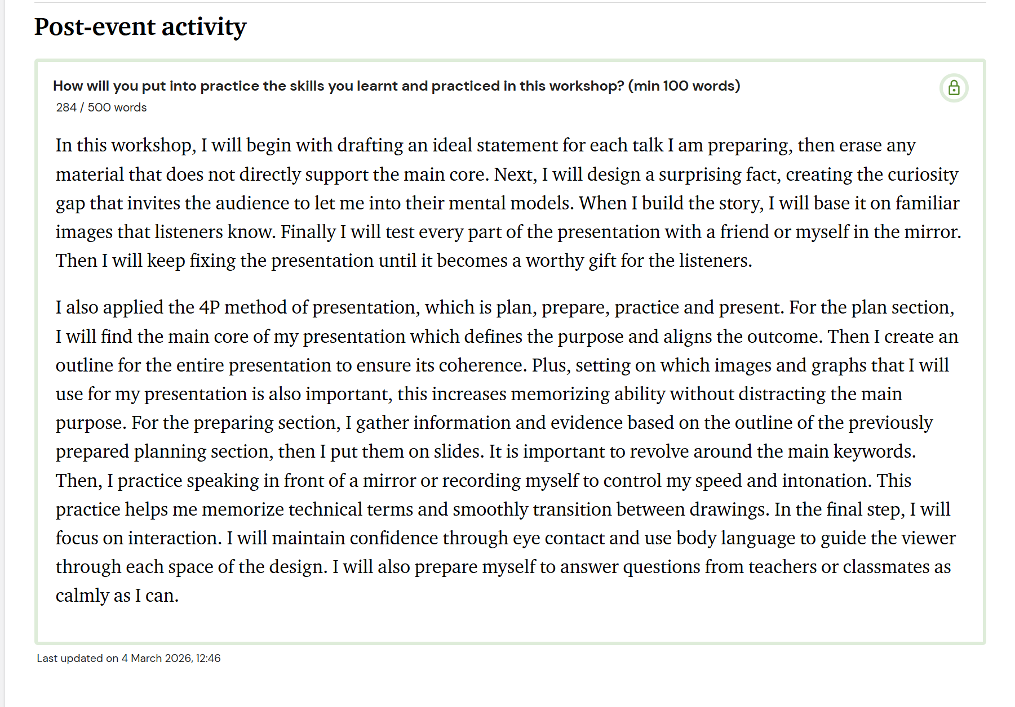
Better Photoshop skills