Statement of Intent and Action Plan

Student Name: Phuong Vi Nguyen (Mango). Student Number: 25185750
Title or Theme: Landscape and Environment

Section One: Harmonizing Tech & Nature

My name is Phuong Vi (Mango), Foundation student majoring in Landscape Architecture at BCU. My theme is about Landscape and Environment.

I explore the overall theme of journey through the connections between human and natural environment. These mean techniques and technologies not only can serve humans but also preserve the environment. Instead of viewing architecture and nature as two separate entities, I focus on finding touchpoints where technology and landscape design can support each other. To connect with the theme landscape and environment, by using technology to preserve the environment (such as smart irrigation systems or carbon-absorbing materials), the natural "journey" of the area is allowed to continue instead of being interrupted by urbanization.

I was inspired by some of the actual projects, (see research section for this information) and I want to explore the connections between human and environment, which technologies and architecture serve human needs and protect the environment. I will work toward building a model – landscape piece.
I will include Photoshop and Illustrator skills in the masterplan.

The reason I chose this theme is because I sense a disconnect between nature and humanity in today's developed world. I chose this approach because I want to design a space that is not just for viewing, but for feeling. It is about feeling safe when people can immerse themselves in and live in harmony with nature, where the technologies humans create do not harm the environment but instead become support for green living.

Instead of just making small sketches, I challenge myself to build a larger-scale, overall model using Foam and Cardboard. My challenge here is to use Foam to depict the terrain and environment, and cardboard to showcase the sharp, modern structure. I will use Illustrator to create diagrams. Then, I will import them into Photoshop to process the textures, lighting, and shadows, aiming to create perspective drawings with depth and emotion.

Section Two Influences, research, sources and ideas. You must make both primary and secondary research

I was inspired by the LAVA team and Aspect studio. They won an international competition to design a Central park in Ho Chi Minh city (Vietnam), with construction due to start in 2020 (Harrouk, 2019). The project inspired me a lot because the use of technologies helps conserve nature and brings benefits to human life. It lays the foundation for a deeper relationship between humans and nature, while emphasizing the profound importance of the living environment to everyone today.
The Central Park of Ho Chi Minh City
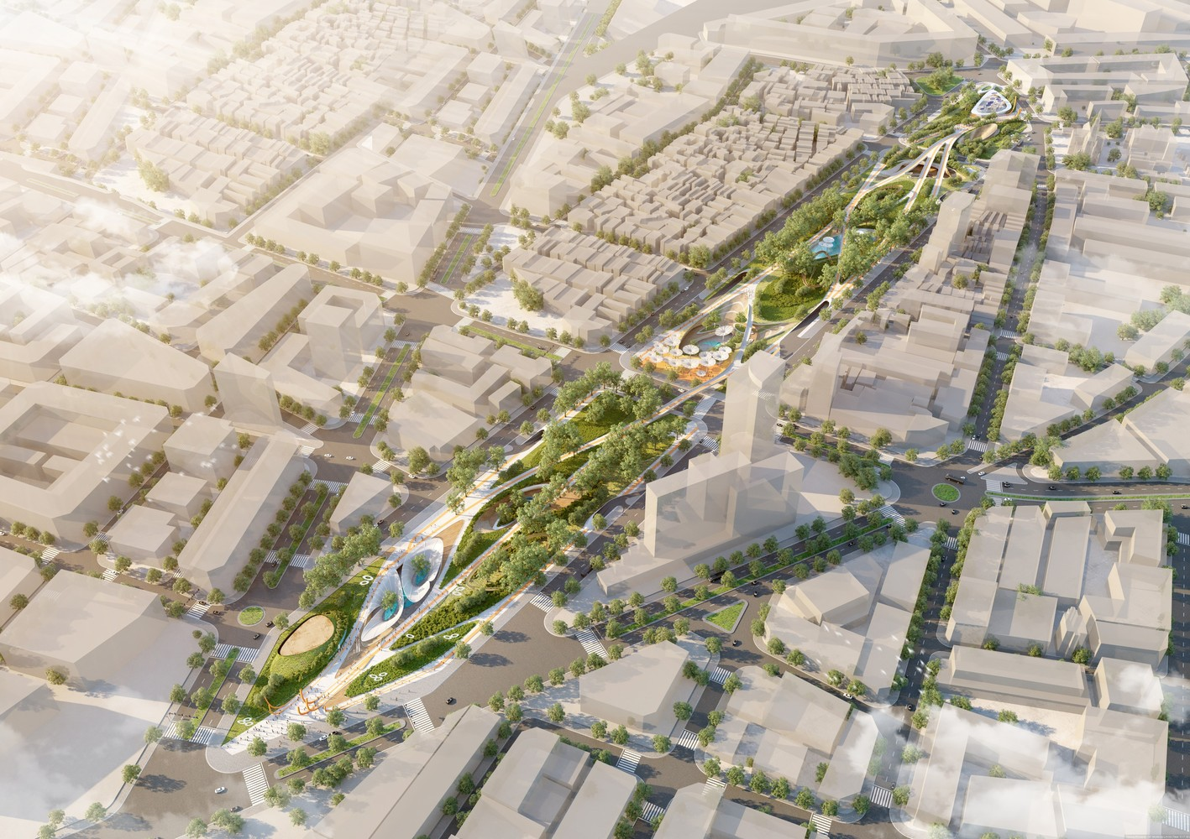
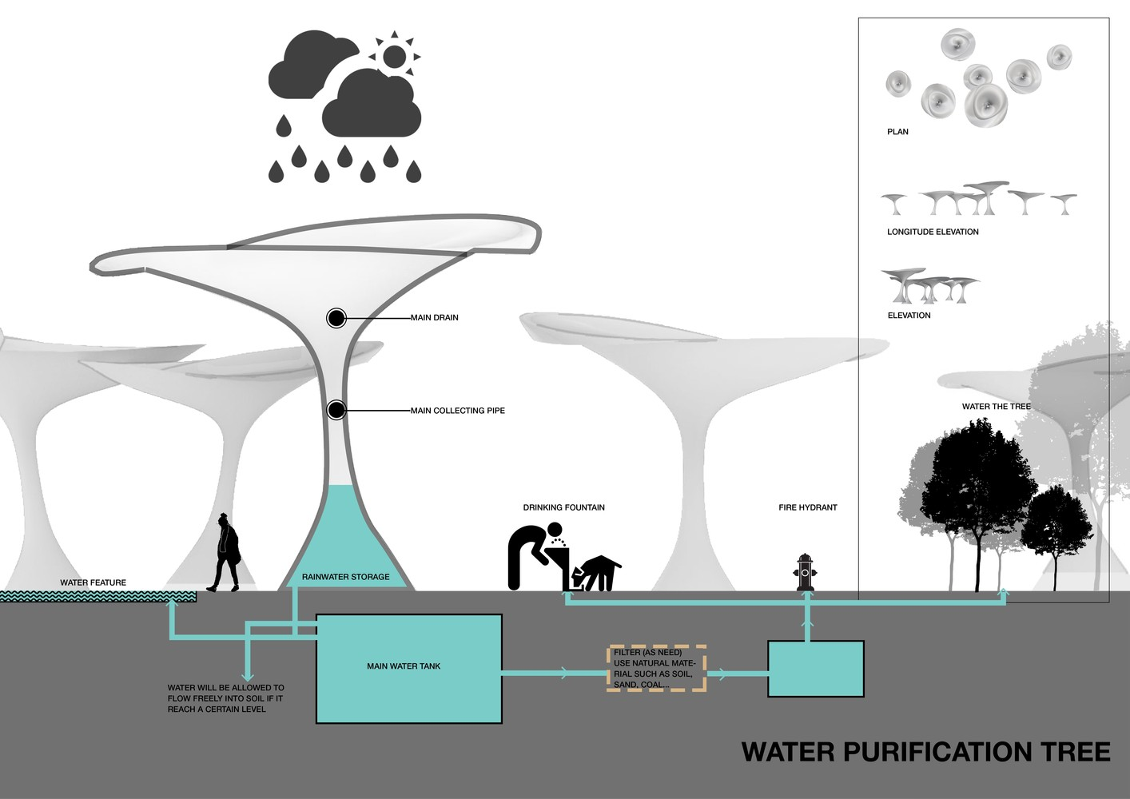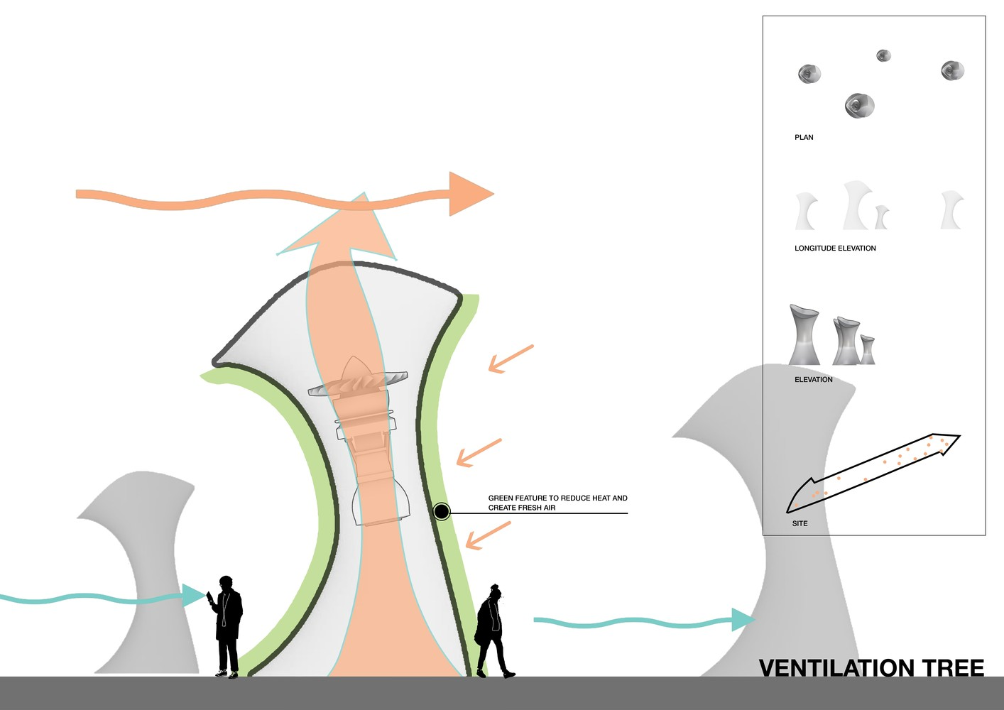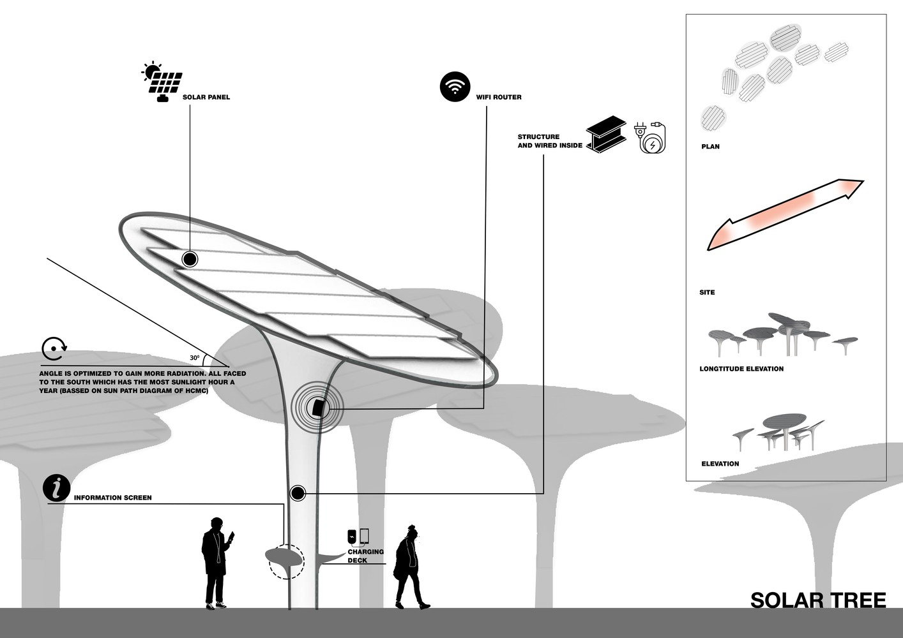
The project is notable for its artificial trees such as ventilation trees, water purification trees and solar trees which have shapes as reverse funnels, big mushrooms or umbrellas. They are designed to integrate with modern materials, integrated solar panels and waste/water collection systems (Harrouk, 2019). The project showed the harmonious connection of both natural and artificial trees, when natural trees and ventilation trees create fresh air and reduce heat for people in hot weather of Vietnam, purification trees and solar trees collect the natural energy to serve for visitors. The LAVA team and Aspect studio designed pathways, lawns, and water features all utilize organic curves, continuously winding and intertwining without sharp edges. This creates a soft feature specially contrast with the buildings surrounding which are high and box-shape and grid-like road network surrounding Ben Thanh Market. The park will play a role as a green lung in the heart of Ho Chi Minh city for energy production and environmental cleanup. Functional optimization is a success point of this project because they utilized the climatic characteristics of Vietnam, simultaneously solving the heat problem of Vietnam climate for people.
Kongjian Yu
- Artist: Kongjian Yu (12/05/1963–23/09/2025)
He is a founder of the landscape architecture firm Turenscape and also an advocate of the "sponge city" concept. This approach prioritizes nature-based solutions, such as wetlands, parks, and permeable pavements, to absorb and retain water. This approach is a stark contrast to traditional concrete infrastructure, offering cities a way to combat urban flooding and accelerate climate change by working with nature rather than fighting it (Florian, 2025).
The reason I chose him is that instead of simply designing landscapes to decorate the city, he makes it functional in addressing climate change issues. He emphasizes the importance of landscape design for the environment, especially in the context of climate change in today's urbanized era. He uses landscaping as an art of survival, because it helps prevent climate change, leading to a reduction in the occurrence of natural disasters (storms, floods, urban heat, and urban pollution) that have killed so many people (Ghisleni, 2024).
- Projects:
- Project: Red Ribbon Park
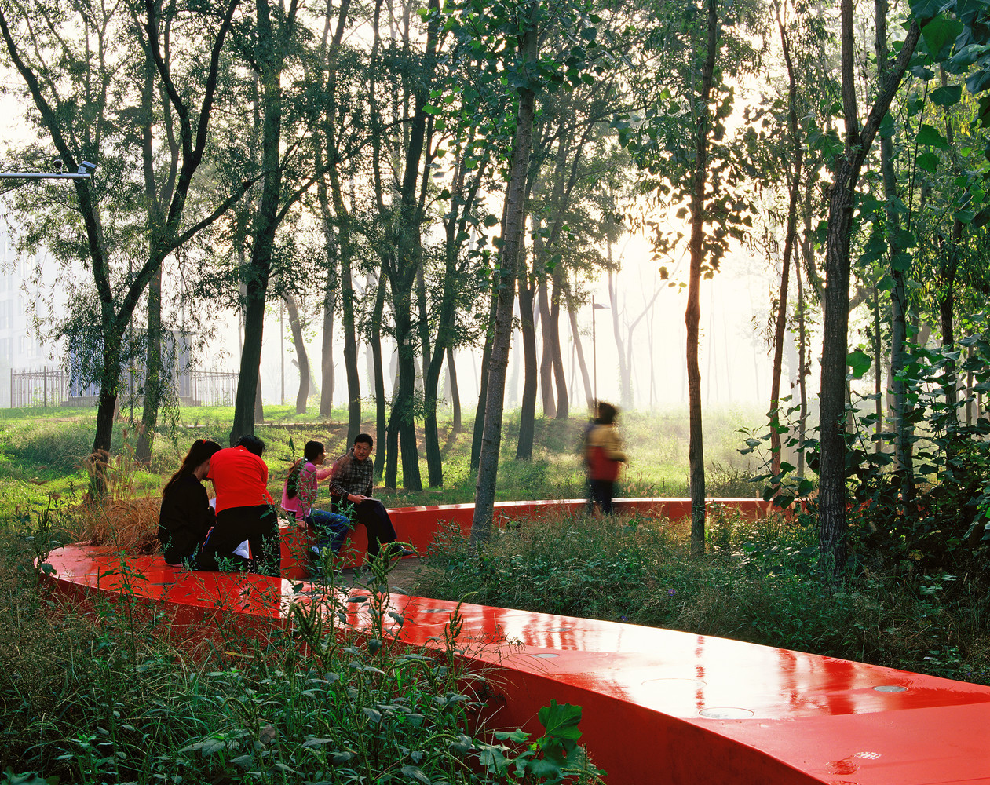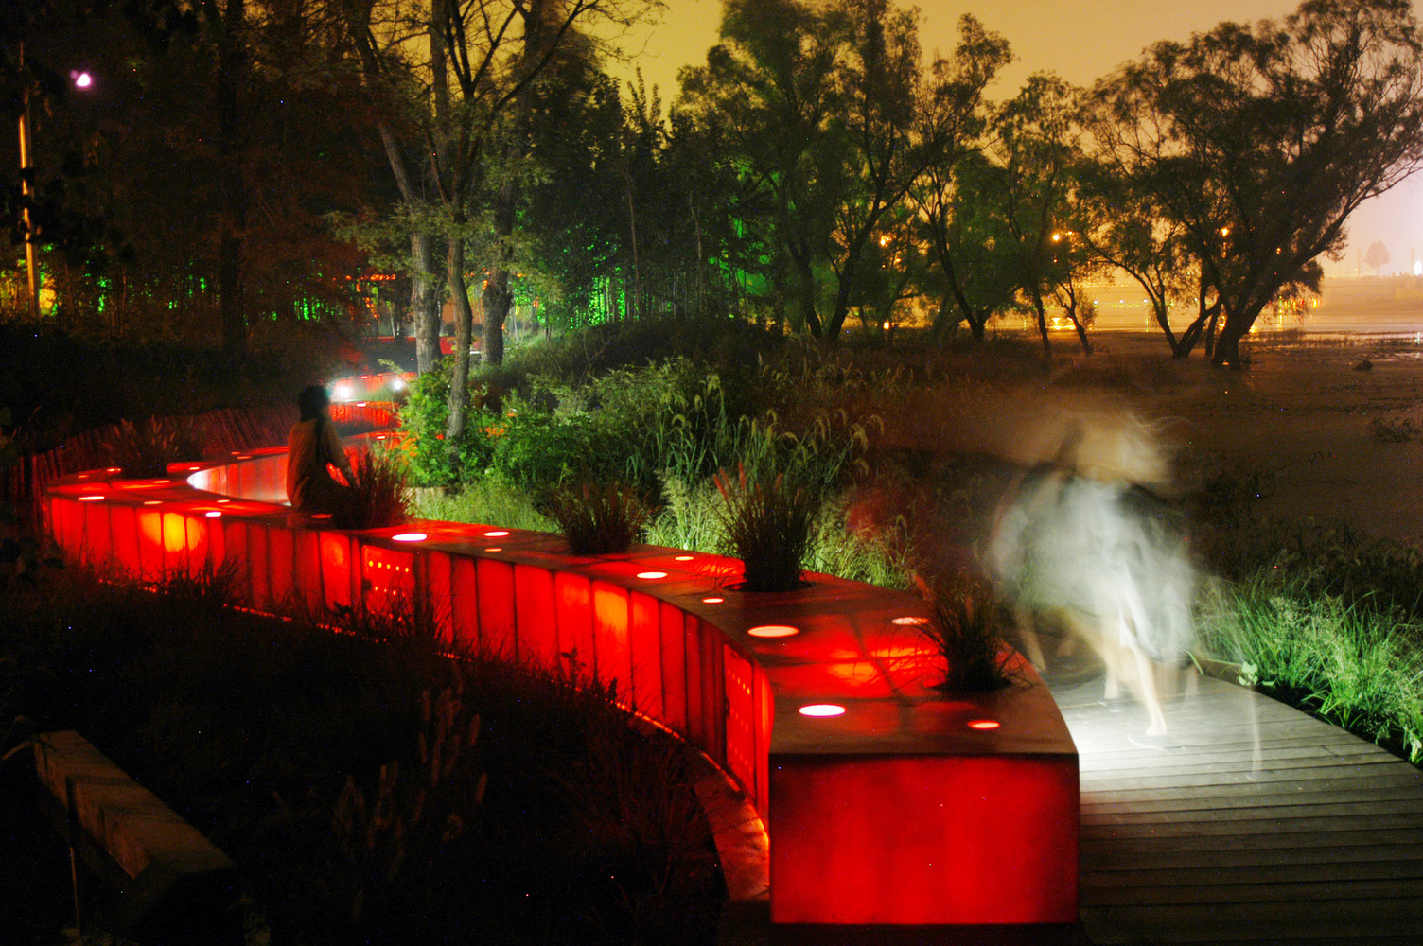
The site is located in Tanghe River (Qinhuangdao, China) which has a pristine natural landscape with lush native vegetation, but once viewed by the community as a chaotic, unsafe, and unsightly area (ArchDaily, 2013). A red leading line extending 500 meters was added and became a special highlight for the park. Walking along this red ribbon allows people to view the entire natural landscape of the river. Using red, a warm colour for this line, creates a contrast point with the green colour of natural vegetation. Insteading of land reclamation or the construction of large concrete roads that would destroy the riverside ecosystem, wooden walkways are raised off the ground to protect the vegetation below, allowing people to access nature without stepping on it. The red ribbon runs through the trees and forests and also winds along the river. This has very little impact on the surrounding vegetation. At night, the red ribbon has an internal lighting system. The ribbon glows brightly, transforming into a warm red streak of light stretching through the darkness of the forest. This makes the ribbon stand out and differentiate itself from the natural vegetation background. It also provides sufficient light and creates a safe environment for people walking at night without erasing the peaceful atmosphere of the river. Besides, this park features a striking contrast between its materials. There is a contrasting combination of hardscape and softscape material which shows the smooth surface of fiberglass material(hardscape) merges with the roughness of the vegetation surroundings(softscape). Turenscape wanted to preserve native weeds, shrubs and messy growing of the habitats that was a special point of the studio showing the beauty of nature without interfering with its shape. The Red ribbon succeeded in solving the challenge of transforming the polluting riverside area into a green, clean and safe public space with minimal impact on the environment. The message of Kongjian Yu in this project is that using minimalist solutions can create huge improvements, important to the landscape and environment.
Connection with my project: Instead of overusing hard concrete for the solution of filtering the water in the riverside area, Yu used the wetland system of natural environment and native vegetation. This brings me many inspirations of using the availability of nature when it grows on its own for the solutions of saving itself. From the Red Ribbon park, I was inspired by the red leading line which serves people to rest on and is a pathway to lead people to nature, also offers a light source and safe environment at night. Plus, materials of the red line are wood and fiberglass which are eco-friendly, then I can use them for my own project.
- Project: Qinhuangdao Beach
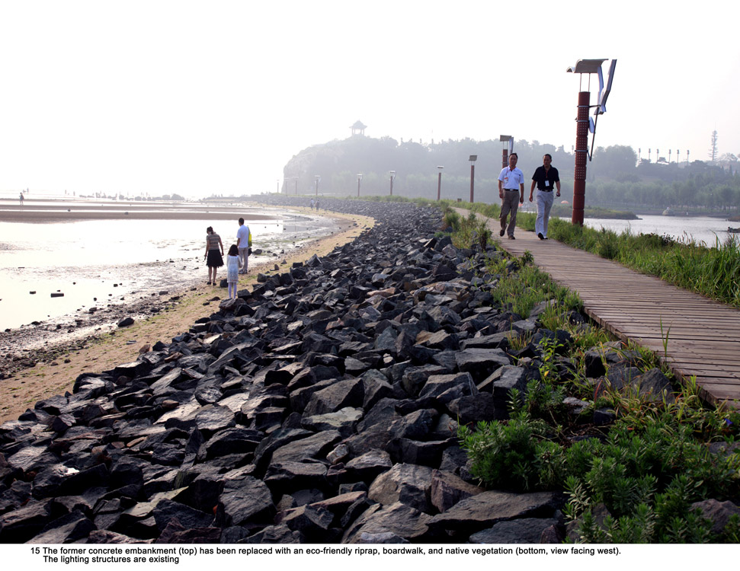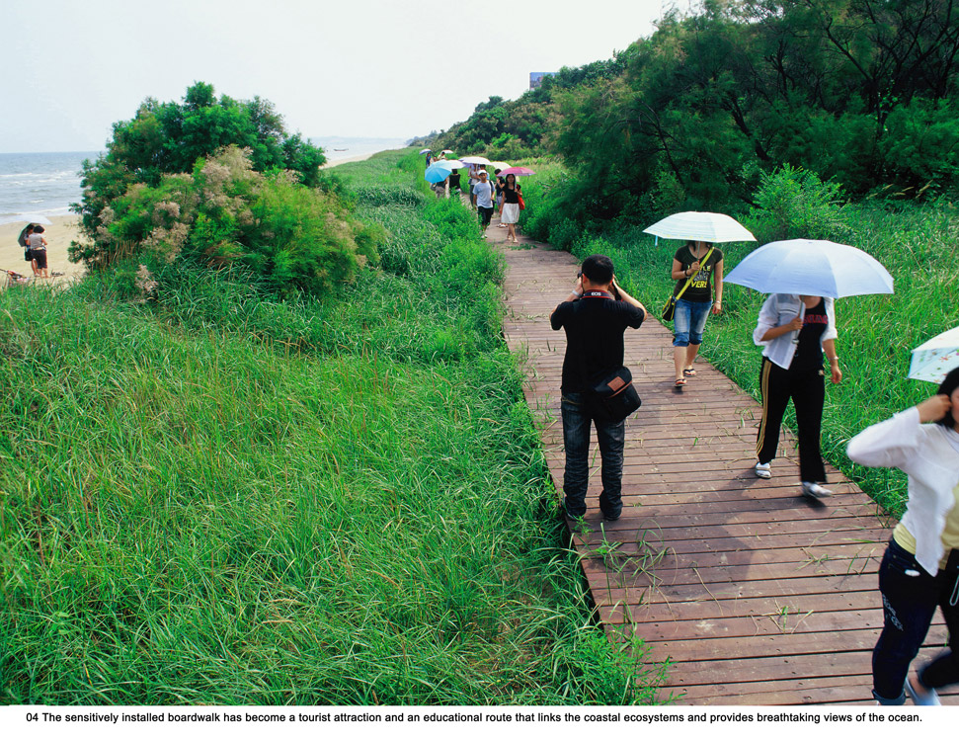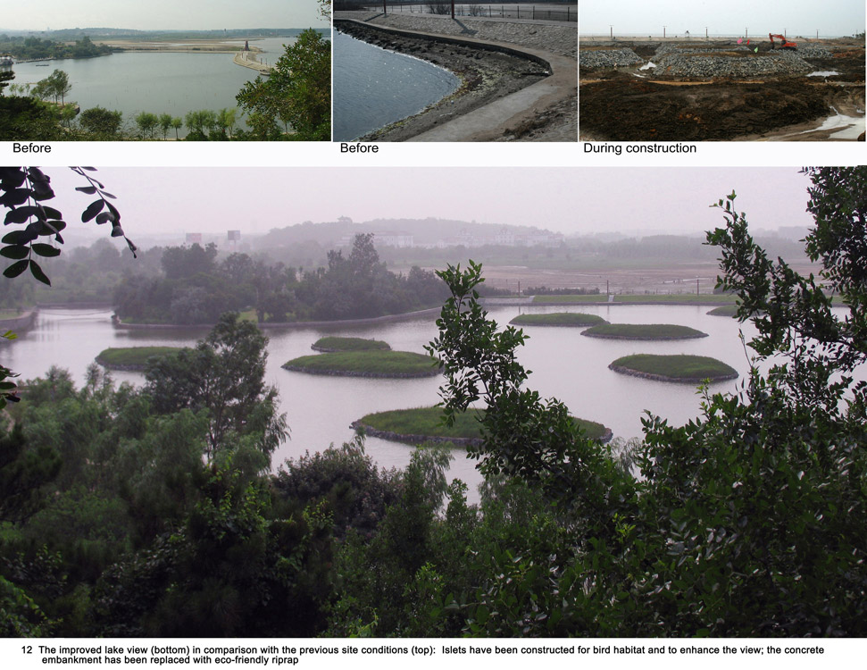

The project area is located on the Bohai Sea coast, a region that suffered severe erosion, degraded vegetation, and was littered with waste because of unplanned development activities in the past (Landezine, 2012). There is the same combination between hardscape and softscape material as The Red Ribbon park, using fiberglass boardwalk for people which wind along the shoreline of the beach. This helps visitors to experience the diverse plant communities surrounding. The walkway also serves as a soil structure which protects erosion coastline that was affected by sea winds and waves. The blend of softscape and hardscape created a contrast between the sturdiness of the boardwalk and the softness of vegetation. They design the wooden circulation pathways to raise off the sand, prevent people from trampling on the preserved dunes and also guide visitors into the naturally coastal landscape. Turenscape utilized the construction debris to create bubble-shaped holes as a solution for managing rainwater. The bubble shaped water both retains natural water and creates habitats for the plant which also creates an environment for many birds to recover. This is a highly effective solution that does not require a high investment but still reserves the ecosystem which was a degraded place. Moreover, instead of destroying and rebuilding the landscape, they allowed the architecture to blend seamlessly with it. Furthermore, they utilized the ocean breeze to cool the building during hot summer months (Landezine, 2012). This is a rather clever solution, optimizing energy consumption and minimizing CO2 emissions. Especially, the old concrete wave barrier was renovated from not responding both ecological and aesthetical factors to meeting the requirements by using environmentally friendly rip-rap stone and native vegetation. This helped to decrease the coastal erosion and land degradation and also contribute to the local ecological restoration of the surrounding environment. Overall, this is a highly resilient design which made a strong impression by solving the problems of coastal erosion and degradation without losing aesthetic value.
Connection with my project: Overall, this project helped me gain ideas and research for building an erosion-resistant stone embankment for the coastal park. Integrating environmentally friendly materials and vegetation is truly a great idea, minimizing coastal erosion, providing a certain level of safety, and creating a green ecosystem for the surrounding environment in today's urbanized era.
The Red Ribbon park and Quinhuangdao Beach have the same material choice for pathway, which was wood and fiberglass, but the Red Ribbon creates a visual focal point with vibrant colours against a green background than the contrast in Quinhuangdao beach. They all succeed in saving old, polluted places to become projects solving the climate problems, however, Quinhoangdao Beach has more supporting ideas for my project, such as using environmentally friendly rip-rap stone for wave barriers and walkway as erosion solution than the red ribbon. This does not mean the park is not necessary to analyse, it allows me to access the “Sponge City” concept in a different way, because the characteristics of the projects’ area are different. This shows that a sponge city can work in a diverse type of area in an urban city. Both the Red Ribbon Park and Qinhuangdao Beach gave me the idea that using the roughness of vegetation is the least disruptive solution to concrete construction for absorbing wave energy, preventing erosion, and creating calm waters where ecosystems can thrive. I wanted to keep the pedestrian walkways intact and not interfere too much, only using the surrounding vegetation to increase wave energy resilience.
In another way of using techniques, Kongjian Yu chose using low technique, nature-based solutions for solving the problems, while high technique was a choice of LAVA team and Aspect studio in dealing with issues. This creates a different mindset in facing climate change, both high and low techniques showing the benefits in using them.
Supporting Research

According to Rainer and West (2015), plant design needs to shift from cultivating individual plants to designing tightly interwoven communities because they have abilities of maximizing biodiversity, self-sustaining & low maintenance and climate resilience. This theory includes 4 layers of plants which are structural and framework plants, seasonal theme plants, ground-covering plants and filler species. Structural and framework plants play a role of shape space, provide shade, and create a stable visual structure year-round, even in winter when other layers have withered which are trees with clearly defined architectural forms, while seasonal theme plants It is the most eye-catching layer which include clusters of flowering plants, ornamental plants. Besides, the ground-covering layer was mentioned as an important part of the plan communities whose roots intertwine tightly to completely cover the ground. It helps retain soil moisture, prevents weed seeds from germinating, and combats erosion. Finally, the Filler layer includes plants with short life cycles and rapid growth which play the role of reservation, keeping the place for the plants from the structure layer and seasonal theme layer not yet mature. This helps prevent the growth of weed.
Based on the supporting research, I design the ecosystem in the breakwater section which also has 4 layers of plants. For the structural layer, I use Pinus Halepensis which has drought tolerance and creating shade reduces the urban heat island effect (Forests 2020). This support for the climatic characteristics of Prado Beach are described above. I chose Pancratium Maritimum for the seasonal theme plant because it is one of native plants in France and capable of withstanding soil salinity and sea winds (Horticultura 2025). For ground-covering plants, I want to choose a plant which can adapt to nestle among the cliffs and coastal embankments exposed to strong salty winds, and survival strategies in nutrient-poor soil conditions is Crithmum Maritimum (de la Riva et al., 2016). Then to fill the gaps between the ground cover and the structural layer, interweaving with other species to create a cohesive, naturally lush plant community, I choose Eryngium maritimum (Cortés-Fernández et al., 2022).
James Corner Field Operations
- Artist: James Corner (born in 61) and James Corner Field Operations
James Corner is a founder of Field Operation, well-known for its ability to harmonize rigid infrastructure engineering with natural ecosystems. He has dedicated 40 years to the landscape architecture field and urbanism (Field Operations, n.d.). With his viewpoint, the landscape here is not only romantic with its lush green gardens or beautiful flowers, but also reflects the society, politics, and human existence on a planet where humans are bound by the laws of nature. He argued that landscape is not only decorating function for buildings, but it also provides infrastructure functions for the purpose of organizing city purposes in the modern era. Field Operation was founded in 1999; their projects aim to address ecological challenges and create value for the community such as redeveloping abandoned urban areas.
- Project: Timber Bridge of The High Line (In collaboration with Diller Scofidio + Renfro and botanist Piet Oudolf).
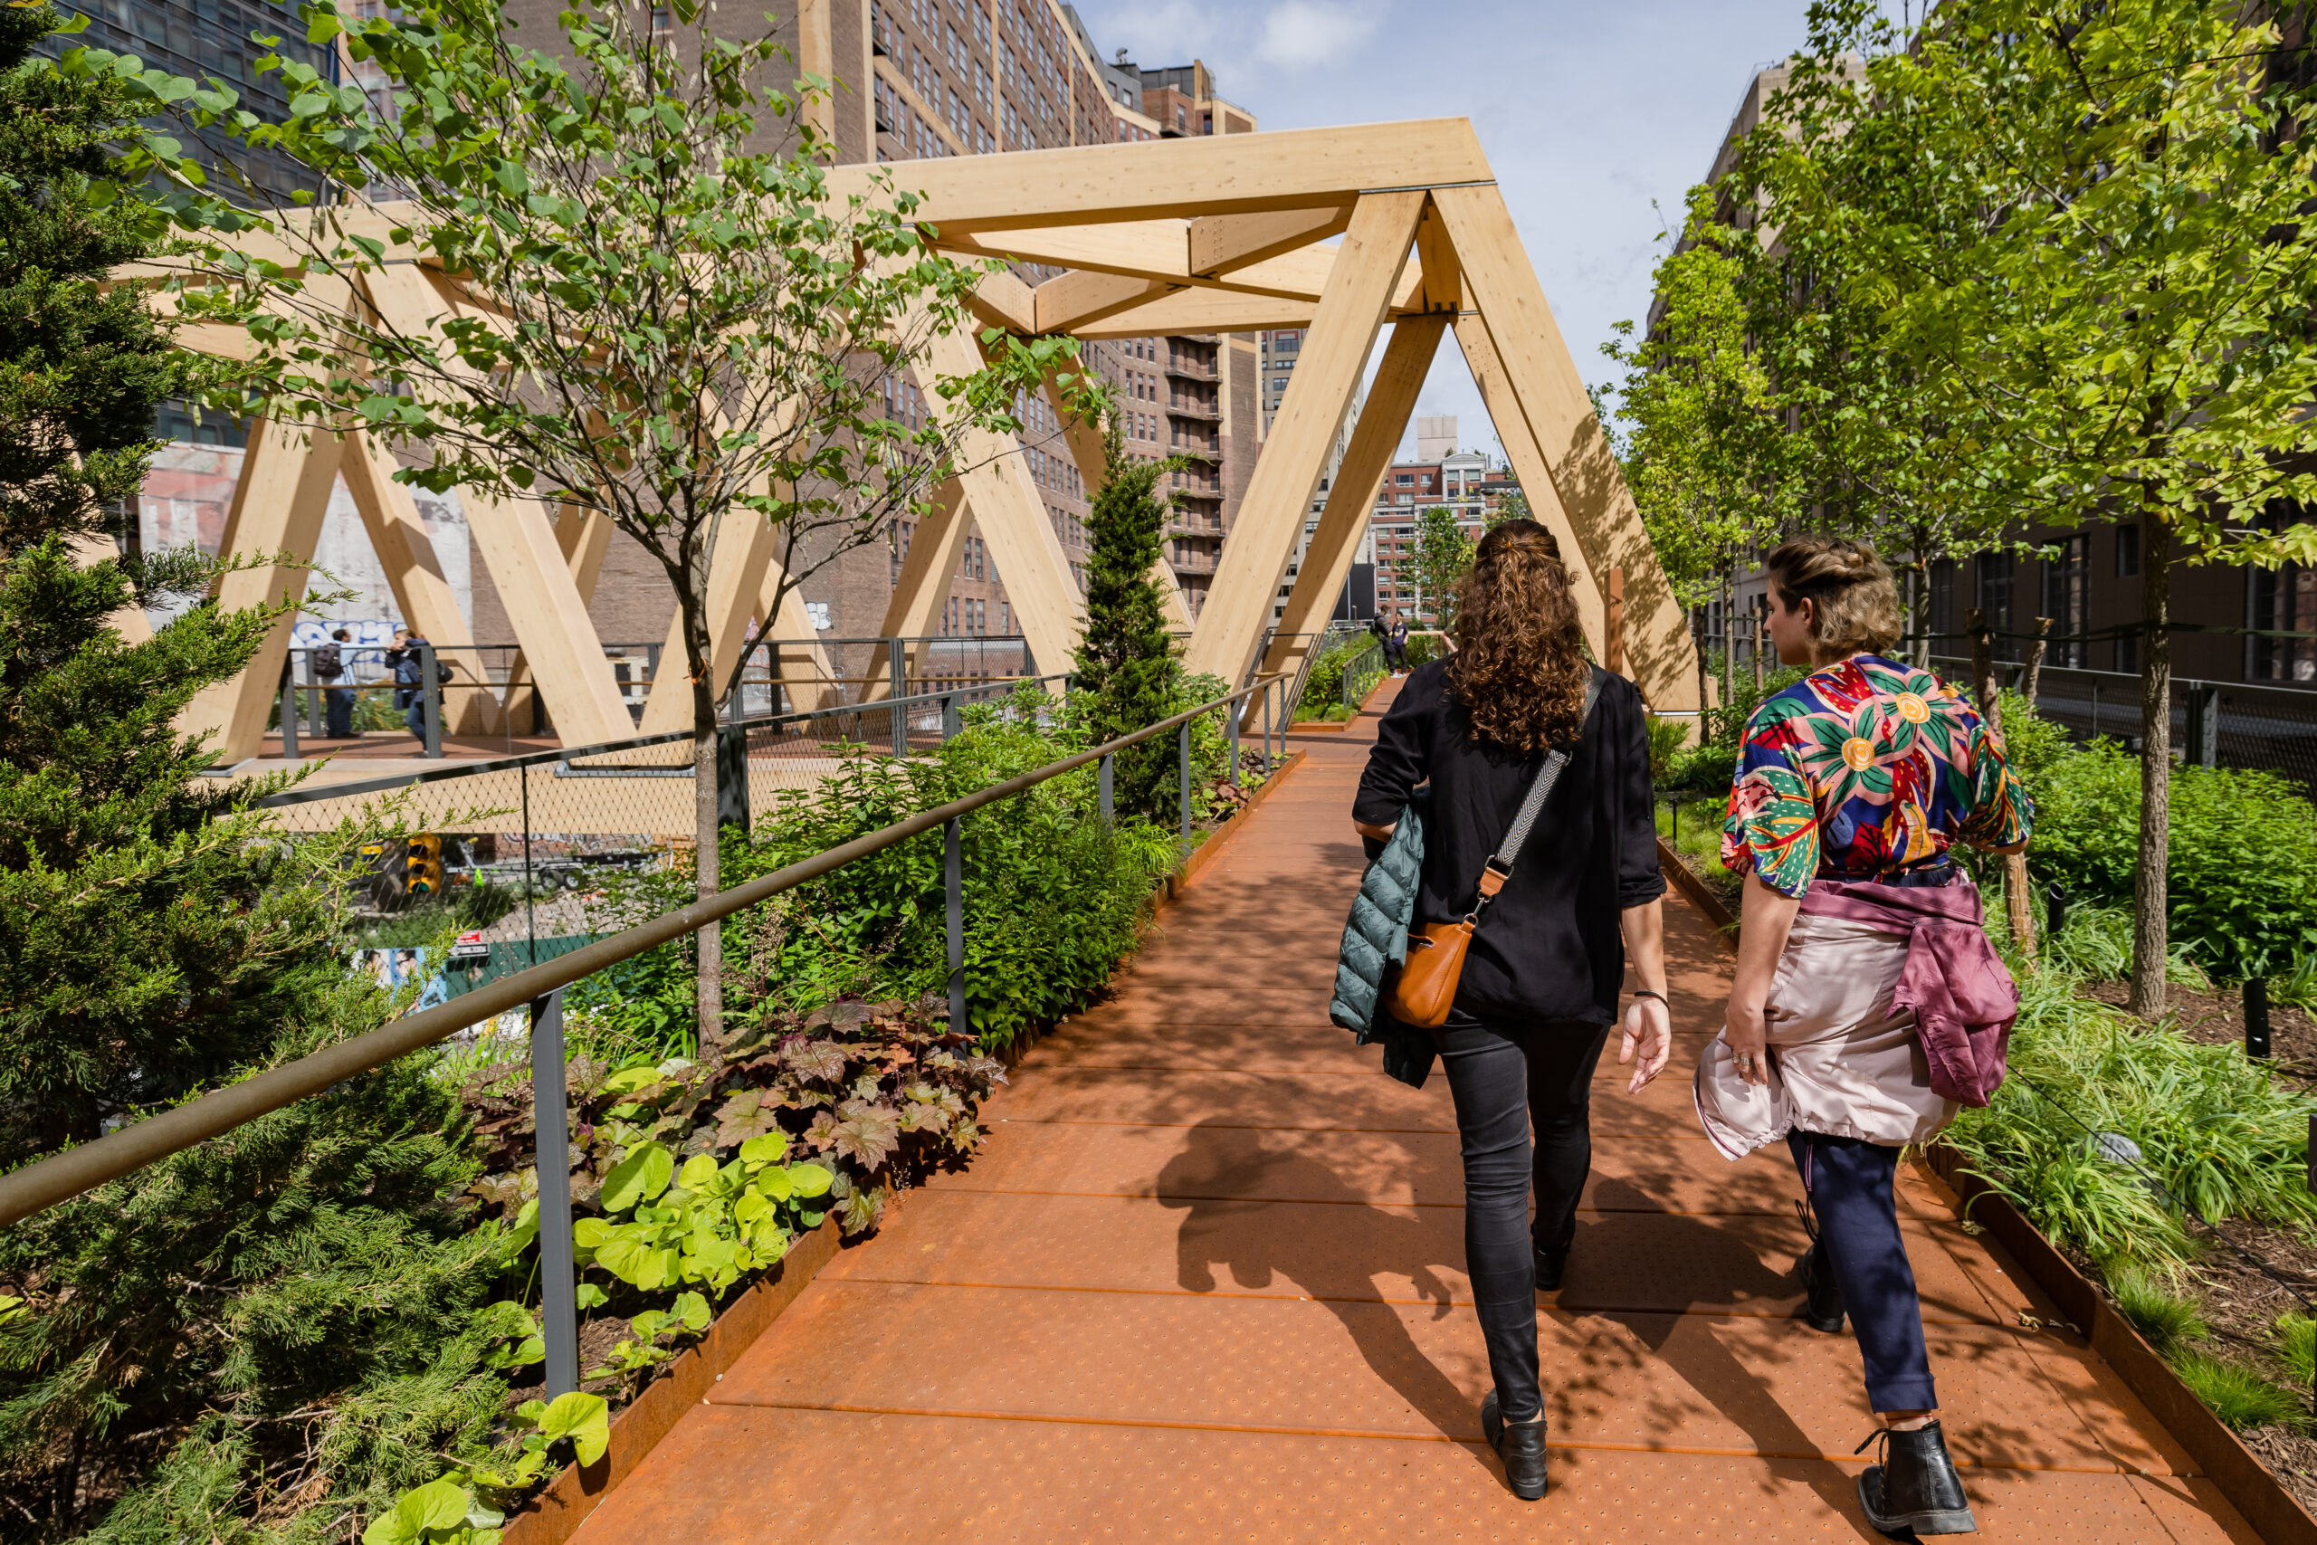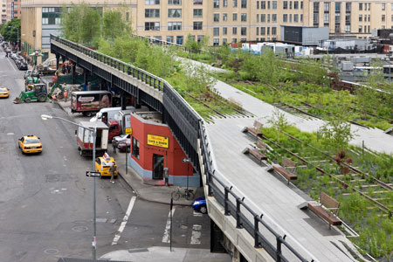
The project is about the transformation of an abandoned elevated freight railway into a linear park. The special point of this project is the bridge which connects Manhattan's High Line to the renovated Penn Station. The bridge is supported by Y-shaped steel columns which have minimal connections to the ground to serve for the purpose of not disrupting traffic routes below (Mazade, 2023). The project includes a pair of bridges that both complement and contrast with the existing High Line structure. The Woodland Bridge which has deep raised beds allow for the planting of a lush green strip of trees, in parallel this bridge also provides places for visitors to view the urban landscape and streets below. The park's elevated location creates a separation from the chaos of traffic below, providing a tranquil space. This creates an urban landscape picture that includes both dynamic and static elements, a harmonious combination. The natural factor of this part is the deep raised beds are constructed within the structure to support large trees and develop a lush landscape for birds and native pollinators. The green factor became an important factor in integrating natural elements into architecture, also blurring the boundaries between rugged architecture and the softness of nature. When the abandoned railway was covered by the green of nature, the design recreates that wild and resilient spirit of nature. It conveys that nature knows how to survive and reclaim space even in the heart of a concrete urban environment.
Connection with my project: I want to design a higher pathway as a bridge inside the park to guide the pedestrians to view the natural scenery. This allows people to immerse themself to natural scene such as the seascape, surrounding vegetation or the scene shows people walking below. Additionally, I want to use the Y-shaped steel columns for my design of bridge which can make minimal connection to ground for not destroying the land below.
West 8
- Artist’s name: West 8 (was founded in 1987)
West 8 is an international office, majoring in urban design, landscape architecture and infrastructure projects, and won many big prizes. The “Second Nature” concept of them is a vital factor of their design which is a blend of practicality and functionality with the respect of the nature of place. This serves that their design can provide the practical needs (water resource management, population growth, traffic congestion) and also reinforces the existing culture to which the building belongs through identity, symbolism, or expression (Skerl, 2024).
The reason why I chose West 8 for my research is that projects of this studio are turning the urban area into many vibrant multi-purpose parks. Plus, their projects are not only arranging green spaces, but also abstract art. They create artificial hills or undulating mounds, which is what distinguishes urban architecture.
- Project: Jubilee Garden
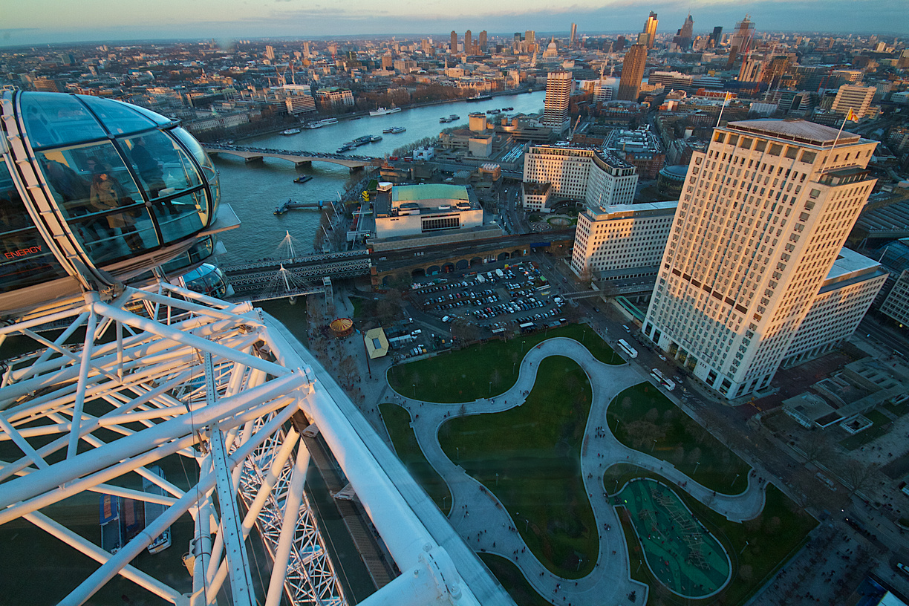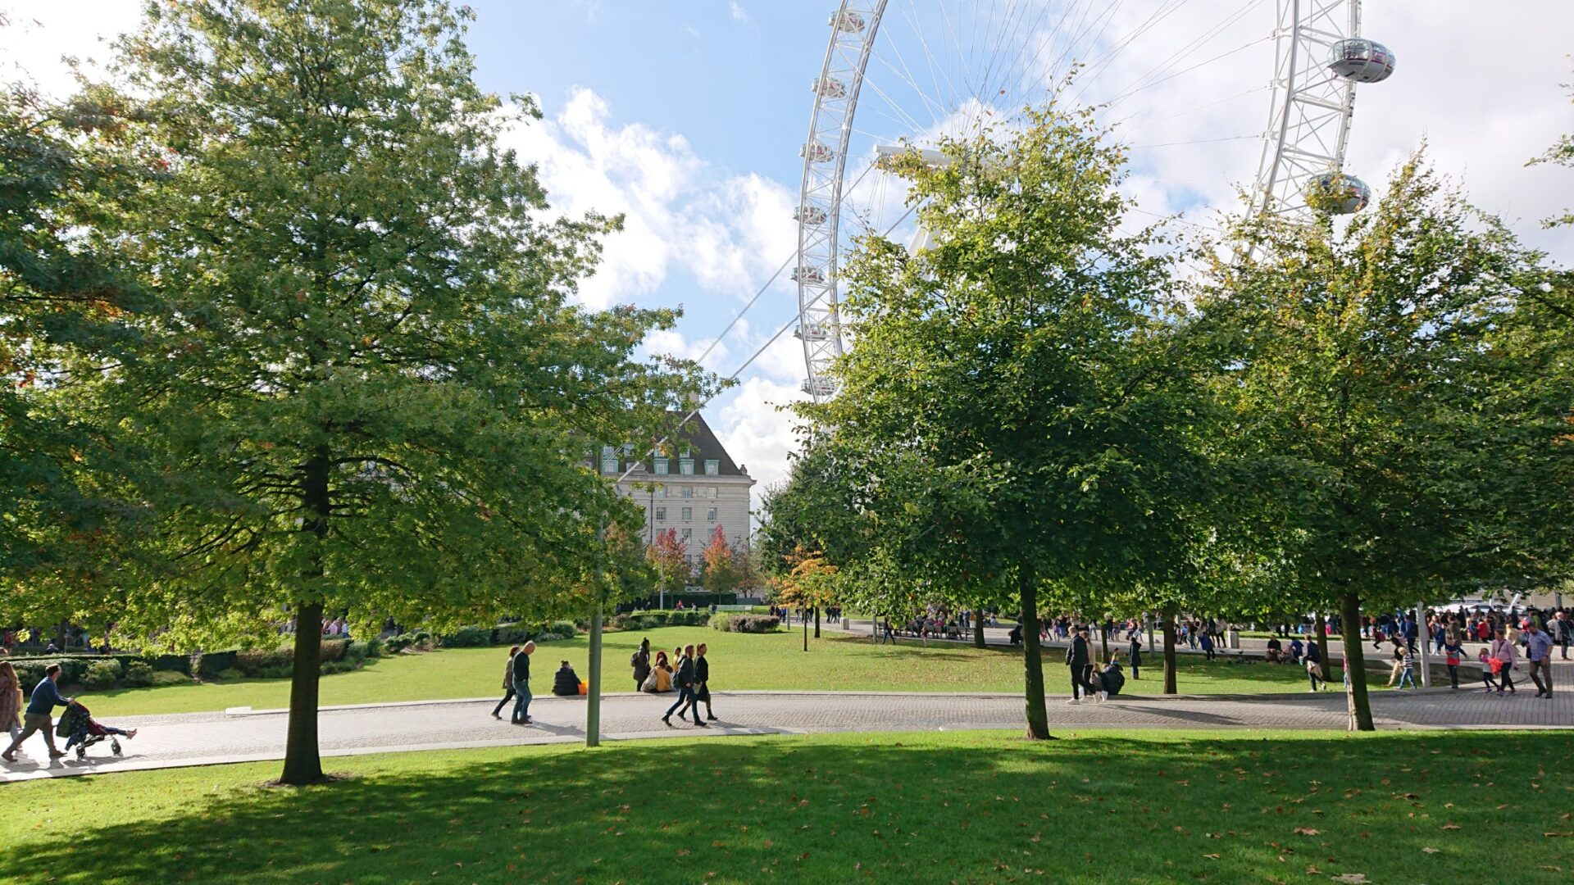
The Jubilee Garden is one of the park projects in urban areas of West 8. Unlike typical flat parks, the grass here is undulating into hills of varying heights. From a flat garden irreparably damaged during the construction of the Jubilee Railway to becoming a lush green oasis on the banks of the River Thames. This undulating terrain combined with the sharpness of the pathway made by granite stone create not only the guide way for people but also the forming seamless long benches. This is a multi-functional park which includes tranquil picnic areas, children's playgrounds, walking paths, or riverside spaces for hosting large events. This serves the crowds but still provides private shelter areas for refreshing and immersing themself into the natural atmosphere amidst the hustle and bustle of the city as London. This artwork proves that landscape architecture is not only designed and set in the flat terrain but also developed in the undulating place.
Connection with my project: I want to design undulating mounds as Jubilee Garden which make a soft vibe for an overall place and also increase the soil depth to plant big trees for more shade. Plus, using granite for pathways also creates a harmonious relationship between the softscape and hardships cape of the park which I can add in my project.
Comparing this project with the High Line of James Field Operation: Both projects involve restoring and developing a barren, abandoned area to be a green public area available for citizens' surroundings. While Jubilee Garden has undulating mounds on a wide square for its focal point, the High Line includes a sturdy linear, elevated, narrow, and long architectural structure. Besides the purpose of these projects are also different when the High Line promotes people to walk and view the urban landscape, Jubilee Garden wants people to have a place of resting or relaxing among the crowded cities. This creates a totally different way people used the areas for both developing and building them, but they all have one main purpose is to bring people closer to the environment and save the environment in nowadays urbanism era.
Art Movement
- About Art movement
According to Reina-Rozo (2021), Solarpunk is defined in this guide as a speculative genre that blends art, technology, and sustainable futures. Solarpunk envisions a world where technology and ecology work together to create equitable, hopeful futures. This is an aesthetic, philosophical, and social movement that emerged in Brazil in the early second decade of the 21st century, particularly in 2011, as a reaction to the dystopian pessimism of other creative endeavours. For characteristics of solarpunk, it depicts a world where ecology, democratic technology, solar and wind, and tidal energy are vital elements to create a well-being world in the future. This does not mean that solarpunk only uses high-tech to solve environmental problems, it includes both high-tech and low-tech when these kinds of technologies are combined and support each other. As a result, solarpunk societies could reach a post-scarcity state, where everyone has enough resources without destroying the planet (Gillam, 2023).
- Representative artwork
Garden by the Bay
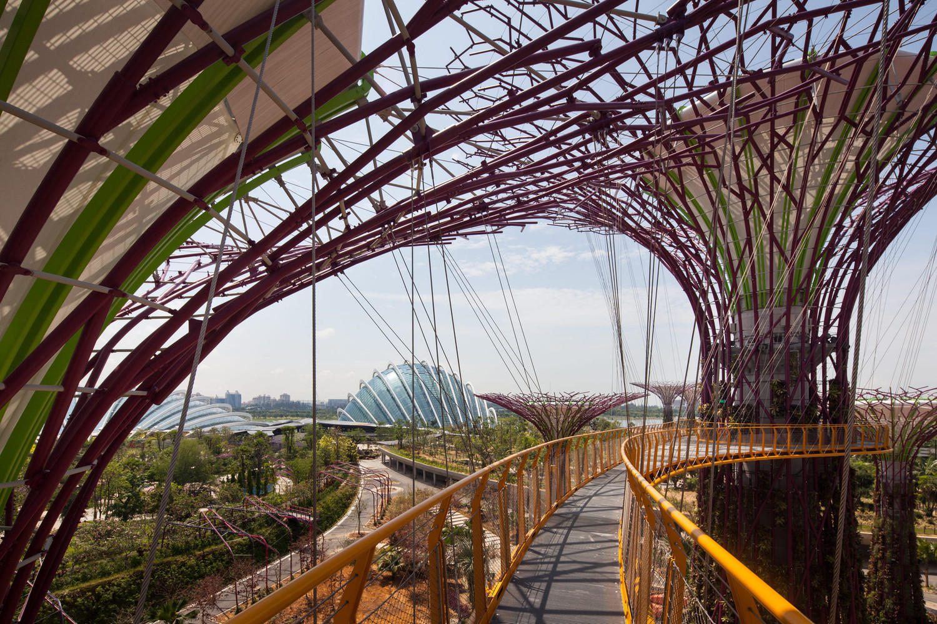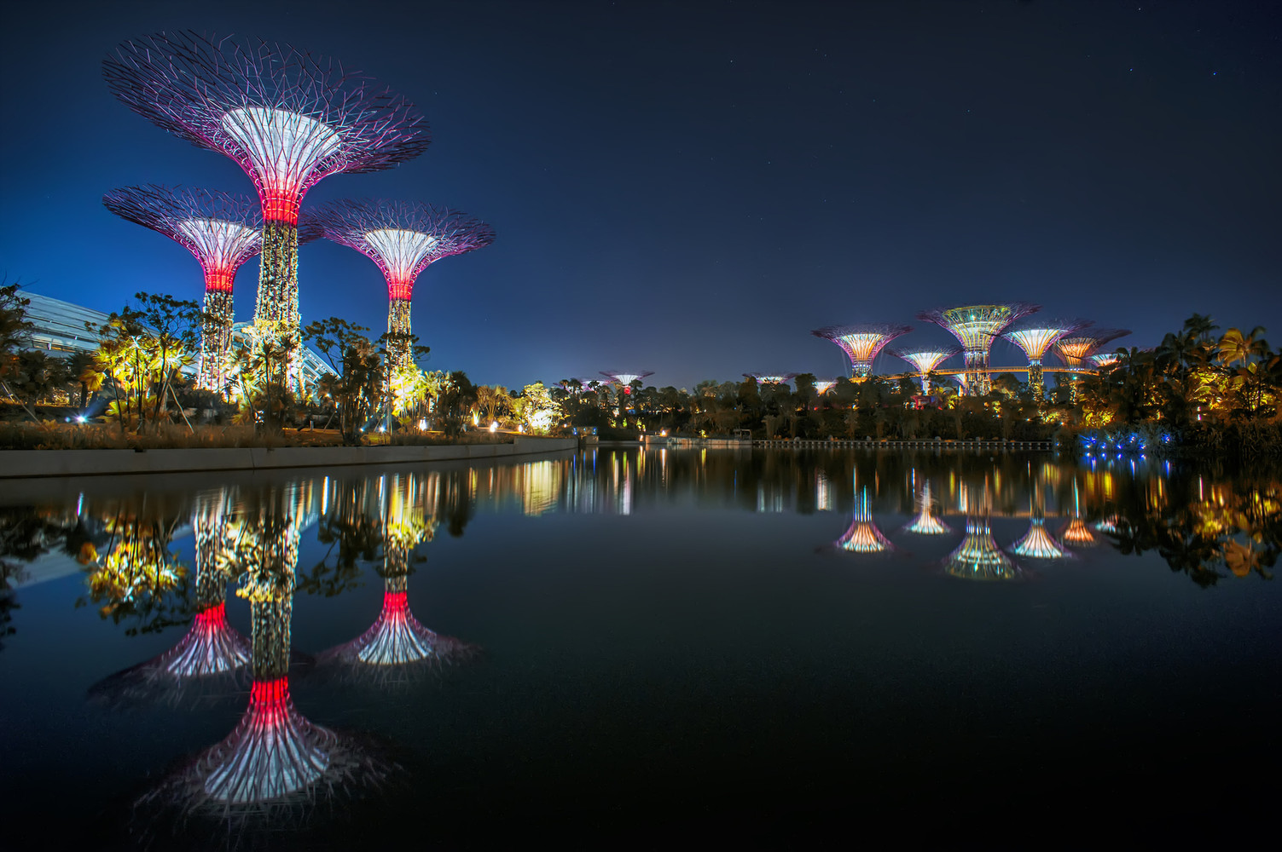
Garden by the Bay is a combination of nature, technology, environmental management, and imagination, while also serving as a testament to the art of gardening and landscape architecture (Greenroofs, 2022). This proves that Garden by the Bay is an example of the Solarpunk art movement. The project area is located in Marina Bay, a large, reclaimed land area which was a barren piece of land, lacking roads, drainage, and electricity, has been transformed into a lush green space home to over one million trees (Greenroofs, 2022). Technologies used in the project show that technologies do not nature, they are serving nature and people. This became a special point of the project when people could see giant artificial supertrees which illustrate an image of a giant forest in a unique futuristic style. These trees also have multifunction as becoming huge columns for climbing plants, epiphytic plants and tropical ferns integrated with light systems for people’s nightlife and sustainable energy and water technologies play a crucial role in cooling greenhouses (archdaily, 2012). These trees are not only the focal point of the entire project but also represent a strong contrast merge of hardscape and softscape material when a sharp, rigid geometric framework constructed from a concrete core and steel truss became a foundation for climbing plants to cling. The impressive height of supertrees brings an overwhelming sense of spatial proportion for the viewer making people who visit the garden become tiny creatures because it draws the observer's gaze from the ground all the way up into the air. There is an elevated walkway system connecting the supertrees, guiding users through natural and urban landscape, this eliminates the gap between people and nature which allows people to have 360-degree panoramic views of the lush greenery of Gardens by the Bay and the Marina Bay skyline. This artwork shows the connection of technologies and nature where they exist and support each other. The success point of Garden by the Bay is how people integrate mechanical engineering, visual arts, and ecology into a single space.
Site and Location research
The reason for choosing a part of Prado Park for development in my final outcome is Prado Beach is experiencing the formation of undulating "sediment hills" resembling off-road racetracks, posing a danger to pedestrians and obstructing children's view when they get too close to the water's edge (Rampal-Guiducci, 2024). The City of Marseille - 6th and 8th Arrondissements (2025) outlines how to create abilities of adapting climate for this area by developing resilient solutions to coastal erosion and rising sea levels, but also to the intensification of climatic events. This report also mentions that creating coherence between the intervention site, its urban environment and its natural space is essential criteria in development.
To support this, according to the Ville de Marseille report, existing coastal protection structures (designed in the 1970s) are at risk of becoming erosion and undersize by 2050 due to the impacts of climate change and rising sea levels. So, developing erosion-resistant stone embankments for the coastal park is necessary for absorbing wave energy and preventing the erosion. Prado Park is also affected by the Mistral winds blowing from the north and sea spray, which causes degradation of vegetation and structures. The report supported that building mounds is necessary for this area to protect the plant growth and bring a shaded picnic area for citizens who live there. Protecting the space from strong winds allows for the growth of tall plants, while unprotected areas can only sustain low-lying vegetation (Ville de Marseille et al., 2018).

Section Three Techniques and processes

Based on a development of processes I have experience in the workshop and research, I decide to make models for my final outcome which combine with materials such as cardboard, foam and plastic also blend with layering technique. Using 3D models to be my final outcome is a decision for form and developing my skills in spatial thinking and mastery of craftsmanship.
The foundation of this project comes from development of making models processes which move on from basic simple assembly to a higher level of complexity. I focus mainly on techniques for trimming creases and scoring on the cover to create curve paths in parallel combined with layering techniques which not only build the thickness of material but also show the topography of the design. Plus, the experiment of peeling layers of cardboard helps bending the cardboard to make the curve part and create different texture of models. The models are made based on an overall sketch and many detailed sketches to make sure the form of the model can describe the core of my outcome in the right way. There are many experiments to explore the limitation of materials then showing the perfect version for showcase.
Using many types of materials show the diversity of material when they combine to final outcome. Firstly, cardboard is one of my main materials in the models which are structural and rustic. The wavy properties in the middle layer of cardboard give it more versatility, as it can display a different texture, contributing to the texture diversity of the overall model. Additionally, when a portion of the smooth layer is removed, the wavy layer helps to bend the cardboard more smoothly. Besides, the pattern represents the stiffness and porosity of the cardboard's nature. When the spacing of the wavy pattern is larger, the cardboard becomes more porous, making it easier to make mistakes when cutting with a craft knife. Secondly, there is a different factor between cardboard and foam when foam can create a soft form of material. Through shaping foam material, I can create organic surfaces, images of rocks eroded by water or soft mounds. The sharpness of the utility knife can determine whether the foam is cut smoothly or not. The sharper the knife, the cleaner the cuts and the less excess material is left behind. Thirdly, plastic becomes a focal point of material while both cardboard and foam show a matte texture, plastic has a glossy texture. This creates a harmonious combination for diverse materials in the decision of choosing materials in my outcome.
The layering technique in this project shows the combination of sticking cardboard and foam together to create the thickness of layers. This supports geological structures in nature or elevation maps in landscape architecture. By changing the spacing and thickness between the layers of cover, I can simulate the erosion of time or the deposition of geological strata.
Another reason for choosing 3D models is showing the interaction with the environment’s factors, especially the light. For a physical model, the light in a different environment shows the different images given. While cardboard shows the shadow of objects, plastic will refract light in its colour. This demonstrates the tactility of models, not only about touching it but also how it interacts with the surroundings which a 2D sketch can not show.

Section Four Action Plan

Week | Task – What is the main priority for this week? | Time Frame | Action Completed
Week 1 | Research about Claude Lorrain | 1 weeks | Understand and document research about Claude Lorrain
Week 2 | 10 objects Annotation  respond to Claude Lorrain  Respond to 10 objects | 2 weeks | Sketching to respond to Claude Lorrain
Week 3 | Research and respond to Symbolism and Surrealism Art Movement | 1 days | Finishing 10 objects museum and responding to these art movement
Week 4 | Research about the theme  Update WordPress | 1 weeks | Document and discussing the main theme of final outcome
Week 5 | PDP draft for ILSART  Getting WordPress’s feedback | 1 weeks | Updating WordPress from week 1-4
Week 6 | PDP draft ver 2 for ILSART  Evaluation for ILSART | 1 weeks | Finishing PDP draft of ILSART
Week 7 | Submit ILSART’s Assessment A  Research about 3 artists  Primary research in London | 2 weeks | Choosing 3 artists and their works to analysis  Having primary research for Jubilee Garden, etc.
Week 8 | Statement of Intent  Research Art Movement  Respond to 3 Artists  Testing with the materials (foam, cardboard) | 2 weeks | Have sketches of responding for 3 artists  Experimentation with foam
Week 9 | Making models  Getting feedback from statement of intent | 1 weeks | Finish an overall model and one detailed model
Week 10 | Making detailed models  Preparing for Presentation  Design sheets | 1 weeks | Finish design sheet and presentation slides.  Finish models
Week 11 | Deadline
Week 12 | Exhibition
Milestone Deadlines & Key Dates

Materials & Preparation

Reference:
Harrouk, C. (2019). LAVA+Aspect design the Central Park of Ho Chi Minh City. [online] ArchDaily. Available at: https://www.archdaily.com/922558/lava-plus-aspect-design-the-central-park-of-ho-chi-minh-city [Accessed 10 Mar. 2026].
Florian, M.-C. (2025). Kongjian Yu, Creator of the Sponge City Concept, Passes Away in Brazil Plane Crash. [online] ArchDaily. Available at: https://www.archdaily.com/1034437/kongjian-yu-creator-of-the-sponge-city-concept-passes-away-in-brazil-plane-crash (Accessed 10 Mar. 2026).
Ghisleni, C. (2024) 'Urban Landscape as an "Art of Survival”: An interview with Kongjian Yu, the Advocate of the Sponge Cities Concept', ArchDaily, 23 June. Available at: https://www.archdaily.com/1017697/urban-landscape-as-an-art-of-survival-an-interview-with-kongjian-yu-the-advocate-of-the-sponge-cities-concept (Accessed: 10 Mar 2026).
ArchDaily (2013) 'Red Ribbon Park / Turenscape', ArchDaily, 7 November. Available at: https://www.archdaily.com/445661/red-ribbon-park-turenscape (Accessed: 15 Mar 2026).
Landezine (2012) 'The Qinhuangdao Beach Restoration by Turenscape', Landezine, 16 February. Available at: https://landezine.com/the-qinhuangdao-beach-restoration-by-turenscape/ (Accessed:15 Mar 2026).
Turenscape. (2011, August 30). The Qinhuangdao Beach Restoration by Turenscape. Landezine. https://landezine.com/the-qinhuangdao-beach-restoration-by-turenscape/
Camarero, J. J., Sánchez-Salguero, R., Ribas, M., Touchan, R., Andreu-Hayles, L., Dorado-Liñán, I., Meko, D. M. and Gutiérrez, E. (2020) 'Biogeographic, Atmospheric, and Climatic Factors Influencing Tree Growth in Mediterranean Aleppo Pine Forests', Forests, 11(7), p. 736. Available at: https://doi.org/10.3390/f11070736.
Pouris, J. and Rhizopoulou, S. (2025) 'Metabolic and Stomatal Traits of Pancratium maritimum L. (Sand Daffodil) Subjected to Induced Salinity', Stresses, 5(1), p. 14. Available at: https://doi.org/10.3390/stresses5010014.
de la Riva, E. G., Lloret, F., Pérez-Ramos, I. M., Marañón, T., Navarro-Fernández, C. M., Olmo, M. and Villar, R. (2016) 'The importance of functional diversity in the stability of Mediterranean shrubland communities after the impact of extreme climatic events', Journal of Plant Ecology, 10(2), pp. 281–293. Available at: https://doi.org/10.1093/jpe/rtw027.
Cortés-Fernández, I., Sureda, A., Adrover, M., Caprioli, G., Maggi, F., Gil-Vives, L. and Capó, X. (2022) 'Antioxidant and anti-inflammatory potential of rhizome aqueous extract of sea holly (Eryngium maritimum L.)', Ecology and Evolution, 12(7), e9164. Available at: https://doi.org/10.1002/ece3.9164.
Field Operations (no date) James Corner, FASLA, PLA. Available at: https://www.fieldoperations.net/studio/people/james-corner-fasla-pla (Accessed: 10 Mar 2026).
Mazade, K. (2023) 'SOM connects block-long glulam bridge to the High Line', Dezeen. Available at: https://www.dezeen.com/2023/05/18/som-block-long-glulam-bridge-high-line/ (Accessed: 10 Mar 2026).
Skerl, U. (2024). Office Profile: West 8. [online] Landscape Architecture Platform | Landezine. Available at: https://landezine.com/office-profile-west-8/ (Accessed 15 Mar. 2026).
Landezine (2015). Jubilee Gardens by West 8. [online] Landezine. Available at: https://landezine.com/jubilee-gardens-by-west-8/ (Accessed 15 Mar. 2026).

Reina-Rozo, J. D. (2021). Art, energy, and technology: The Solarpunk movement. International Journal of Engineering, Social Justice and Peace, 8(1), 47-60. https://doi.org/10.24908/ijesjp.v8i1.14292.(Accessed: 20 Mar 2026).
Gillam, W.J. (2023) 'A Solarpunk Manifesto: Turning Imaginary into Reality' , Philosophies, 8, article 73. Available at: https://doi.org/10.3390/philosophies8040073 (Accessed: 20 Mar 2026).
Greenroofs.com (2022). Gardens by the Bay, Supertrees. [online] Greenroofs.com. Available at: https://www.greenroofs.com/projects/gardens-by-the-bay-supertrees/ (Accessed 20 Mar. 2026).
Archdaily (2012). Gardens by the Bay / Grant Associates. [online] ArchDaily. Available at: https://www.archdaily.com/254471/gardens-by-the-bay-grant-associates (Accessed 22 Mar. 2026).
Rampal-Guiducci, J. (2024) 'Prado beaches: the City of Marseille carries out early reprofiling', Gomet', 3 March. Available at: https://gomet.net/plages-du-prado-un-reprofilage-precoce/ (Accessed: 10 Mar 2026).
City of Marseille - 6th and 8th Arrondissements (2025) 'Master plan for the development of the South Coast', Ville de Marseille. Available at: https://mairie-marseille6-8.fr/votre-mairie/actualites/plan-guide-damenagement-du-littoral-sud(Accessed: 10 Mar 2026)
Ville de Marseille (2018) Program study for the global enhancement of the Prado Seaside Park in Marseille: Phase 1 - Diagnostic study. Marseille: Ville de Marseille. (Accessed: 10 Mar 2026)

Bibliography
World Bank Group (2024) Climate Change Knowledge Portal: Vietnam. Available at: https://climateknowledgeportal.worldbank.org/country/vietnam (Accessed: 30 March 2026).
Saunders, W. S. & Yu, K. (2013) Designed ecologies : the landscape architecture of Kongjian Yu. 1st ed. [Online]. Basel: Birkhäuser.
Architizer, (n.d.). What Is Solarpunk Architecture and How Does It Fit Into the Built Future? [online] Architizer. Available at: https://architizer.com/blog/inspiration/stories/solarpunk-architecture-and-the-built-future/ (Accessed: 15 Mar 2026).
Republic of the Bees, (2008). From Steampunk to Solarpunk. [online] Republic of the Bees. Available at: https://republicofthebees.wordpress.com/2008/05/27/from-steampunk-to-solarpunk/ (Accessed: 22 Mar 2026).
World-Architects, (n.d.). Qinhuangdao Beach Restoration: An Ecological Surgery. [online] World-Architects. Available at: https://world-architects.com/en/turenscape-haidian-district-beijing/project/qinhuangdao-beach-restoration-an-ecological-surgery (Accessed: 10 Mar 2026).
Sousa, M. (2019) 'Sponge City: Nature is the solution for floods', ArchDaily Brasil. Available at: https://www.archdaily.com.br/br/924346/cidade-esponja-a-natureza-e-a-solucao-para-inundacoes (Accessed: 10 March 2026).
Dreith, B., (2023). Concrete-based urban areas "will fail" says Kongjian Yu. [online] Dezeen. Available at: https://www.dezeen.com/2023/10/19/sponge-cities-flooding-interview-kongjian-yu-turenscape/ (Accessed: 10 Mar 2026).
The High Line, (n.d.). Connections. [online] The High Line. Available at: https://www.thehighline.org/connections/?utm_source=highline&utm_medium=website-design&utm_content=connections-announcement&utm_campaign=connections-announcement (Accessed: 10 Mar 2026).
Field Operations, (n.d.). High Line Moynihan Connector. [online] Field Operations. Available at: https://www.fieldoperations.net/project/high-line-moynihan-connector (Accessed: 10 Mar 2026).
West 8, (n.d.). Jubilee Gardens. [online] West 8. Available at: https://www.west8.com/projects/jubilee-gardens/ (Accessed: 10 Mar 2026).

