COURSEWORK COVERSHEET AND RECEIPT
(This form must be completed and attached to all assessed coursework)
BCUIC ID Number: | 172036
First Name:  (PLEASE USE BLOCK CAPITALS) | PHUONG VI | Family Name:  (PLEASE USE BLOCK CAPITALS) | NGUYEN

Choose BCUIC Course:

X | Foundation in Art & Design  Foundation in Law  Foundation in Business  Foundation in Technology, Engineering and Built Environment

First Year Degree in Business
First Year Degree in Economics and Finance
First Year Degree in Accountancy and Finance
First Year Degree in Marketing, Advertising and PR
First Year Degree in Technology, Engineering and Built Environment

Pre-Masters in Law
Pre-Masters in Business
Pre-Masters in Art and Design

Module Code: ILS1ARTB | Module Name: Interactive Learning Skills and Communication: Preparation and Progression in Art
Lecturer/Tutor: Lydia Parkes
Assignment Title: Preparation and Progression in Art and Design Assessment A
Tick the box if you have uploaded your work on TURNITIN: x
Tick the box if you have applied for Mitigating Circumstances:

Declaration: I can confirm that the work that I have submitted is my own original work and that I have made appropriate references to any sources used. I have read and understand that BCUIC plagiarism and collusion policy in the Academic Services/Student Handbook and confirm that this work complies with those guidelines. I confirm that the printed version of the assessment and any electronic copy I am required to submit via TURNITIN are identical. I understand that failure to meet the guidelines may result in one or more of the outlines penalties being imposed.

Signed: Phuong Vi Nguyen Date: 14/07/2026

ASSESSMENT & EXAMINATION FEEDBACK FORM
MODULE CODE | ILS1ARTB | STUDENT ID | 172036
SEMESTER | 2602 | DATE | 14/07/2026

Additional Guidance:
Feedback provided in this form should be accompanied by corresponding annotations on the student’s script in the appropriate colour as follows:
- RED = FIRST MARKER
- GREEN = SECOND MARKER
The First Mark stands as the ‘Agreed Mark’ unless there is a deviation beyond 10%
Agreed Mark section is to be completed by the Second Marker with the mark entered matching the First Mark where there is a deviation of less than 10% to indicate agreement/confirmation.
The additional section added for ‘Agreed Mark’ is to be completed / signed by the Second Marker where the deviation is less than 10%.

-Where there is a deviation of more than 10% the First Marker and Second Marker are to consult further to reach a consensus on the Agreed Mark.

If a consensus cannot be reached between the First Marker and Second Marker a Third Marker / Moderator will be appointed by the Academic Services Team to confirm the Agreed Mark.

Where there is a deviation of more than 10% the First Marker and Second Marker are to consult further to reach a consensus on the Agreed Mark.

WordPress link

Section A
 | Mark Allocated | Percentage % | Signature
First Marker
Second marker
Agreed mark
Moderator (if applicable)
Signature (Moderator)

FIRST MARKER NAME (PRINT) |  | FIRST MARKER  (SIGNATURE)

Section B (see comments below)
Overall Comments:

Tips to improve your work (1st Marker)

1.
2.
3.

The best part of the work was:

Second Markers Comments

I confirm agreement with the marking standards of this sample

Second Marker Signature:

Exploring political influences on the design of Unite d’Habitation by Le Corbusier
Charles-Édouard Jeanneret-Gris, also known as Le Corbusier, was born in Switzerland 1887 and witnessed both World War I and World War II. This experience made him follow the purism theory and became a pioneer of Brutalist architecture, exploring simple materials (UNESCO,2019). This essay will use the Political element of PESTLE to analyse how post-war government policies affected his decisions regarding materials choices.
After World War II, the French government faced a severe housing crisis due to heavily damaged infrastructure. In the political aspect, the government’s intervention to restore social stability was extremely urgent so they commissioned Le Corbusier to design a large-scale residential complex in Marseille. Unité d'Habitation was created to not only solve the housing shortage problem, but also play a role as a vertical city, offering accommodation for 1600 people which integrated public amenities such as shops and a gym located on the rooftop (Foundation Le Corbusier, n.d.).
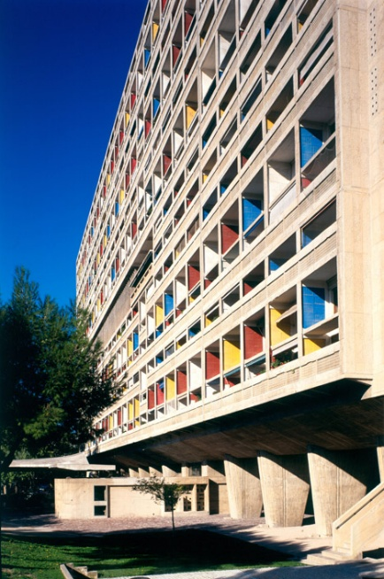
Figure 1: A vertical city solution for post-war housing (Frearson, 2014)
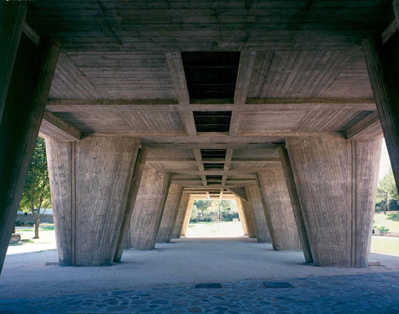
Figure 2: The texture of Béton Brut (Frearson, 2014)
Strict post-war political policies, especially the Monnet Plan (1946-1952) which prioritised raw materials for basic heavy industries, caused the shortage of steel which forced the use of raw concrete, known as Béton Brut (Brunnermeier, James and Landau, 2016). At an early period of his career, Le Corbusier was extremely passionate about standardisation and often preferred industrially produced materials such as steel, reinforced concrete, and glass (Samuel, 2007). At the time, he viewed concrete as a fixed material and always aimed for a pristine finish, or at least to create the illusion of smoothness by applying plaster to completely conceal the rough surface underneath. However, the birth of Beton Brut was an accidental incident at Unité d'Habitation when the concrete pouring suffered from numerous construction errors, which he called a "massacre of concrete”. By accepting these imperfections, Le Corbusier turned a material shortage driven by political motives into a powerful aesthetic statement. He successfully demonstrated high-density living had the ability to adapt to the lack of material choices and have its own beauty of architecture.
To conclude, the Unité d'Habitation has been explored through the political lens showing how post-war governmental policies affected modern architecture development. The challenge of political and strict resources provided the chance of utilising raw concrete as a material language. This project of Le Corbusier showed that it not only solved the need for accommodation for people at the time but also created work of art that possesses its own unique, rustic beauty.

Reference:
Bacon, M. (2015) Le Corbusier and postwar America: The TVA and Béton Brut. Journal of the Society of Architectural Historians, 74(1), pp. 13–40. Available at: https://doi.org/10.1525/jsah.2015.74.1.13.
Brunnermeier, M.K., James, H. and Landau, J.-P. (2016) The Euro and the battle of ideas. Milken Institute Review, 19 October. Available at: https://www.milkenreview.org/articles/the-euro-and-the-battle-of-ideas [Accessed 13 July 2026].
Fondation Le Corbusier (n.d.) Le Corbusier, Unité d'habitation, Marseille, France, 1945-1952. Available at: https://www.fondationlecorbusier.fr/en/work-architecture/achievements-unite-dhabitation-marseille-france-1945-1952/ [Accessed 26 June 2026].
Frearson, A. (2014) Brutalist buildings: Unité d'Habitation, Marseille by Le Corbusier. Dezeen, 15 September. Available at: https://www.dezeen.com/2014/09/15/le-corbusier-unite-d-habitation-cite-radieuse-marseille-brutalist-architecture/ [Accessed 8 June 2026].
Samuel, F. (2007) Le Corbusier in detail. Amsterdam: Elsevier.
Sbriglio, J. (2004) Le Corbusier: l'Unité d'habitation de Marseille. [e-book] Paris: Fondation Le Corbusier. Available through: https://ebookcentral.proquest.com/lib/bcu/detail.action?docID=4338395 [Accessed 13 July 2026].
UNESCO (2019) Unité d'habitation. Available at: https://lecorbusier-worldheritage.org/en/unite-habitation/ [Accessed 20 June 2026].

Exploring technological influences on the design of Unite d’Habitation by Le Corbusier
The Unité d'Habitation is a pioneering building by Charles-Édouard Jeanneret-Gris (Le Corbusier) for Brutalism. This essay will explore the work under the lens of technological influences through examining the construction method and structural engineering by using technological element in PESTLE to analysis. It will show how Le Corbusier utilised technological solutions to overcome severe post-war constraints.
The challenge for Le Corbusier during this project was to build a vertical city capable of housing 1600 residents (Frearson,2014). The Unite d’Habitation required complex technological solutions for both spatial distribution and physical infrastructure. The apartments were designed to span 21-meter depth of the residential block which unitized the natural light and ventilation function (Millais 2015). This layout helped optimize the circulation of residents which created internal streets (corridors) on every third floor for people living inside. The technological layout had the added benefit of saving space and reducing the amount of material needed as there was a shortage.
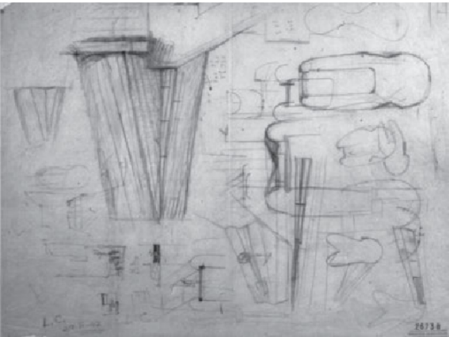
Figure 1: Design sketch of the Pilotis, signed L.C. 12/10/1947 (FLC 26738) (Sbriglio, 2004)
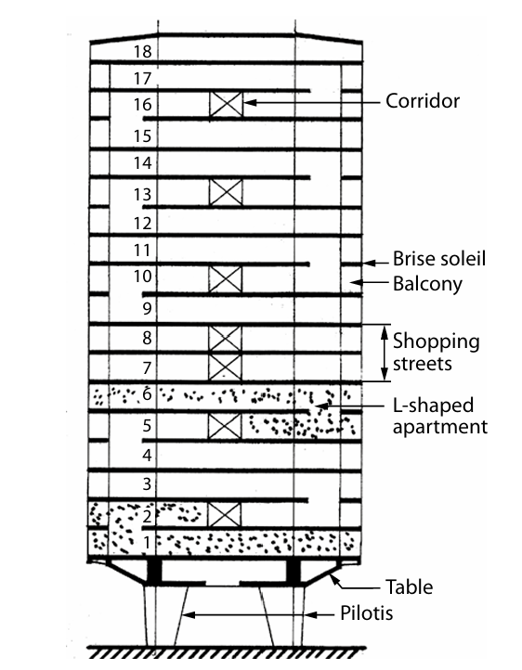
Figure 2: Section showing the principal concepts (Millais, 2015).
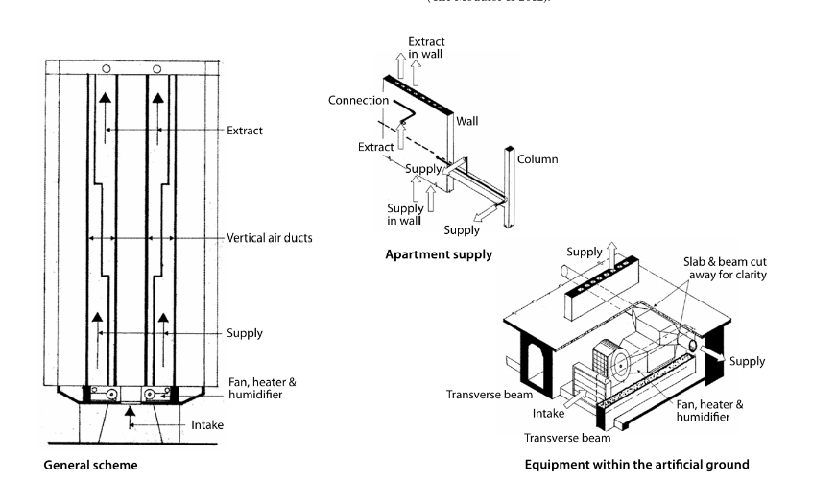
Figure 3: The heating and extract schemes (Millais, 2015)
In addition to this artificial ground played a role as a central hub for building mechanical and heating technologies. It was a hollow engineering structure, supported by a system of massive Pilotis, reinforced concrete pillars (Foundation Le Corbusier, n.d.). The Pilotis bares the entire load of the 18-story building, freeing up ground space for pedestrians and landscaping, while concealing all the complex distribution network of plumbing, electricity, and waste management (Sbriglio,2004). Instead of using the traditional way burying the complex infrastructure underground which can cause significant construction costs and budgetary burdens in the post-war period. Le Corbusier integrated major utility networks within this elevated level (Avin 1973). The mechanical systems are efficiently branched into standard vertical axes from the horizontal piping system supported by Pilotis. This helped serving the upper floors more optimal and easier because these shafts run straight up through the core of the building. The integration of Pilotis and mechanical system demonstrated the necessary engineering function affected on the architecture form, created a utility turned into a monumental feature. Therefore, Brutalism was not only an aesthetic style but also a technological solution, adapting the optimal requirements in terms of materials and functionality.
In conclusion, the technological analysis of the Unite habitation shows the specific structural and mechanical engineering methods utilised and pioneered by Le Corbusier in collaboration with his engineering team (ATBAT) responded to post-war restrictions and needs. Using the concrete Pilotis and artificial ground allowed the building to support a massive structure while housing complex mechanical systems which helped serve the residents inside more effectively.
Reference:
Architecture Dictionary (n.d.) Piloti. In: Architecture Dictionary. Available at: https://www.archdictionary.com/piloti [Accessed 7 July 2026].
Avin, U.P. (1973) Le Corbusier's Unité d'habitation: A slab for all seasons. Master's thesis. University of Cape Town.
Fondation Le Corbusier (n.d.) Le Corbusier, Unité d'habitation, Marseille, France, 1945-1952. Available at: https://www.fondationlecorbusier.fr/en/work-architecture/achievements-unite-dhabitation-marseille-france-1945-1952/ [Accessed 26 June 2026].
Frearson, A. (2014) Brutalist buildings: Unité d'Habitation, Marseille by Le Corbusier. Dezeen, 15 September. Available at: https://www.dezeen.com/2014/09/15/le-corbusier-unite-d-habitation-cite-radieuse-marseille-brutalist-architecture/ [Accessed 8 June 2026].
Kroll, A. (2010) AD classics: Unité d'Habitation / Le Corbusier. ArchDaily, 5 November. Available at: https://www.archdaily.com/85971/ad-classics-unite-d-habitation-le-corbusier [Accessed 13 June 2026].
Millais, M. (2015) A critical appraisal of the design, construction and influence of the Unité d'Habitation, Marseilles, France. Journal of Architecture and Urbanism, 39(2), pp. 103–115.
Samuel, F. (2007) Le Corbusier in detail. Amsterdam: Elsevier.
Sbriglio, J. (2004) Le Corbusier: l'Unité d'habitation de Marseille. [e-book] Paris: Fondation Le Corbusier. Available through: https://ebookcentral.proquest.com/lib/bcu/detail.action?docID=4338395 [Accessed 13 July 2026].

Essay: Exploring the influence of environmental issues on the work of Bjarke Ingel
The new headquarters of Bjarke Ingles Group (BIG) located at Nordhavn, Copenhagen, demonstrates the combination between Brutalist architecture and modern environmental responsibility. Through the environmental element of the PESTLE model, we can understand why BIG created a sustainable structure using low-emission materials and renewable energy systems to respond to climate change, the energy crisis and urban ecosystem degradation.
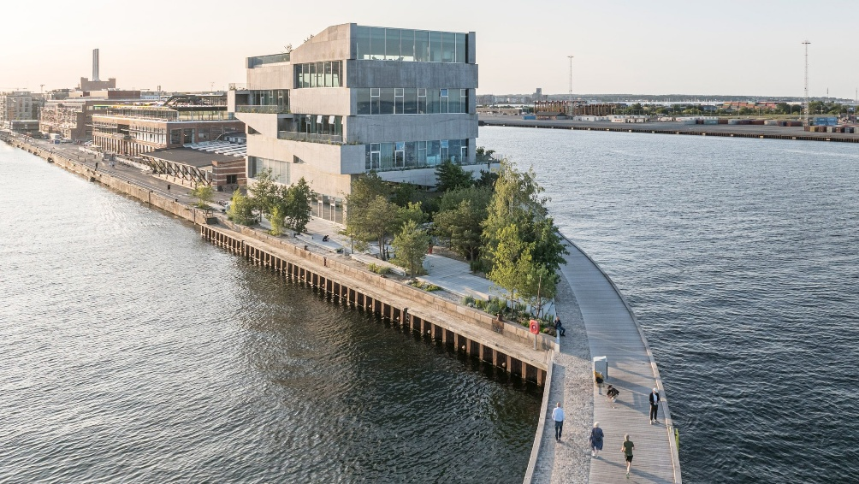
Figure 1: Exterior perspective of the building (BIG, n.d.)
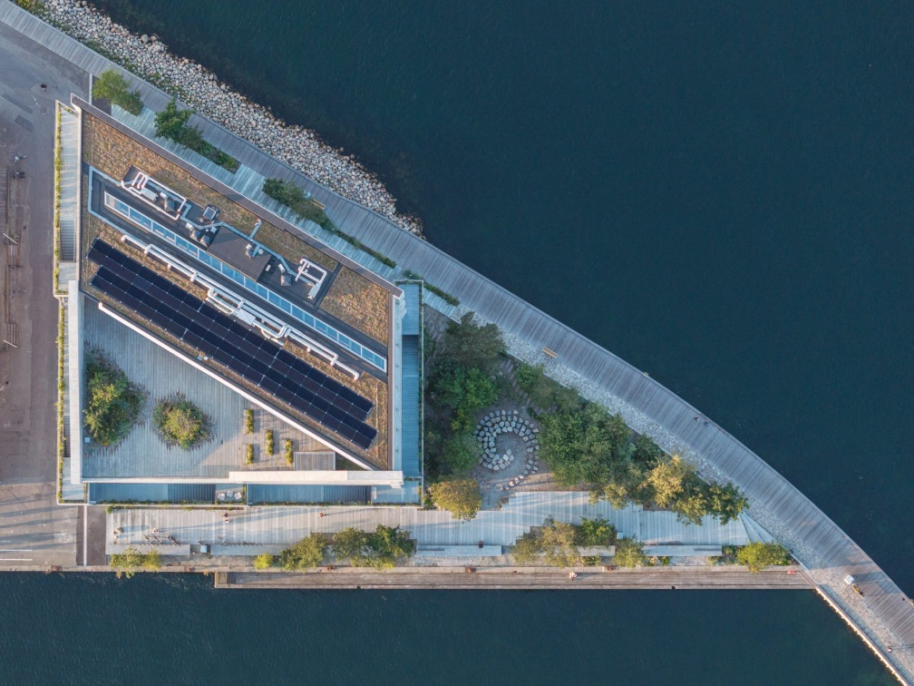
Figure 2 : An aerial view showing the overall layout of BIG HQ (Photograph: Ghinitoiu, 2024)
The project BIG HQ presents the traditional Brutalism aesthetic of concrete, whilst concealing ecological innovation (Archello, 2024). BIG envisions its headquarters as a pioneering project that pushes the boundaries of the potential applications of concrete and construction methods. BIG used “Uni-Green” concrete, a6 material developed in collaboration with Unicon which significantly reduces 25% CO2 emissions compared to traditional concrete (BIG, n.d.). This concrete is produced by replacing clinker, known for its high CO2 emissions, with calcined clay and limestone fillers (C3Globe, 2024). Additionally, the design created a structural and aesthetic durability, maintaining an enduring presence in Copenhagen, reducing the need for future interventions.
BIG HQ was designed to utilise renewable energy through passive and active solutions. The building utilised the natural light by using large glass doors and windows surrounding the facade and simultaneously with a natural ventilation system for air conditioning (The Plan, 2024). The building also integrated geothermal energy and solar panels, installed on the roof to offer the clean and sustainable (C3Globe, 2024). These decisions regarding materials and energy were made to ensure the building has a low carbon-equivalency impact, aiming to achieve DGNB Gold sustainability certification (Charles,2024).
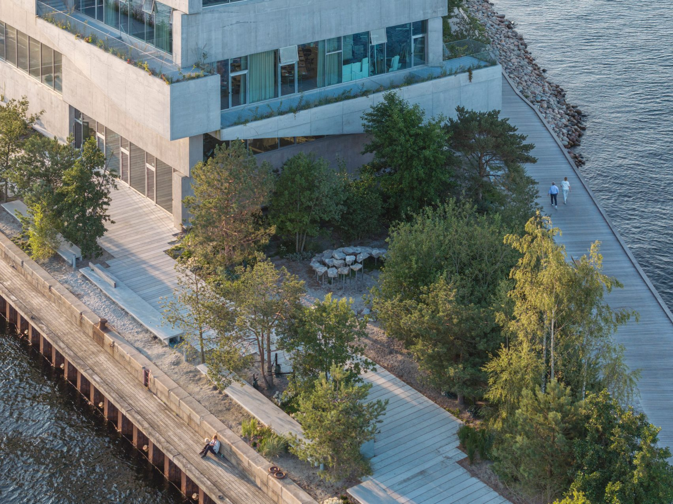
Figure 3: Coastal eco-park at BIG HQ (BIG, n.d.)
The environmental factors of the project not only appear in the structure, but also in the surrounding landscape. Landscaping should stem from the reality that public spaces and biodiversity are gradually shrinking in urban areas. For instance, according to Urban Green Space Report 2024, 344 cities revealed a net decrease of 63 million square meters of urban green space compared to the previous year(Husqvarna AB, 2024). BIG turning an industrial area of the harbour to the 1500 m² park is a huge contribution to the ecosystem. This park was designed to withstand the harsh coastal environment by planting native plants, capable of withstanding wind and salt spray (BIG, n.d.). This not only helps decrease the urban heat island effect but also act as a natural wind barrier and creates an environment for local species.
To conclude, analysing BIG HQ through the environmental lens of PESTLE showed this project is a pioneer in solving environmental problems. By applying low-carbon concrete, integrating renewable energy and actively preserving the coastal ecology. BIG HQ proved that large-scale and aesthetic architecture can contribute to the sustainability of the environment.

Reference:
ArchDaily (2024) Piranesian HQ and Park / BIG. Available at: https://www.archdaily.com/1022884/piranesian-hq-and-park-big [Accessed 26 June 2026].
Archello (2024) Brutalist-like BIG HQ enjoys "confident and commanding presence" in Copenhagen harbor. Available at: https://archello.com/news/brutalist-like-big-hq-enjoys-confident-and-commanding-presence-in-copenhagen-harbor [Accessed 26 June 2026].
BIG | Bjarke Ingels Group (n.d.) BIG HQ 11526. Available at: http://big.dk/projects/big-hq-11526 [Accessed 26 June 2026].
C3GLOBE (2025) BIG HQ and Park. Available at: https://c3globe.com/big-hq-and-park-by-big/ [Accessed 26 June 2026].
Charles, S. (2024) BIG wraps Copenhagen headquarters with 140-metre-long concrete staircase. Dezeen, 29 October. Available at: https://www.dezeen.com/2024/10/29/big-headquarters-copenhagen/ [Accessed 26 June 2026].
Ghinitoiu, L. (2024) An aerial view showing the overall layout of BIG HQ [Photograph]. In: S. Charles, BIG reveals its "piranesian" headquarters in Copenhagen. Dezeen, 29 October. Available at: https://www.dezeen.com/2024/10/29/big-headquarters-copenhagen/ [Accessed 26 June 2026].
Husqvarna AB (2024) Urban Green Space Report 2024. Available at: https://hugsi.green [Accessed 13 July 2026].
The Plan (2024) The New BIG Headquarters at the Port of Copenhagen, a “Piranesian” Space - BIG - Bjarke Ingels Group. Available at: https://www.theplan.it [Accessed 26 June 2026].

Essay: Explorng the influence of Social events on the design of University Children’s Hospital Zurich.
The University Children’s hospital in Zurich, designed by Swiss architectural firm Herzog & de Meuron, shows the change in modern healthcare architecture. Through using the social element in the PESTLE model, we will be able to understand how environmental architecture adapts to the psychology, cultural and emotional needs of a changing modern society. The design focused on children, the most vulnerable group, to show the role of architecture in supporting society (STIRworld, 2024).
From a social perspective, this project has shown an increase in societal demand for infrastructure. Historically, hospital architecture was designed to convey sterility, stripping away all signs of vitality from within the walls that confine the sick. Jacques Herzog said, “hospitals are the ugliest places in the world” and “They are a product of blind functionalist thinking, while neglecting basic human needs.”, so Herzog & de Meuron firm wanted to show their belief that "architecture can contribute to healing"(Dezeen, 2024). This belief places human experience into the heart of architecture design, built based on believing space can create the difference in the treatment process by erasing the stigma surrounding harsh and isolating medical facilities.
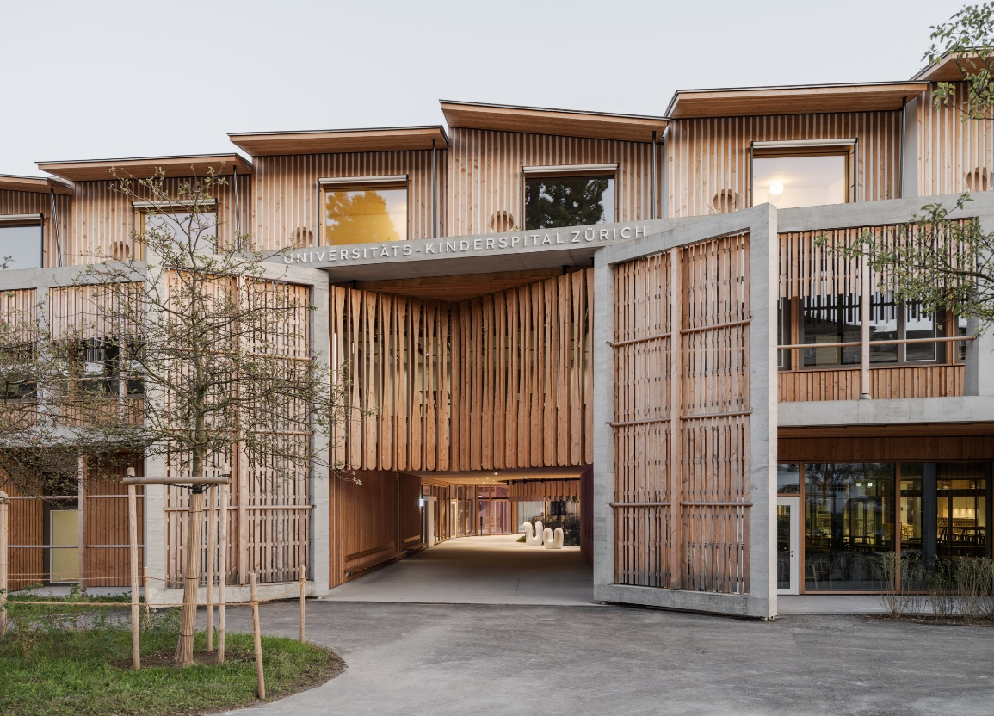
Figure 1: Main entrance and timber facade of the University Children's Hospital Zurich (Herzog & de Meuron, n.d.)
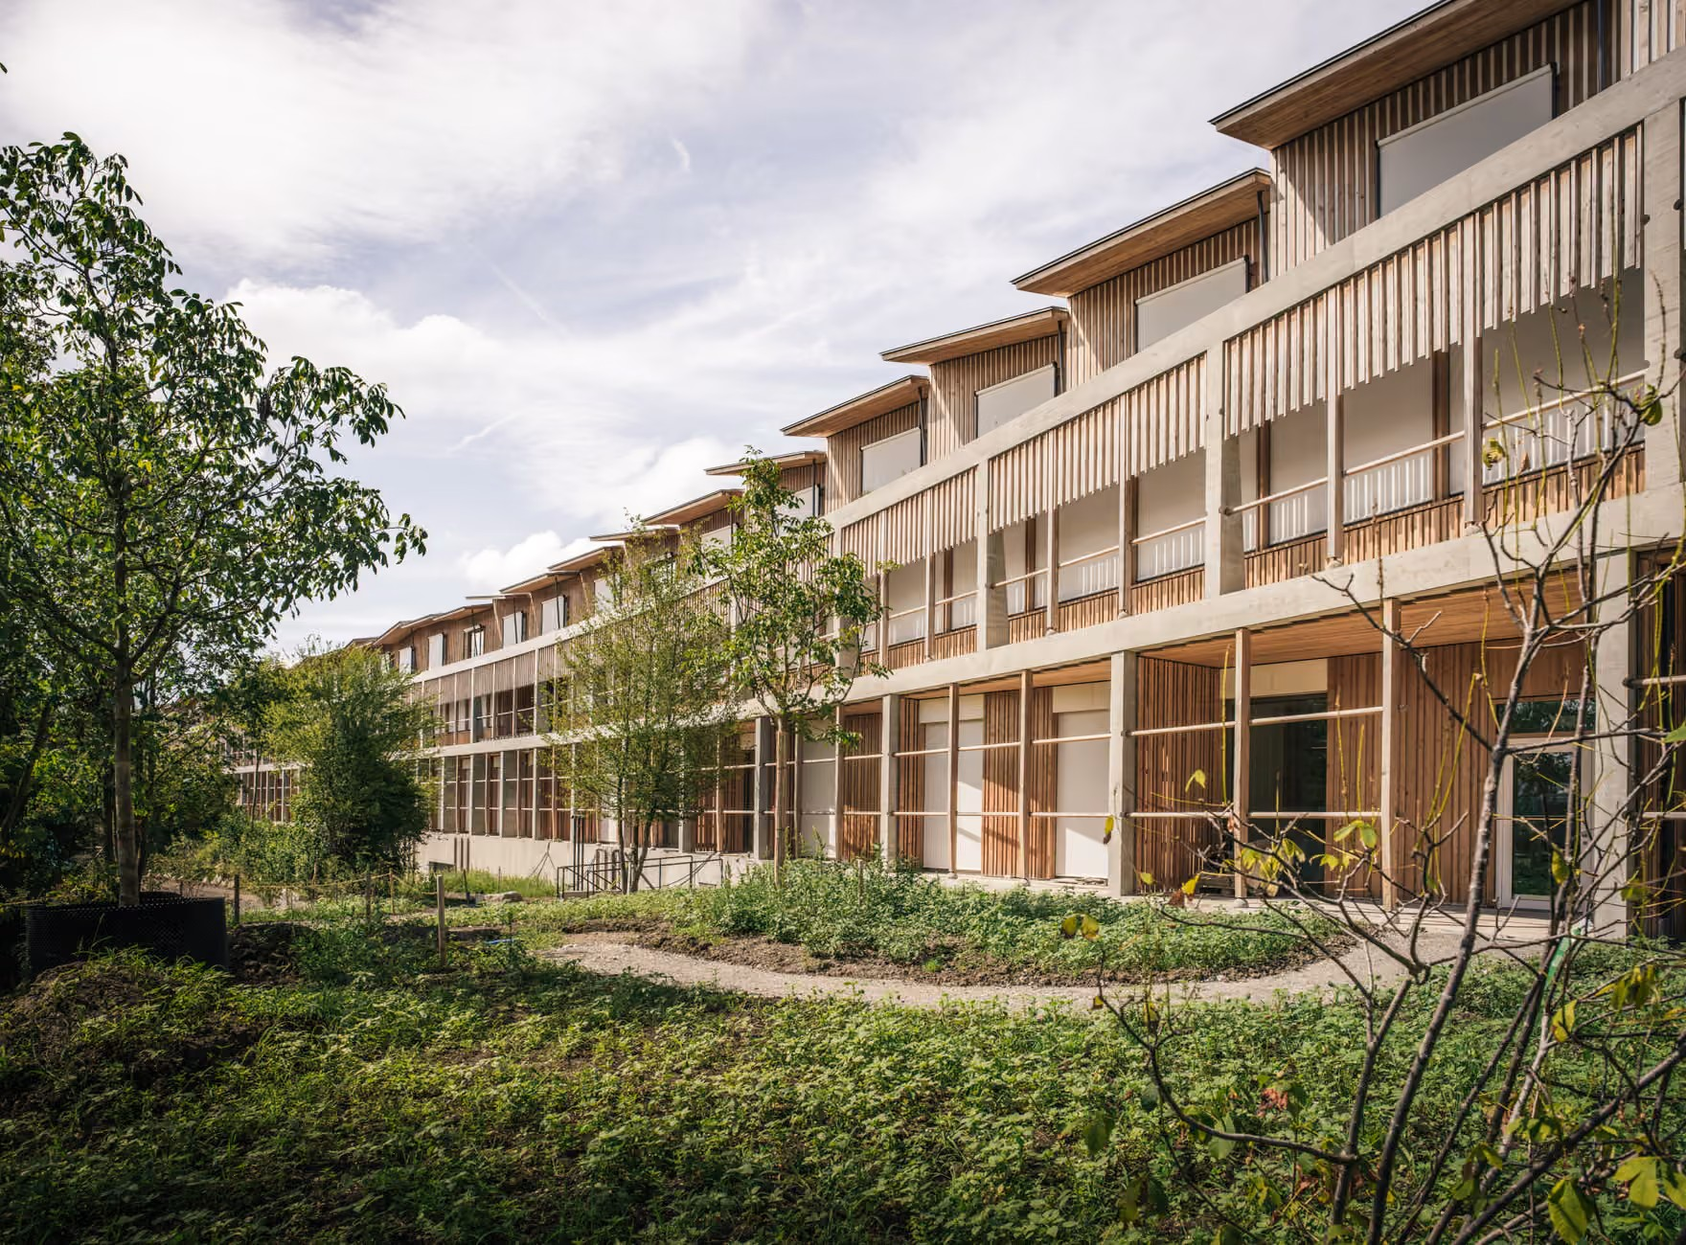
Figure 2: The curved facade and surrounding landscape featuring cottage-style roofs (Herzog & de Meuron, n.d.).
The architects demonstrated the understanding of social psychology in children by prioritizing the comfort of children and their family emotions. “The curved, three-story main facade with its endearing small-scale wooden houses and variously sloped roofs offers a friendly and warm welcome to young patients and their families” Pierre de Meuron said. Additionally, medical specialties are organized as distinct neighborhoods connected by indoor streets and squares which show a layout of a community-oriented environment that encourages social interaction and a sense of belonging (Herzog & de Meuron, n.d.). Moreover, 114 patient rooms on the top floor were designed as a wooden cottage with its own roof (Dezeen, 2024). Using this friendly image of warm, loving houses, combined with load-bearing wood panelling, it evokes a sense of warmth instead of normal hospitals’ coldness, to create a friendly, welcoming, and safe atmosphere designed to soothe children going through difficult times.
To conclude, analysing the University Children’s hospital through a social lens shows that design can contribute as a means of psychotherapy. By placing the human emotion, children's health care and the proportion of family-oriented spaces within the architectural vision, Herzog & de Meuron successfully redefined the architecture standard for community health care facilities. This project serves as an environment that nurtures, heals, and respects human emotions in modern society.

References
ArchDaily (2024) University Children’s Hospital Zurich / Herzog & de Meuron. Available at: https://www.archdaily.com/1021824/university-childrens-hospital-zurich-herzog-and-de-meuron [Accessed 14 July 2026].
Arquitectura Viva (2024) University Children’s Hospital Zurich. Available at: https://arquitecturaviva.com/works/hospital-infantil-universitario-de-zurich-6 [Accessed 14 July 2026].
Dezeen (2024) Herzog & de Meuron designs University Children's Hospital in Zurich. Dezeen, 13 October. Available at: https://www.dezeen.com/2024/10/13/herzog-de-meuron-university-childrens-hospital/ [Accessed 14 July 2026].
Herzog & de Meuron (n.d.) 377 Kinderspital Zürich. Available at: https://www.herzogdemeuron.com/projects/377-kinderspital-zurich/ [Accessed 14 July 2026].
STIRworld (2024) Herzog & de Meuron reframe the architecture of healing with a hospital in Zurich. Available at: https://www.stirworld.com/see-features-herzog-de-meuron-reframe-the-architecture-of-healing-with-a-hospital-in-zurich [Accessed 14 July 2026].

