What French cultures influenced Vietnamese architecture and design (Ernest Hébrard and the Indochinese Style in Vietnamese Architecture)
Architecture is not only a place to live but also to show the change of culture, power dynamics and identities are constantly evolving. Some of architecture concepts in terms of design are an example to the cultural synthesis, in turn, arose from the very unequal power structures of colonialism (Cooper, 2000). This essay will investigate the work of Ernest Hebrard (1875–1933). He was a French architect and an urban designer, a pioneer of creating Indochina Style. Through analysing one of his pieces of works, Louis Finot Museum (Vietnam National Museum of History) completed in 1932 (Cooper, 2000). I will analyse how Hebrard associated European space principle and the Vietnamese native aesthetic traditions.
The main reason for choosing Hebrard was because of his hybridity theory which influenced the final project on creating the foundation of history and exchange culture. project aims to “heal” the historic memory of Dahomey site in the Jardin d'Agronomie Tropicale (France). Understanding how architecture was used as a tool of imposition of power in the past will provide a solid foundation to reverse that perspective, transforming the current landscape into a space of respect, ecology, and cultural reconciliation.
Understanding the context of historical, social and political aspects of the Indochinese Federation at the beginning of the 20th century is necessary to show how Indochina style was created and how it was applied to Vietnamese architecture at the time. Hebrard was appointed director of the urban planning service in Indochina by Governor-General Maurice Long in 1921 when French architecture played a role of completely imposing on Vietnam (Simonetti, 2016). The public architecture building was built following the Neoclassical and other models of Europe (Cooper, 2000). The purpose there was to show off the imperial power, establishing order and alleviating the anxieties of colonial authorities in controlling a foreign land (Scott, 2015). However, the solid concrete blocks, flat roofs, and dense glass windows completely fail against the harsh tropical monsoon climate, turning the buildings into suffocating "thermal incubators"(Chang and Winter, 2015). Politically, in the 1920s there was a shift in colonial policy from assimilation to association. Instead of removing native culture, the French started combining it into their system to enable the people of Vietnam to define the influence of the style (Paliard, 2019). The Indochina style of Hebrard was born in this situation. According to Cooper (2000), architecture and urban planning under colonial rule was just a means for allowing the French colonialists to expose their dominance and inviolability over the empire. Hebrard put an aesthetic cover to Asian buildings as just a way to maintain the facade of social, cultural, political, and technological superiority (Cooper, 2000), which deeply hid the anxieties about the integrity of the governing apparatus.
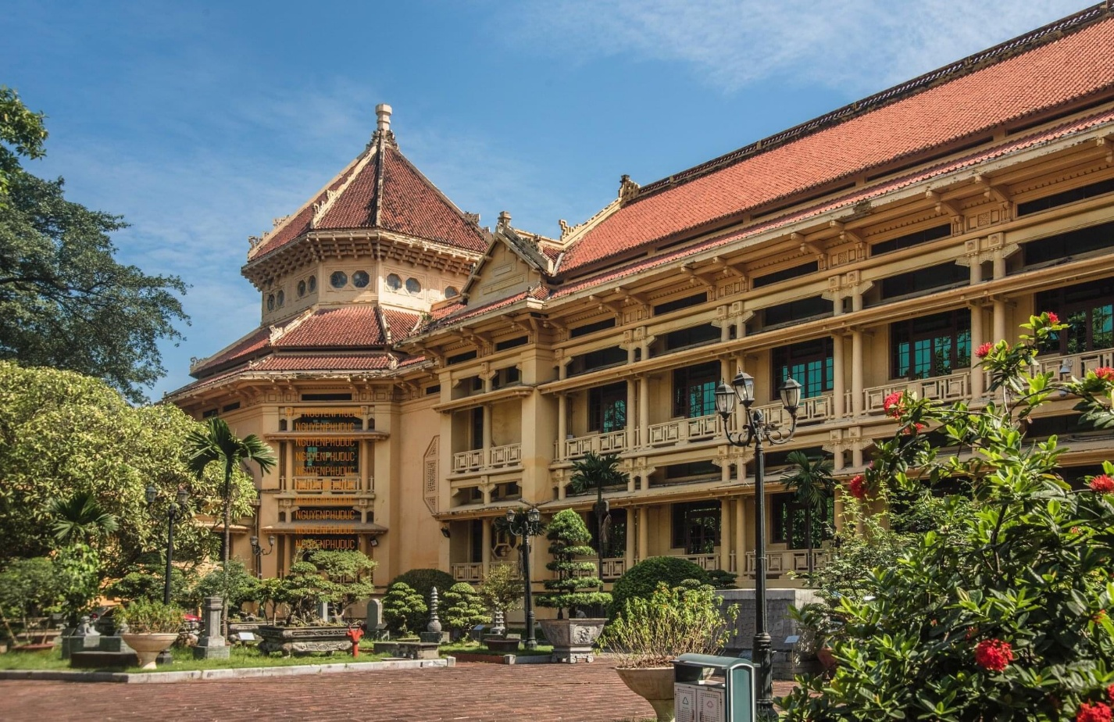
Figure 1: The façade of Louis Finot Museum (Vietnam National Museum of History) (Bảo tàng lịch sử Quốc gia, 2026)
Louis Finot museum is a vivid example of the architectural thinking of Hebrard. For space structure, the building strictly followed the principle of axial symmetry of the Western Beaux-Arts school, with a modern reinforced concrete foundation and beam system. However, this is away from the traditional design principles but in fact making Hebrard’s own mark. Instead of a French-style pitched roof, Hébrard uses a multi-tiered, overhanging roof system (brise-soleil) to provide shelter from rain and create intense shade Chang and Winter, 2015). The central hall was designed as a massive octagon, using as a natural thermal chimney to draw hot air upwards and release it outwards. Surrounding the building are deep corridors and wooden louvers that allow continuous crosswinds. In colour, the building used warm earthy yellow tones, contrasting with the green of the wood and the deep red of the tiles creates a visual harmony, complementing the tropical light.
Hebrard used hybridity and eclecticism in this architecture work which blends between Beaux Art of western art and some details of eastern art. In detail, the facade is similar to Japanese Shinto temples, the steep-tiled porch roof borrowing ideas from Hindu temples in India and the two-tiered roof of the central core alluded to Siamese, Cambodian and Laotian temple structure (Cooper, 2000). Although this building was praised for its honouring western art, it showed a conflict of colonialism when blending many features of Japan, India, Thailand and Cambodia in this building, Hebrard blurred the boundary of the distinct identity of each country. With French at that time, Western is an abstract thought, depicted as orientalism meaning. The blurring was the mean for France imposed dominant aesthetic values. This invention of Indochinese created a misconnection of the native history, turning this building into an affirmation of French power and intervention in Indochina (Cooper, 2000).
According to studies on colonial architecture (Simonetti, 2016; Paliard, 2019), Hebrard was influenced by construction based on the local climate and materials. Besides, his career also connected with the culture exchange of the art between France and Vietnam. Hebrard also had a close connection with Victor Tardieu who founded École des Beaux-Arts de l'Indochine (School of Fine Arts of Indochina) in Vietnam. Like the way Tardieu encouraged Vietnamese artists to use traditional lacquer in creating national art instead of copying the lacquer from France or Japan (Paliard, 2019; Simonetti, 2016). His Indochina style became the standard spread throughout the region. This revolution was demonstrated clearly when the Vietnamese bourgeoisie and the Chinese diaspora in Hanoi also began applying Hébrard's design techniques to their private homes (Vuong et al., 2019). Now, his artwork is no longer considered a mere imposition but has been accepted as a part of Vietnam's national heritage.
According to the author, the first impression of the artist’s work was a sense of visual grandeur that made people feel small, but it was not intimidating or imposing. Because of its warm yellow, rough details of the ceramic tiles and the depth of the shadows cast under the eaves evoke a feeling of familiarity and comfort. The structure strongly echoes traditional temples of Vietnam, but it extends a greater beauty. Although it is linked with the painful and sorrowful memories of the Vietnamese people during the war and colonial periods, viewed today, it stands as a testament to the past and a heritage of Vietnam. There is a shift after researching and analyzing. At the beginning, it is revealed to be when Hebrard blended the art of western and eastern together, but it must be critically challenged that "respect" for local culture lied sophisticated political ambitions. His skills and physical solutions demonstrated a remarkable technical skill, but the imposition of past values ​​hidden beneath the foundations of the project is built remains deeply problematic and open to strict objection.
In conclusion, the Indochina style of Hebrard is a synthesis of Western technical thinking and indigenous aesthetics, although it still bears the strong imprint of colonial power. The purpose of this research is to understand the core of hybrid architecture for the final project. But instead of turning the landscape and history into a blank, the project aims to maintain historical remnants and organise the landscape to frame the existing ruins. This method allows to preserve the message of Indochina style brought to Vietnam in the past and bring the healing message about the pain of history in a sustainable and harmonious ecological space.

Reference:
Bảo tàng lịch sử Quốc gia (2026). Bảo tàng lịch sử Quốc gia. [online] Bảo tàng lịch sử Quốc gia. Available at: https://baotanglichsu.vn/en/articles/3173/74665/vietnam-national-museum-of-history-to-be-open-for-free-on-international-museum-day.html (Accessed 1 July 2026).
Chang, J.-H. and Winter, T. (2015) 'Thermal Modernity and Architecture', The Journal of Architecture, 20(1), pp. 92-121.
Cooper, N. (2000) 'Urban planning and architecture in colonial Indochina', FCS (French Cultural Studies), 11, pp. 75-99.
Ebert, B. and Schilling, M.R. (2016) 'A technical analysis of paint media used in twentieth-century Vietnamese lacquer paintings', Studies in Conservation, 61(sup3), pp. 52–67. doi: 10.1080/00393630.2016.1227051.
michel. “Art Schools and the Influence of French Artists in Vietnam - Society of Friends of the Cernuschi Museum.” Société Des Amis Du Musée Cernuschi, 20 Sept. 2023, amis-musee-cernuschi.org/en/les-ecoles-dart-et-linfluence-des-artistes-francais-au-viet-nam-2/. Accessed 20 June 2026.
Paliard, P. (2019) 'Apport de la France, Promotion de L’expression d’un Style National Vietnamien dans la Première École des Beaux-Arts de L’Indochine', Open Library of Humanities, 5(1), pp. 1–19. doi: 10.16995/olh.376.
Scott, P. (2015) 'Authority and Anxiety', in Low, S.W. (ed.) Between Declarations and Dreams: Art of Southeast Asia Since the 19th Century. Singapore: National Gallery Singapore, pp. 18–25.
Simonetti, M.-A. (2016) The Ecole des Beaux-Arts de l’Indochine: Victor Tardieu and French Art Between the Wars. Master’s Thesis. University of Illinois at Chicago.

