Introduction
In this semester, I want to focus on how my theme “the root of memory” connect to the theme of journey. Therefore, I will redevelop and reserve a park (Jardin d’ Agronomie Tropicale) from urban amnesia and bring back the historical story of the place before people explore the diversity of the culture spreading on the architecture. During the start of the semester, I still on the mood of celebrating the 51st anniversary of the liberation of the south and National reunification in Vietnam. This makes me remember how my nation developed from the pain of the past and I also want to convey the message of history to people nowadays. It is important that people know about the history of the place because it would be meaningless to convey a message about culture and healing if those who come here do not understand the history of the structure. Thus, the concept of project is surrounded by historical, sustainable, landscape and connection perspectives. It will show the connection between two countries (France and Vietnam) in modern area with bringing the story of history on both culture and architecture. Also, maintaining the sustainable of the landscape to demonstrate the enduring existence of site history.
My motivation is “What should I do with the remnants of a painful past?”, When I remember the historical events, there is a historic garden that is forgotten in the heart of the city. Jardin d’ Agronomie Tropicale was a colonial exhibition in 1907. Now it is just a forgotten place, swallowed up by the wild. Facing with this problem, the core of my project is preserving the memory, neither about restoring the glories of the past, nor about tearing them down to erase the memory. Instead, I want to create a healing mood of the past. Additionally, as Vietnamese landscape architecture student, doing a project in French colonial history, this project is profoundly personal. My intial conceptual inspiration is the spirit of “Reunification” and the deeply rooted cultural desire to find harmony after prolonged conflict. Historically, colonial architecture was ultilised as a tool for aesthetic and political imposition, thereby I want to reserve this perspective. This project has an important meaning to me because it challenges the painful historical view and uses landscape to convey a historical message and make the garden more connected to the surrounding urban life.
Influence
Indochina style and Ernest Hebrard
My theme focusses on the historical, narrative, and environmental aspects. For historical influences, Jardin d’Agronomie and the Dahomey glass house strongly imbued with the atmosphere of the colonial era which belonged to the 1907 colonial exhibition (Chabrel et al., 2024). To understand this structure, the project places the context into the broader scope of the Indochina style, created by Ernest Hebrard (Cooper, 2000). Although Hebrard was not the designer of the glass house, his core design will help possess a mature and multi-dimensional historical perspective. I will adopt his architectural hybridity concept to transform into landscape hybridity to encourage diversity, traumatic memories and create a space for healing. Furthermore, this helps foster cultural exchange between Vietnam and France. Based on this historical foundation, I suggest creating pavilion because pavilion will serve to create a necessary moment of stillness (Natalia, 2025). It is a place where visitors can sit down, read historical information panels, observe the ruins from a distance, and quietly reflect on the past or present. This helps people nurture their mental
Ernest Hebrard was a French Ernest Hebrard architect and urban designer. He was known as the "father" of Indochinese architecture which is a architectural combination of French art and the traditional cultures and tropical sensibilities of Southeast Asia (Vietnam, Laos, and Cambodia). Hebrard used hybridity and eclecticism in this architecture work which blends between Beaux Art of western art and some details of eastern art (Simonetti, 2016).
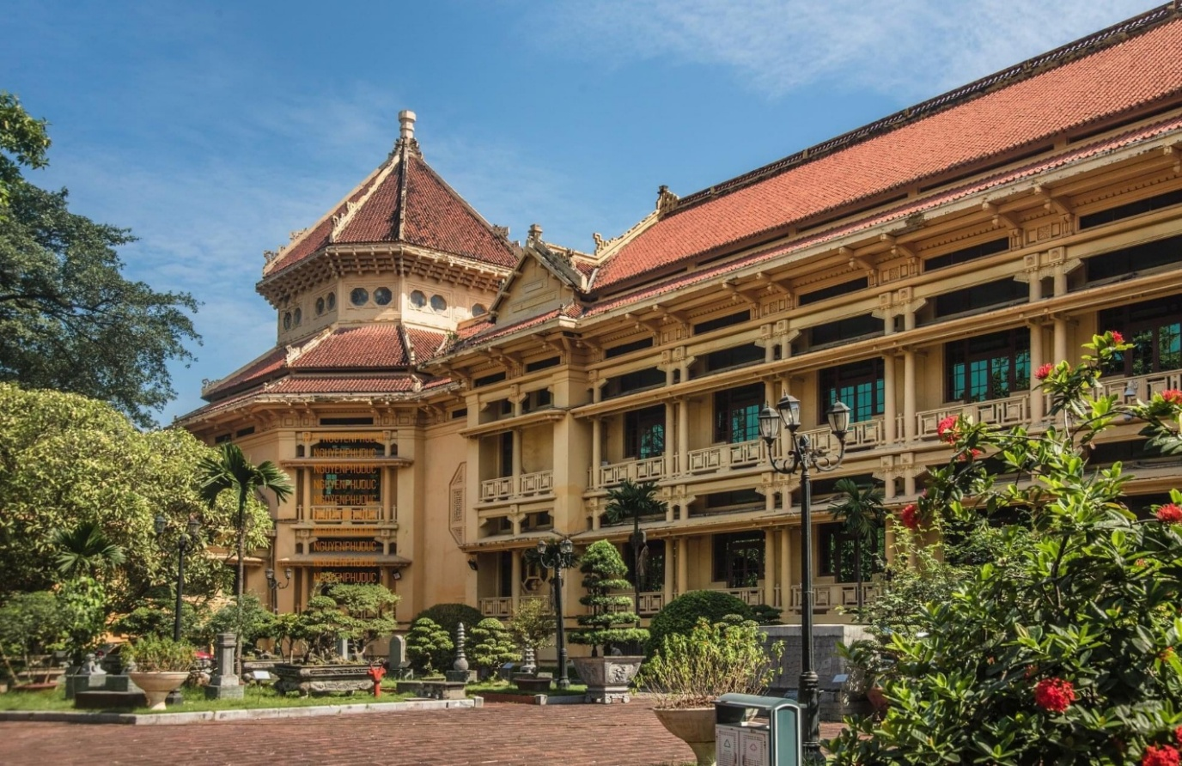

Figure 1: The façade of Louis Finot Museum (Vietnam National Museum of History) (Bảo tàng lịch sử Quốc gia, 2026)
This artwork is the vivid showcase of Hebrard’s technique, Hebrard used hybridity and eclecticism in this architecture work which blends between Beaux Art of western art and some details of eastern art (Chang and Winter, 2015). In detail, the facade is similar to Japanese Shinto temples, the steep-tiled porch roof borrowing ideas from Hindu temples in India and the two-tiered roof of the central core alluded to Siamese, Cambodian and Laotian temple structure (Cooper, 2000). Although Hebrard’s artwork in Vietnam reflected the French policy colonial in the past, it can be reserved by using the technique to introduce the culture and architecture in the friendly way. By approaching this knowledge, I understand that architecture can be blend by many cultures depending on the purpose of artist. Thus, my pavilion will reflect the Indochina style on it to introduce Vietnamese Architecture to the French garden.

Joseph Beuys
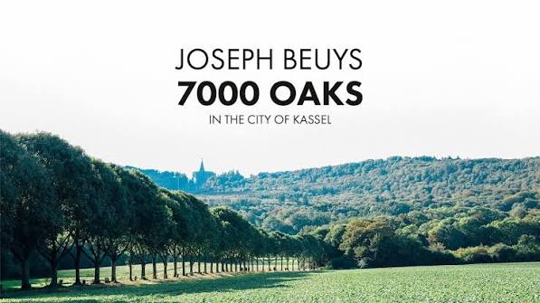
Figure 2: 7000 oaks by Joseph Beuys (Soremki , 2026)
Additionally, Joseph Beuys is one of the most influence artists in my project (National Gallery of Canada, 2017). His artwork does not influence me in my design, but it influences in the meaning. Beuys and volunteers planted 7,000 oak trees throughout the city of Kassel, each paired with a basalt stone. The combination of static, inorganic material (basalt) and the natural life cycle of growth (oak trees) represent a non-linear approach to reshaping space. This makes thing about the coexistence of human and environment in the modern era. I feel that the oak trees represent natural entities living alongside human development and urbanization. “Every effort has been made to minimise the environmental impact of this installation. Materials were brought to site by bicycle. Care has been taken to use local existing resources, avoid single use plastic and chemicals. Wherever possible materials will be reused or recycled at the end of the display.”, Beuys said. Thereby, this is important to raise the awareness of the ecosystem. By acknowledging this, I think I should choose friendly environmental material and choose a design which does not intervene or destroying the vegetarian.
Chinese Influence
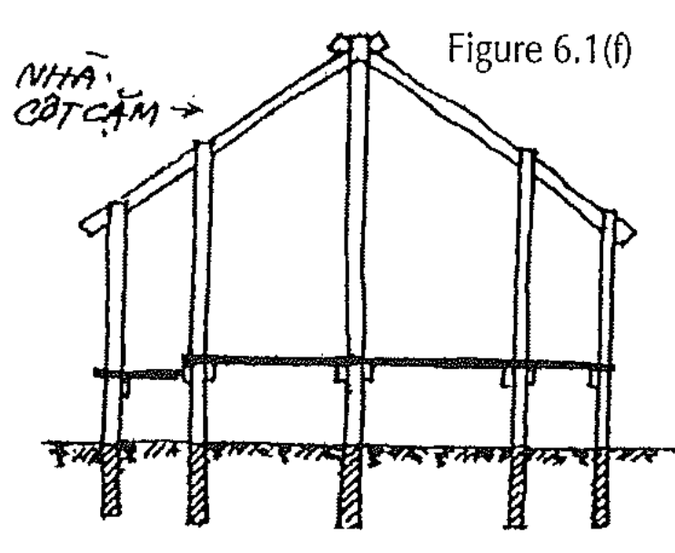
Figure 3: Nhà cột cặm
The Vietnamese northerners had adopted the Chinese preference for building on the ground, with posts either embedded in the earth or placed on stone bases (Golosova and Chu, 2019) . Vietnam is a Sinosphere country which means that the culture was influenced by Chinese culture. Also, Vietnam has 1000 years under Chinese rules, this period was before the French colony, but the structure and the architecture still exist nowadays, showing that this influence included Chinese and French architecture have become a part of Vietnamese architecture. These architectural features do not cancel each other out across different eras; instead, they coexist to this day (Vuong et al., 2019).
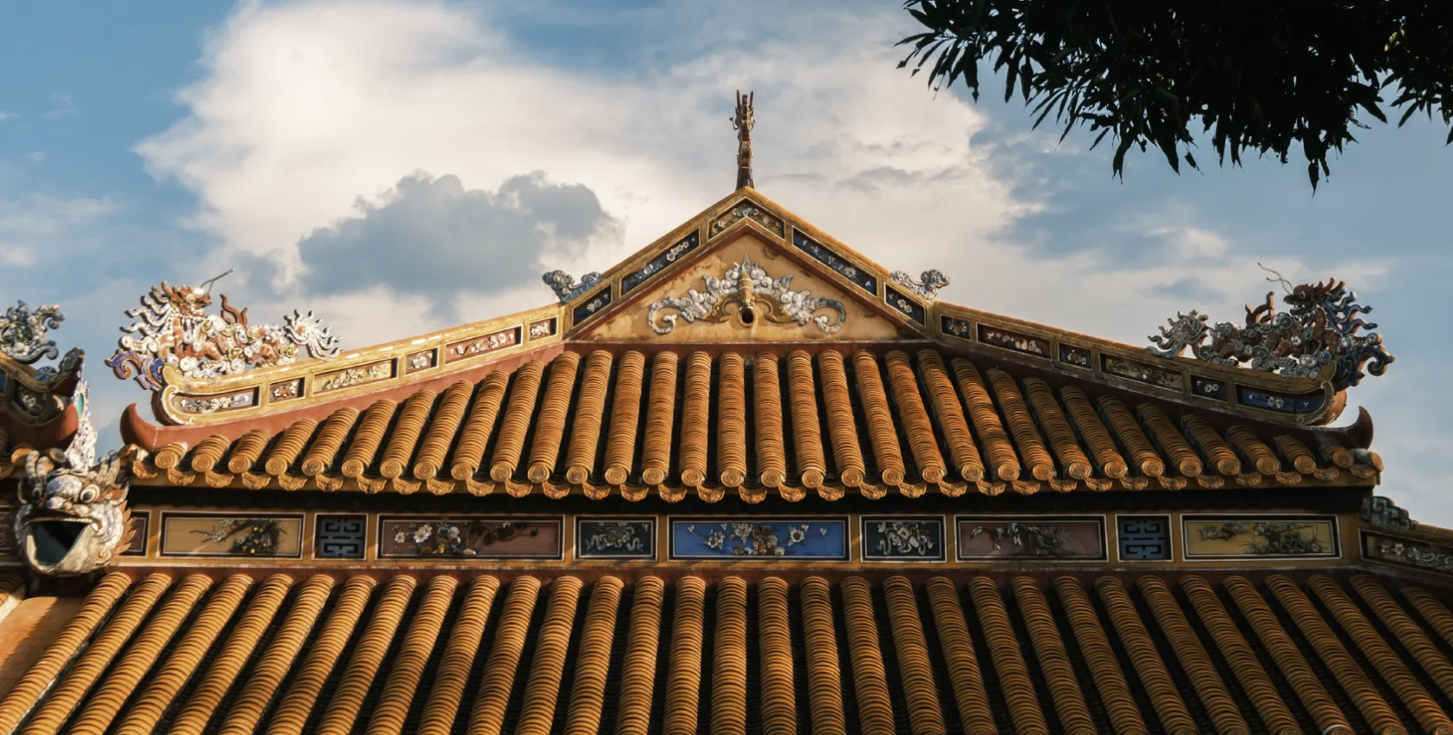
Figure 4: Yin-yang roof tile (Balderstone and Logan, 2003)
The Yin-Yang tile roof is another element of Chinese architecture that has strongly influenced Vietnamese architecture. Yin-yang roof tiles, originating from traditional Chinese architecture, found their way into Vietnamese living spaces at a very early stage. Yin-Yang roofing tiles consist of two types, facing tiles (Yang) and facing tiles (Yin) tiles, interlocked to create a distinctive undulating roof surface (Huynh, 2025). This structure not only enhances ventilation and water drainage but also serves as an Eastern feature of Yin-Yang harmony.
Art Movement
I was influenced by Eco-art movement, which characteristics is using art to raise the awareness of the ecosystem. Artists utilise natural materials or engage directly with environmental forces such as wind, water, or sunlight. Eco Art is a contemporary art movement that focuses on the relationship between human and environment (Kagan, 2014; Markova, 2025). The term emerged in the 1990s to describe artistic practices that had begun to take shape in the late 1960s. The core objective of the movement is not merely to reflect nature, but to directly restore, regenerate, and heal damaged environments.
There was no inventor of this art movement, a collective movement. Pioneers who laid the theoretical and practical foundations included Mierle Laderman Ukeles (with his 1969 manifesto "Maintenance Art"), and the artist duo Helen Mayer Harrison and Newton Harrison.
So, I decided to design a free-standing pavilion which has a minimal impact on the land and the vegetarian of the place to adapt the strictly rule of the conservation area of the site. Through this approach, the architecture defers to nature, reflecting a deep respect for both the site's complex history and its future as a resilient ecosystem.
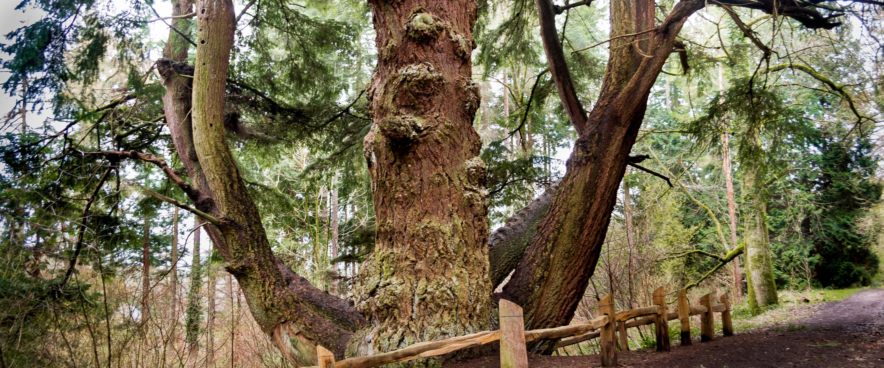
Figure 5 and 6: Bamboo and Douglas Fir (Rahmani, 2013; Forestry England, 2026).
I choose bamboo because it is renewable, inexpensive and with its light physical characteristics it means minimal energy is used to transport it which makes it a highly sustainable resource (Mairs, 2015; Rahmani, 2013). Plus, Douglas fir is a strong, high-quality softwood that rivals hardwoods such as premium oak (Forestry England, 2026). These materials, including bamboo and Douglas fir can support each other in building a pavilion for the project.
For supporting my project, I do research on the site location of Jardin d’agronomie tropicale in Bois de Vincennes Forest (Chabrel et al., 2024). This place evokes an atmosphere of escapism and exoticism. The setting is an interplay between a hybrid ecosystem, blending native plants with exotic tropical species and colonial architectural ruins gradually being reclaimed by nature, such as the Dahomey Greenhouse with its rusted steel framework. It was once a site used to showcase French colonial power, notably during the 1907 Colonial Exhibition, which featured "human zoos." Today, space has nostalgia and a sense of abandoned desolation, awaiting a design solution that can "heal" and recontextualise its history, rather than simply leaving it to decay or eras it entirely.
The pavilion will serve as a safe, purposefully designed observation point. I can use it to direct the gaze of those resting there straight toward the beautiful architectural features of the ruins and the landscape. Visitors require a physical space (sheltered from sun and rain) where they can pause, read historical information panels, and reflect in tranquility, rather than simply passing through as they would on a standard pathway.
Processes and Techniques
This semester, I will use Maya to visualize my project while using 3D printing to print out the structure of the pavilion. I will use physical models to generate ideas and develop designs. For digital models, I want to develop my digital skills through using Maya. I developed my skills through experiments and mistakes. I will use Twinmotion to apply the material and set the landscape surrounding. This helps me do architecture visualization.
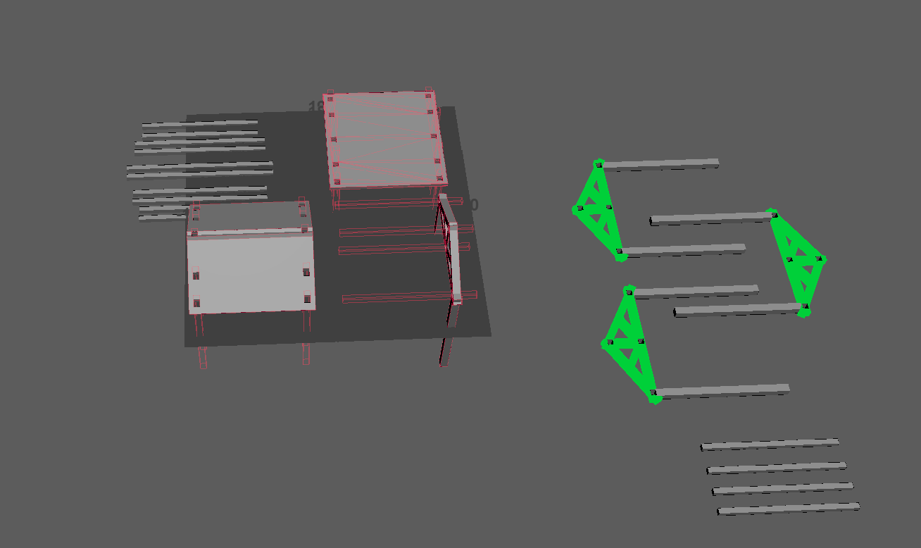
Figure 7: 3D modeling in Maya
For physical modeling, I focused on the structure of the project. This allowed me to create more realistic technical sketches and forms. After understanding truss structure, I applied it for the structure of the 3D model.
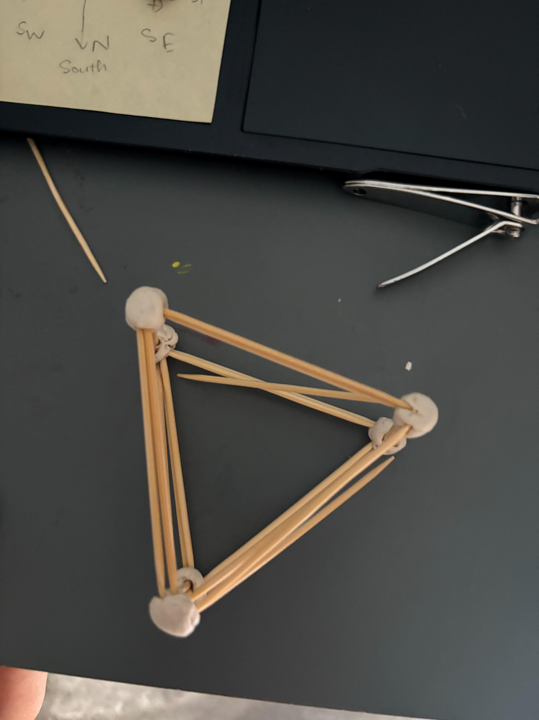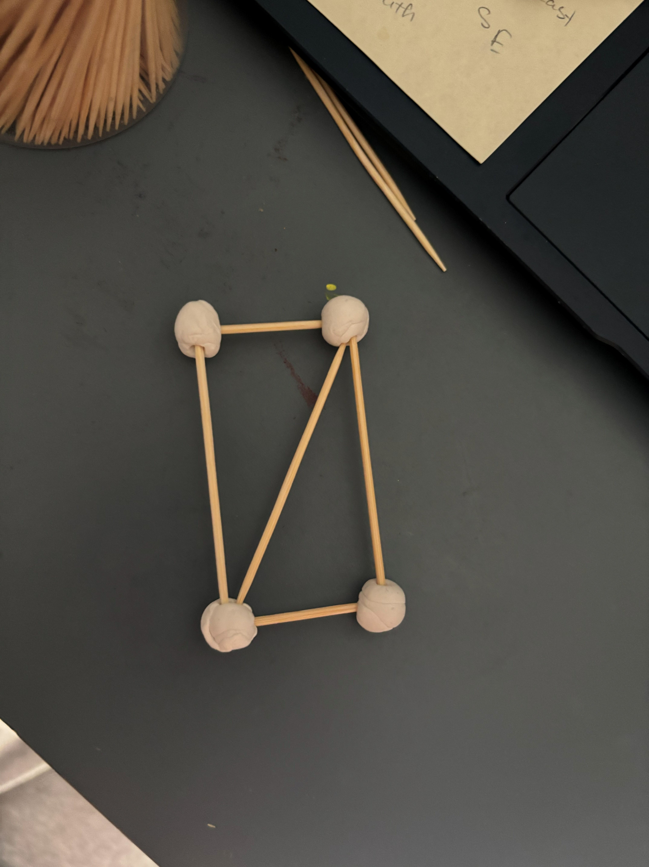
“Truss models”
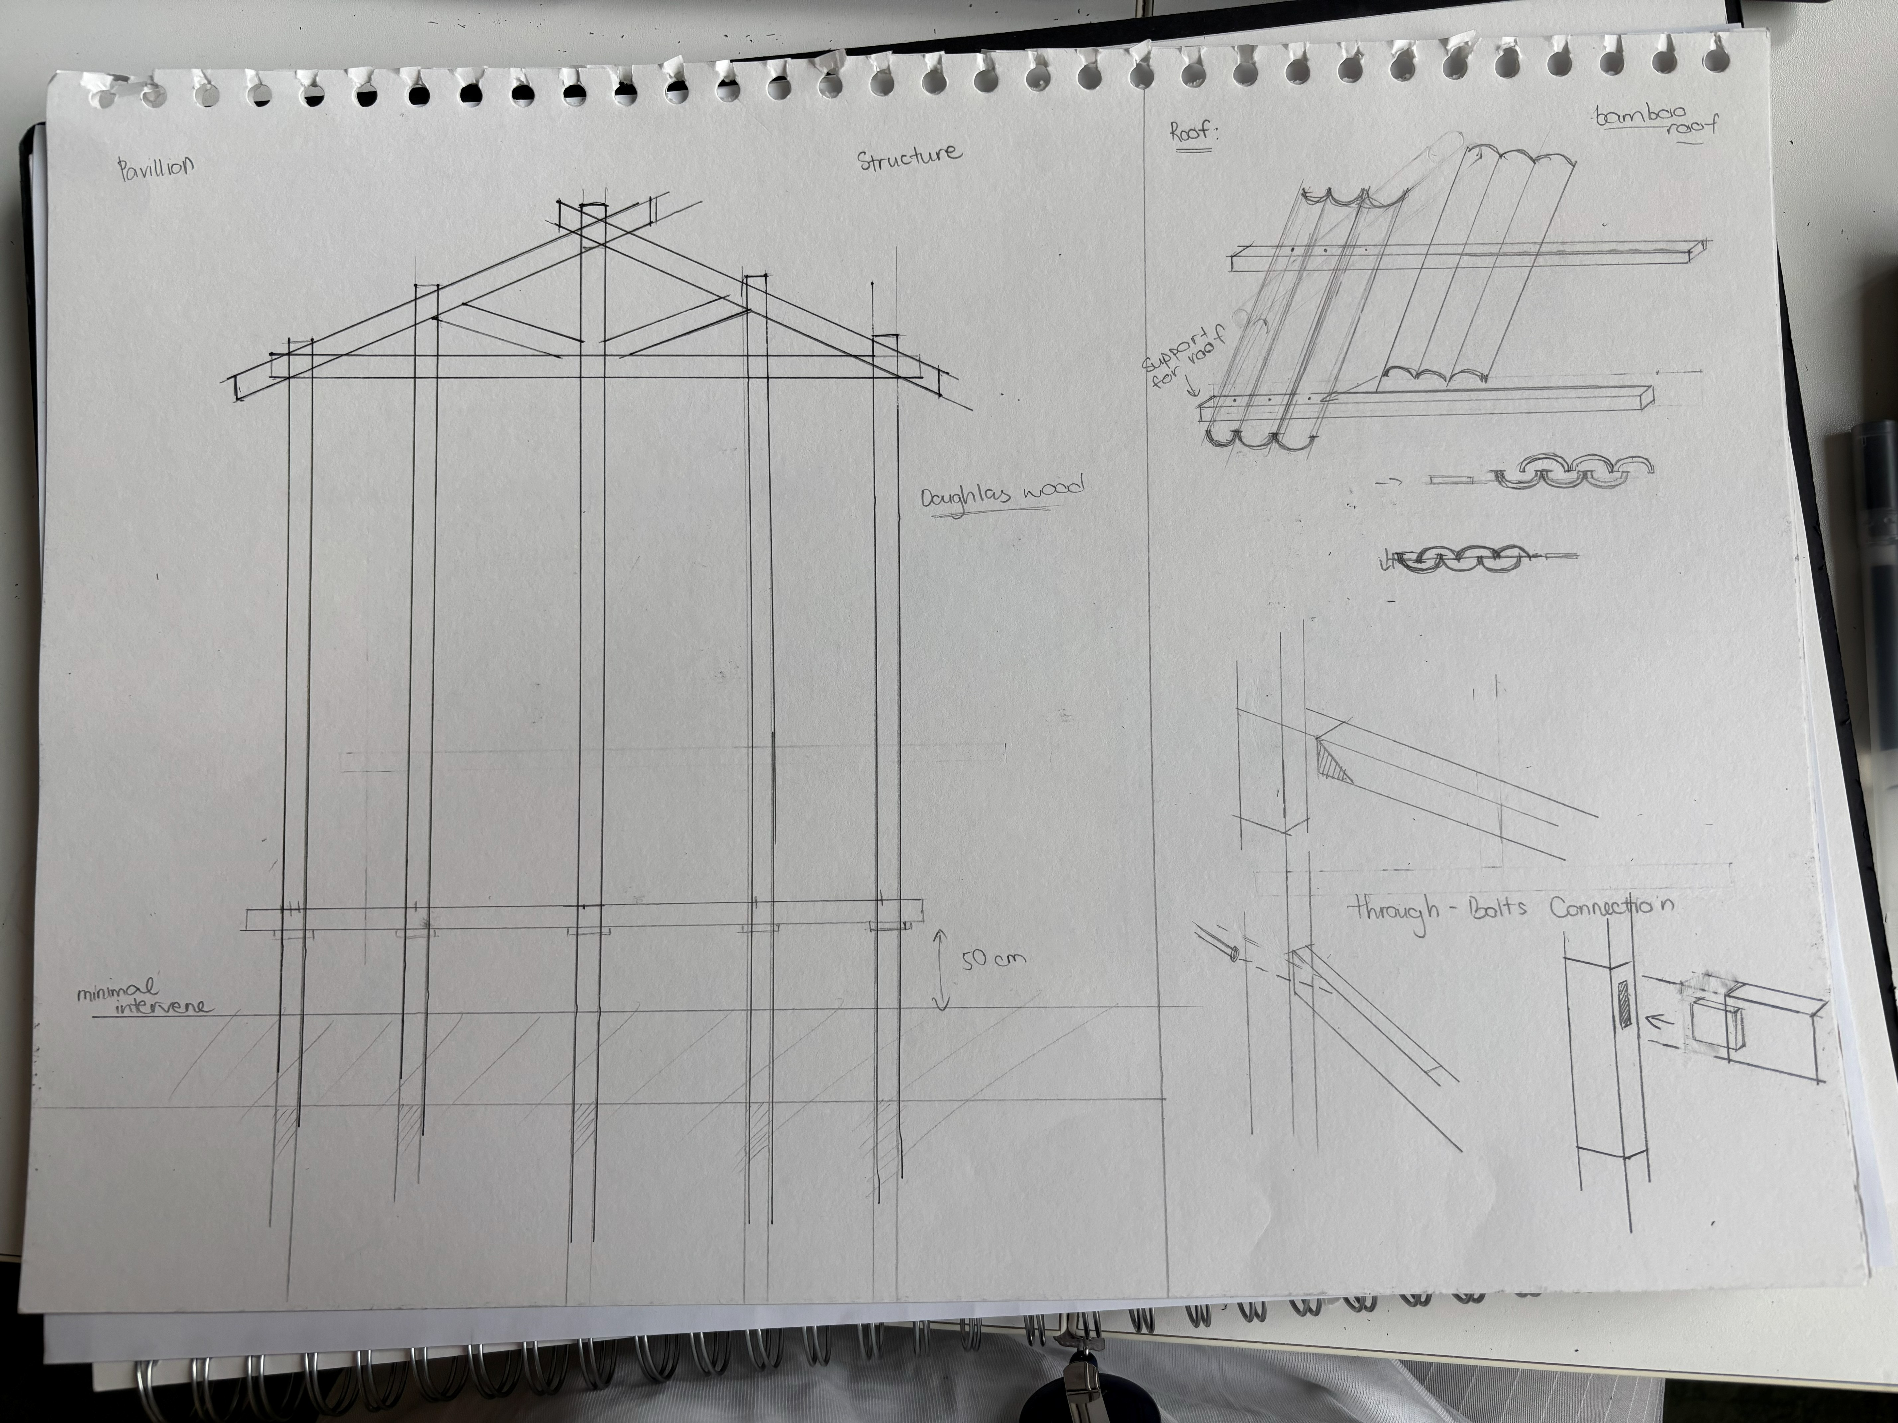
Technical sketch
After using both physical and digital models, they helped me understand each face of the pavilion and sketch technically.

m Plan Document
Final Major Project - ART 103 and ART 104

Project Start Date: Final Deadline:

Title
Brief Statement

Last semester, I redeveloped a park, Parc Balnéaire du Prado, in Marseille, France. I used a range of technologies to address environmental issues and explored how they could improve the site while benefiting residents. My focus was landscape and the environment. For this semester’s project, I chose Jardin d'agronomie tropicale - René Dumont. My aim is not to celebrate colonial power and the glorify war, but to present the contemporary relationship between Vietnam and France through a mature, multifaceted view of history, using Vietnamese architecture in a French context.

Aims of project:
My project aims to transform a ruin space steeped in colonial history into a symbol of French and Vietnamese cultural fusion, while respecting the environment of the site. I want to influence Vietnamese architecture to a European country (France) and learn how to develop the place without changing or affecting on the history. Besides, I also want to convey the message of history and healing people through the landscape to draw the back the attention of citizens surroundings to the site because it has been ignored.
Research:
I will research on the historical of the place and how French culture influence Vietnamese architecture in the past to show the connect between two countries (Indochina style). I also research suitable materials and structures for the place to adapt the environment. Plus, I will research deeply on the Vietnamese architecture to bring Vietnamese elements through my designs. Additionally, the site analysis and resources about the context and statement of the place is also important because it will affect directly on making decisions of designs.
Development of ideas:
I will connect my research into my project and bring my ideas to designs. I think the important thing for my project is the language of material and patterns because they can tell the story of culture and history without writing it down. I also looked at the different types of pavilions to understand which elements are needed. I considered the choices of material and structure that affected the environment to make sure that it is minimal intervention to the land.
Project outcomes:
My project is creating Indochina pavilion with friendly and sturdy materials which offer citizens and people to gather there. It will have minimal intervention to the land to respect the environment and reserve the green area.

Week | Task – What is the main priority for this week? | Time Frame | Action Completed
Week 1 | Deciding of what I want to do | 2 weeks | Week 2
Week 2 | Deciding the location of the project | 1 week | Week 3
Week 3 | Research on the location and artists influence | Until week 5 | Week 4
Week 4 | Finishing the site analysis | Until the end of week 4 | Week 4
Week 5 | Research for the solution of reserving and development  Start designing and mood board.  Experiment with 3D models | Until week 6 – beginning of week 7 | Week 8
Week 6 | Selecting the right solutions and starting to design based on research. | beginning of week 7 | Week 8
Week 7 | Design ideas on Vietnamese feature | 2 weeks | Week 9
Week 8 | Working on digital work and research more | Week 8 | Week 10
Week 9 | Experiment with 3D printing  Printing models | At the beginning of week 10 | Week 10
Week 10 | Design sheets  finishing all physical and digital models |  | Until the submission
Week 11 | Deadline
Week 12 | Exhibition
Milestone Deadlines & Key Dates

Materials & Preparation

Reference:
Atelier Parisien d'Urbanisme (APUR) (2013) Le Jardin d'Agronomie Tropicale Bois de Vincennes: Perpectives d'évolution du site. Paris: APUR.
Bảo tàng lịch sử Quốc gia (2026). Bảo tàng lịch sử Quốc gia. [online] Bảo tàng lịch sử Quốc gia. Available at: https://baotanglichsu.vn/en/articles/3173/74665/vietnam-national-museum-of-history-to-be-open-for-free-on-international-museum-day.html (Accessed 1 July 2026).
Balderstone, S. and Logan, W. (2003). Vietnamese dwellings: tradition, resilience, and change, in Knapp, R. G. (ed.) Asia's Old Dwellings: Tradition, Resilience, and Change. Hong Kong: Oxford University Press, pp. 136–157.
Chabrel, G., Derer, L., Hammouti, I. and Hersemeule, O. (2024) Le Jardin d'Agronomie Tropicale: La parcelle du Dahomey. Université Paris 1 Panthéon-Sorbonne.
Cooper, N. (2000) 'Urban planning and architecture in colonial Indochina', FCS (French Cultural Studies), 11, pp. 75-99.
Daryna Markova (2025). Eco-Art: Transforming awareness through creativity. [online] Domartresidence.com. DOM Art Residence. Available at: https://domartresidence.com/blog/eco-art [Accessed 19 July 2026].
Huynh, G. (2025). YIN-YANG TILE ROOF - THE OLD SOUL REMAINS FOREVER. [online] MLifeOn. Available at: https://mlifeon.com/en/articles/yin-yang-tile-roof-the-old-soul-remains-forever/ [Accessed 28 July 2026].
Golosova, E.V. and Chu, H.M. (2019). The gardens and architecture of the imperial burial complexes of Vietnam as a result of the influence of Chinese culture on the countries of Woutheast Asia. [online] Amazonia Investiga, 8(21), pp. 491–499. Available at: http://www.udla.edu.co/revistas/index.php/amazonia-investiga.[Accessed 28 July 2026]
Kagan, S. (2014). The practice of ecological art.
Forestry England (2026). Douglas fir. [online] Forestry England. Available at: https://www.forestryengland.uk/tree-species/douglas-fir [Accessed 1 Aug. 2026].
https://architizer.com/firms/esan-rahmani (2013). Bamboo pavilion by Esan Rahmani. [online] Architizer. Available at: https://architizer.com/projects/bamboo-pavilion/ [Accessed 6 July 2026].
Mairs, J. (2015). Penda’s bamboo pavilion is a sustainable modular housing system. [online] Dezeen. Available at: https://www.dezeen.com/2015/10/01/penda-rising-canes-bamboo-pavilion-prototype-modular-housing-beijing-design-week/ [Accessed 1 Aug. 2026].
National Gallery of Canada (2017). Joseph Beuys. [online] National Gallery of Canada. Available at: https://www.gallery.ca/beuys [Accessed 19 July 2026].
Natalia (2025). Classic Chinese garden structures: Pavilions, terraces &more. [online] China Xian Tour: Private & Tailor-Made China Tours - China Xian Tour offers flexible private China tours with the lowest price & best service. Available at: https://www.chinaxiantour.com/travel-guide/chinese-pavilion [Accessed 30 July 2026].
Simonetti, M.-A. (2016) The Ecole des Beaux-Arts de l’Indochine: Victor Tardieu and French Art Between the Wars. Master’s Thesis. University of Illinois at Chicago.
Soremki , M. (2026). YouTube. [online] Youtu.be. Available at: https://youtu.be/4m4Aq7_DXrY?si=WLpzWFN7Z5G0sOxo [Accessed 6 Aug. 2026].
Vuong, Q.-H., Bui, Q.-K., La, V.-P., Vuong, T.-T., Ho, M.-T., Nguyen, H.-K.T., Nguyen, H.-N., Nghiem, K.-C.P. and Ho, M.-T. (2019) Cultural evolution in Vietnam's early 20th century: A Bayesian networks analysis of Hanoi Franco-Chinese house designs, Social Sciences & Humanities Open, 1(1), p. 100001. Available at: https://doi.org/10.1016/j.ssaho.2019.100001.

